VANIER
CÉGEP / COLLEGE

Physical Education Manual

Shawna Lambert B.P.E
2026 Online Edition
Happy Health and Fitness for a Lifetime

TABLE OF CONTENTS

Chapter Review Questions and Assignments
for each Chapter will be sent separately.

Chapter 1: Health Wellness & Lifestyle Awareness | Page #
Health & Wellness | 4
The 6 Dimensions of Health | 5
Healthy Lifestyle Habits | 6
The 5 Components of Physical Fitness + FITT Table | 7-10
The Benefits of Physical Fitness on the Dimensions of Health | 11
Healthy Technology Use | 12-17
Chapter 2: Disease Prevention
Coronary Heart Disease (CHD): Risk Factors | 18-19
Controllable Risk Factors | 20-25
Uncontrollable Risk Factors | 26
Information from the Heart and Stroke Foundation | 27-28
Chapter 3: Cardiovascular Exercise
What is Cardiovascular Exercise and What are the benefits? | 29
FITT Principle for Cardiovascular Exercise | 30
Intensity: Heart Rate Training Range, RPE Scale | 31-33
Time & Type | 34-36
Chapter 4: Muscular Conditioning Exercise
What is Muscle Conditioning and What are the benefits? | 37
FITT Principle for Weight Training | 38-44
Basic Weight Training Principles | 45-46
Muscle Anatomy Diagram (Major Muscle Groups)⋅ | 47
Exercise Options for the Various Muscle Groups | 48-56
How to Make a Muscle Conditioning Program | 57-58
Chapter 5: Warm-Up, Flexibility, Posture
Terminology | 59
Components of Warm-Up – Range of Motion and Mobility Exercises | 60-63
Flexibility FITT | 64
Static Stretching Exercises for the Various Muscle Groups | 65-66
Posture Information | 67
Chapter 6: Nutrition
The 6 Essential Nutrients | 68-74
Macronutrient Chart | 75
Eating Plate and Healthy Eating Tips | 76
2019 Canada Food and Wellness Guide | 77-78
Think Before You Chew | 79

Chapter 7: Body Composition & Weight Management
FITT Principle for Body Composition – 4 Keys to Weight Management | 80
Body Composition Analysis, BMI, Body Types | 81-82
Top 10 Guide to Weight Management and a Healthy Body Composition | 83
Weight Loss Programs | 84
Energy Balance and Basal Metabolic Rate (BMR)⋅ | 85-89
Chapter 8: Stress
Eustress–Distress / Personality Types / Stress Management | 90-91
Stress Management Techniques | 92-93
Chapter 9: Fitness Appraisal
Introduction to the Vanier Fitness Appraisal | 94
Blood Pressure and Heart Rate Readings | 95-96
Body Composition Analysis | 97-102
Muscular Strength, Endurance, Agility and Balance Assessments | 103-110
Cardiovascular Endurance Assessment | 111-113
Flexibility Assessment | 114-115
Chapter 10: 102 SMART Goals information | 116-118
Chapter 11: 103 Exercise Program Design Information | 119-125
Related Websites | 126
Bibliography | 127-128
Notes | 129

CHAPTER 1
HEALTH, WELLNESS
& LIFESTYLE AWARENESS

HEALTH & WELLNESS

HEALTH

The World Health Organization defines health as being a state of complete physical, mental and social well-being, not merely the absence of disease or infirmity. To be of sound spirit, mind and body is to be healthy.

WELLNESS

- Wellness is defined as the attitude that one has towards one’s overall health and well-being.
- Wellness is achieved by following a lifestyle based on health-enhancing behaviours.
- Wellness involves more than not being sick. It involves making the lifestyle choices that prevent illness and lead to a more balanced, healthier and more satisfying life.
- More specifically, it represents individuals who make specific lifestyle choices that are characterized by personal responsibility, balance, and maximum enhancement of physical, mental, and spiritual health.

LIFESTYLE IS A CHOICE

- Every day, you make decisions that have immediate and long-term effects on your life and your health. You decide what to eat, whether to drink or smoke, whether to practice safe sexual habits, whether to exercise, how to cope with pressures and stress, whether to complete your work, whether to go to the doctor regularly, whether to take your medication, whether to follow the advice given by your doctor etc.
- Each individual is responsible for the lifestyle choices that they make and the positive or negative consequences that go along with those choices.
- Hopefully through education and participation you will be able to make or continue to make positive lifestyle choices so that you can obtain personal health and wellness.
- Making healthy lifestyle choices and following them may not always be easy; in fact, it can be very difficult. It is up to you to set your lifestyle goals and develop strategies to make the lifestyle choices that are important to you.

The goal of this manual is to provide you with the information that you need to allow you to achieve health and wellness. By adopting healthy behaviours like regular physical activity, healthy eating habits, adequate sleep, engaging in healthy relationships, and simply taking a walk-in nature you can take charge of your health, prevent illness and improve the quality of your life. The choice is up to you. The keys to success are motivation, accurate information and knowledge, workable strategies and a belief in your ability to change.

THE 6 DIMENSIONS OF HEALTH | 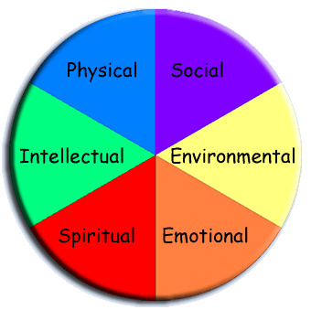

PHYSICAL HEALTH
In order to achieve physical health, I should consider the following lifestyle choices.
- Eating habits  - Exercise Habits (cardiovascular, muscular and flexibility).  - Level of daily activity. | - Safety habits  - Disease prevention (medical check-ups / self-examinations)  - Unhealthy habits: tobacco, alcohol, drug use
PSYCHOLOGICAL / MENTAL / EMOTIONAL HEALTH
In order to achieve psychological and emotional health I should consider the following:
- Time management & organizational skills  - Priorities and decision making  - Relaxation and stress management / coping techniques | - Personal relationships and support groups  - Ability to express emotions and feelings  - Self-esteem and acceptance  - Personal stressors
SOCIAL HEALTH
In order to be ensure social health I should consider my ability to:
- Interact effectively with other people.  - Develop satisfying and fulfilling relationships. | - Adapt to different social settings and act appropriately.  - Be involved in my community, school, interest groups
INTELLECTUAL HEALTH
In order to be intellectually healthy, I should:
- Have good self-awareness.  - Be able to process and act on information.  - Be able to figure out how to solve a problem or challenge. | - Be open to change and new ideas.  - Be able to question and evaluate information.  - Be able to learn from experience by making changes in my life.
ENVIRONMENTAL HEALTH
In order to be environmentally healthy, I should:
- Understand the impacts that humans have on the environment.
- Enjoy experience and protect the beauty and benefits of nature.
- Protect myself and others from the dangers in the air, soil, water and products that I use.
- Be aware of the impact of the products that I use
SPIRITUAL HEALTH
In order to be spiritually healthy, I should:
- Believe in some meaning or higher power, that provides significance to my life.
- Look beyond myself toward others and be able to give, forgive and attend to others needs.
- Be able to identify my own basic purpose in life.
- Learn how to experience love, joy, peace and fulfilment.

HEALTHY LIFESTYLE HABIT DO’S
It’s never too late!

EXERCISE REGULARLY
- Do 20 - 30 minutes of cardiovascular exercise; 3 - 4 times each week.  - Do stretching exercises after each workout.  - Perform 30 – 60 minutes of low intensity physical activity each day. |  | - Do muscular conditioning exercises for all of the major muscle groups; 2 - 3 days each week.  - Schedule weekly recreational activities like walking, skiing, and sports.
FOLLOW A WELL-BALANCED EATING PLAN
- Eat a variety of foods from the 4 food groups.  - Choose foods low in fat and saturated fat.  - Choose foods low in cholesterol.  - Avoid processed foods.  - Use Alcohol in moderation. | - Eat plenty of fruits and vegetables.  - Choose foods high in fibre.  - Use salt in moderation.  - Avoid sugary foods, candy, sodas and drinks.  - Drink 8 cups of water each day.
MAINTAIN HEALTHY BODY COMPOSITION / BODY WEIGHT
- Balance caloric intake and calorie expenditure.  - Follow a regular exercise program.  - Lead an active lifestyle by exercising more and sitting less. | - Eat a well-balanced diet without consuming excessive calories.  - Avoid high calorie, low nutrient foods such as junk foods, candy, and soda.
AVOID DESTRUCTIVE HABITS
- Don’t smoke.  - Avoid exposure to second hand smoke.  - Use alcohol in moderation.  - Never drink and drive. | - Don’t abuse drugs - caffeine, prescription drugs, and illicit drugs.  - Never share needles or drug paraphernalia.  - Set a limit for social media viewing time
GET PLENTY OF REST
- Get 7-8 hours of restful sleep each night. | - Practice time management.
MANAGE STRESS
- Reduce stress and learn to cope with stress.  - Set priorities, personal goals. | - Practice time management.  - Exercise regularly.
PRACTICE SAFE SEX
- Abstain from sexual relations or use condoms.  - Be prepared. | - Avoid alcohol and drug abuse.  - Choose safe sex partners - be informed.
GET REGULAR MEDICAL CHECK-UPS
- Comply with medical advice and prescription medications. | - A yearly medical preventative exam is recommended especially after the age of 40.
ADOPT GOOD SAFETY HABITS
- Always wear a seat belt.  - Follow automobile regulations.  - Ensure your car, bike, motorcycle, boat is properly maintained. | - Wear a lifejacket on a boat.  - Learn CPR.  - Avoid dangerous situations.

PHYSICAL HEALTH
5 COMPONENTS of Fitness
Achieving an optimum level of physical fitness and health involves the development of the 5 components of physical fitness which are:

5 components of Physical Fitness
Cardiovascular  Endurance | Flexibility  Muscular Strength  Muscular Endurance |  |  | Body Composition & Weight Management

FITT TABLE FOR THE COMPONENTS OF FITNESS
Fitness Component | Frequency | Intensity | Time  (duration of workout) | Type
Cardiovascular Endurance  Guidelines | 3 - 5  times / week  2 x / week for maintenance | 60-85% of Max HR  RPE: 2-4  comfortable to moderately hard | 20 - 60 minutes of continuous activity or  1-2 minutes of high intensity intervals (for at least 10 minutes) between muscle conditioning exercises can also be effective. | walk, jog, bike, swim,  soccer, basketball,  elliptical, spinning,  group fitness, box fit  body weight exercises

Muscular Strength & Muscular Endurance Guidelines
Training Goal:  ↓  Select your program goal. | Frequency | Intensity  # of sets /  # or reps (RM)  Reps Maximum | Time  10 – 60 minutes  Depends on the # of exercises, sets and reps you will be doing. | Type  A variety of equipment  can be used
General Fitness  Strength & Endurance  Development | 2 - 3 x’s / week / muscle group | 2 - 3 sets / exercise  Reach Fatigue by 10 - 15 RM  1-2 exercises /  major muscle group | - All major muscle groups should be trained weekly = Full Body Training.  - A Muscle conditioning workout should last no longer than 45 – 60 minutes.  - If your workout takes longer than 60 minutes it is recommended to split your program into 2 or 3 days  For example  Day 1- Upper Body  (Mon. + Thu.)  Day 2 – Lower Body + Trunk  (Tue + Fri.) | Machines,  Cables,
Muscle  Endurance  (limited muscle strength gains) | 2 - 3 x’s / week / muscle group | 1 - 3 sets / exercise  Reach Fatigue by 15 – 25+ RM  2-3 exercises /  major muscle group |  | free weights,  dumbbells,  barbells
Muscle Strength  Advanced  (limited muscle endurance gains) | 1 - 2 x’s / week / muscle group | 2 - 5 sets / exercise  Reach Fatigue by 5 - 10 RM  2 - 5 exercises /  major muscle group |  | body weight,  tubing / elastics
Body Building  Advanced Lifters  VOLUME is KEY | 1 - 2 x’s / week / muscle group | 3 - 6 sets / exercise  Reach Fatigue by 8 - 20 RM  3 - 5 exercises / major muscle |  | Callisthenics
Flexibility  Guidelines | 3 - 5 days / weeks and/or  after each workout | hold the stretch (static stretches) at the point of tension | Static Stretches should be  held for 20 - 30 sec.  Repeat each stretch 2-3 times for flexibility gains. | Static stretches after workouts.  Dynamic stretches before workouts.
Body Composition  Weight. Management  Guidelines  Key = is to balance  Energy In vs out | Do Cardio FITT  Goal: To burn as many calories as you can each workout | Do Muscle FITT  Goals:  To burn calories.  To ↑ muscle mass. To ↑ metabolism. | Follow the Canada Food Guide for healthy eating. Goals:  To balance caloric intake with caloric expenditure.  Eat high nutrient, less processed food. Portion control. | Follow an active lifestyle outside of scheduled physical activity =  Increase in caloric expenditure

1. CARDIOVASCULAR ENDURANCE / AEROBIC EXERCISE
- Cardiovascular endurance is defined as the ability of the heart, lungs and blood vessels to deliver adequate supplies of oxygen to the working muscles during continuous aerobic exercise.
- Aerobic activity is characterized as being continuous, non-stop movement; uses the large muscle groups such as the legs; and is performed at an intensity level that can be maintained for extended periods of time i.e. 5 - 60 minutes. Examples include: brisk walking, jogging, swimming, cycling, group fitness, Stairmaster, x-country skiing and a variety of sports which involve running like soccer, basketball.

The Benefits of Cardiovascular Exercise:

Health Benefits | - ↓ Disease risk – heart attacks, stroke, some cancers, high blood pressure, high cholesterol, diabetes, obesity.  - Improves the efficiency of the heart and lungs.  - Strengthens the immune system – less sicknesses  - Increases bone density - aids in the prevention of osteoporosis.  - Improves digestion and regularity – helps prevent constipation.
Changes in Body Composition | - In co-operation with healthy eating habits, aerobic exercise can assist in weight loss and weight maintenance and thus aid in the prevention of obesity.  - Increase in caloric expenditure – the more intense the activity, the more calories you will burn.  - Increases metabolism
Psychological Benefits | - Reduces stress levels.  - Improves sleep habits - more restful sleep  - Promotes a positive attitude, self-esteem, overall sense of well-being.  - Improves concentration, focus  - Decreases depression and improves mood
Quality of Life | - Increases energy levels  - Fun  - Provides avenue for social interaction  - Improved sex life
2 & 3. MUSCULAR STRENGTH & MUSCULAR ENDURANCE:

Muscular strength is defined as the maximum amount of force that a muscle or muscle group can exert in a single muscular contraction. The strength of a muscle is determined by the maximum weight that can be lifted in one contraction. This is referred to as the One Repetition Maximum (1RM). If you can lift more weight than you could when you started training, your muscles are getting stronger.

Muscular endurance is defined as the number of repetitions or length of time that a muscle or muscle group can continue to apply force or contract against a resistance before reaching the point of fatigue. The more repetitions that can be performed, the more endurance the muscle has. If you can do more repetitions of an exercise from when you started training, your muscle endurance is improving.

All weight training exercises will help you to improve both muscular strength and endurance. The extent which each component is developed depends on the intensity of the workout. The intensity is determined by the # of sets, repetitions and volume of exercises that you are doing.
For example:
- A program that involves 1-2 exercises per body part with 2-3 sets of 20 repetitions maximum will develop more muscle endurance.
- A program that involves 4-5 exercises per body part with 2-3 sets of 5-8 repetitions maximum will develop more muscular strength.
- A program that involves 2-3 exercises per body part with 2-3 sets of 10-15 reps maximum will develop both strength and endurance otherwise referred to as general fitness.

The Benefits of Muscular Strength and Endurance Exercise / Weight Training

Health Benefits | - ↓ disease risk – heart attacks, stroke, some cancers, high blood pressure, high cholesterol, diabetes, obesity.  - Improves the efficiency of the heart and lungs.  - Strengthens the immune system – less sicknesses  - Increases bone density thereby it aids in the prevention of osteoporosis.  - Improves digestion and regularity – helps prevent constipation.  - Strengthens the immune system.
Weight Management / Body Composition | - ↑ muscle mass, metabolism, caloric expenditure  - ↓ body fat.  - ↑ muscle → ↑ metabolism → ↓ body fat  - Increases muscle tone, firmness, definition
Psychological Benefits | - Reduces stress levels.  - Improves sleep habits - more restful sleep  - Promotes a positive attitude, self-esteem, overall sense of well-being.  - Improves concentration, focus  - Decreases depression and improves mood
Quality of Life | - Increases energy levels.  - Strengthens muscles, ligaments, and tendons thereby decreasing the risks of injury.  - Improves posture, balance, stability and co-ordination  - Improves athletic performance  - Personal protection
4. FLEXIBILITY

Flexibility is defined as the Range of Motion (ROM) possible around a joint or group of joint. The ability to move freely about a joint is dependent on the joint structure as well as the elasticity of the surrounding tissues - muscles, tendons and ligaments. Maintaining good flexibility by performing stretching exercises on a regular basis is a key element of fitness that can help to minimize the risks of injury and improve performance.

The Benefits of Flexibility Exercises:

- Good flexibility will contribute to the overall reduction of muscle tension.
- Helps prevent joint injury
- Helps prevent muscle pain prior to, or following exercise.
- Assists in the development and maintenance of good posture.
- Can decrease the severity of arthritis.
- Enhances athletic performance.
- Can decrease post exercise soreness.
- A proper balance between strength and flexibility can help prevent injury to muscles, tendons and ligaments in all areas of the body.

Example: Tight hamstrings and hip flexors (caused by sitting all day long) can cause the pelvis to tilt to far forward and can contribute to pain in the lower back region.

5. BODY COMPOSITION / WEIGHT MANAGEMENT

Body composition is the make-up of the body determined by the proportion of body fat and lean body mass. Lean body mass is the weight of muscles, bones, tissues, organs and skin which are metabolically active and contribute to energy expenditure. Body fat or adipose tissue represents body tissues that store energy for use during daily activity and some forms of exercise, namely aerobic exercise. Fat cells are stored just under the skin (subcutaneous fat cells), around the organs, and between muscle fibres. Body weight as measured by a scale reflects the overall body mass without differentiating between body fat weight and lean body mass. Ideal body weight on the other hand, represents body weight that includes an analysis of total body fat percentage and total lean body mass.

To calculate Your Body Fat % Online Go to: www.bmi-calculator.net/body-fat-calculator

General Body Fat Guidelines for Males and Females

Group | Males | Females
Essential Fat | 2 - 5 % | 10 - 13 %
Elite Athlete (depends on sport) | 6 – 13 % | 14 – 20 %
Healthy | 10 – 15 % | 18 – 25%
Average Population | 16 – 24 % | 25 – 31 %
Obese (medical terminology) | > 25 % | > 32 %

THE BENEFITS OF PHYSICAL FITNESS ON HEALTH DOMAINS
If you were to become more physically fit through regular participation in exercise, the following are some of the many benefits that you could achieve.
PHYSICAL BENEFITS
- Increase in energy levels  - Improved posture and physical appearance  - Decreased % of body fat  - Increase in lean body weight (muscle mass), which leads to an increase in metabolic rate and thus helps in weight control.  - Improved cardiovascular endurance by increasing the body’s efficiency for using O2 which allows the heart to perform more work with less beats.  - Improves sleep | - Improved muscular strength & endurance.  - Improved flexibility, posture and range of motion.  - Weight bearing activity strengthens bones which reduces the risk of developing osteoporosis  - Increase in the heart healthy HDL cholesterol which acts as an arterial cleanser and helps to decrease LDL cholesterol levels.  - Reduces the risks for coronary heart disease.  - Slows down the ageing process  - Improves posture and mobility
PSYCHOLOGICAL / MENTAL / EMOTIONAL HEALTH BENEFITS
- Relieves tension and stress.  - Aids in stress management as the hormone beta-endorphin is released into the blood and acts as a natural tranquilizer – the feel-good hormone.  - Restores mental fatigue | - Decreases mood swings and irritability  - Improves sleep habits  - Provides time for adult play and enjoyment  - Improves self-image and self-confidence
SOCIAL BENEFITS
- Enhanced relationships with family + friends  - Increased social networking opportunities | - Increased opportunity for social contacts  - Provides support groups
INTELLECTUAL / EDUCATIONAL / OCCUPATIONAL BENEFITS
- Develops concepts of mind and body oneness  - Increased alertness and focus  - Enhanced concentration  - Less absenteeism  - More productivity  - Decrease in disability days | - Motivation towards improving personal habits (smoking cessation, better nutritional habits, reducing drug and alcohol use)  - Stimulates creative thoughts and critical reflection  - Lower medical care costs  - Lower job turn-over rate.  - Increased networking possibilities
ENVIRONMENTAL BENEFITS
- Appreciation for healthy environment  - Appreciation and respect of nature  - Promotes play | - Physical transport (walk/bike/skateboard) reduces greenhouse gas emissions.  - Facilitates adherence to activity.
SPIRITUAL BENEFITS
- Appreciation and respect of body and self  - Enhances Relationships  - You take a moment to breathe, reflect and just be | - You test your will  - Your heart is engaged  - Develops happiness and fulfilment

Healthy Technology Use

(Information provided by Joey Stafford-Abbott)

If you are like most College students, you are addicted to your cell phone. You are anxious when separated from it. You spend an average of 10 hours per day intermittently using it. You think it isn’t a problem and you think you’re in control. However, …

What we feel as addiction is part of something much bigger.
It’s an invisible problem that's affecting all of society.

Facebook, Twitter, Instagram, and Google have produced amazing products that have benefited the world enormously. But these companies are also caught in a zero-sum race for our finite attention, which they need to make money. Constantly forced to outperform their competitors, they must use increasingly persuasive techniques to keep us glued. They point AI-driven news feeds, content, and notifications at our minds and are continually learning how to hook us more deeply—from our own behaviour.
Unfortunately, what's best for capturing our attention isn't best for our well-being:
- Snapchat turns conversations into streaks, redefining how our children measure friendship.
- Instagram glorifies the picture-perfect life, eroding our self-worth.
- Facebook segregates us into echo chambers, fragmenting our communities.
- YouTube auto plays the next video within seconds, even if it eats into our sleep.
These are not neutral products. They are part of a system designed to addict us.

The race for attention is eroding the pillars of our society.



Mental Health
The race to keep us on screen 24/7 makes it harder to disconnect, increasing stress, anxiety, and reducing sleep.



Our Children
The race to keep children’s attention trains them to replace their self-worth with likes, encourages comparison with others, and creates the constant illusion of missing out.


Social Relationships
The race for attention forces social media to prefer virtual interactions and rewards (likes, shares) on screens over face-to-face community.


Democracy
Social media rewards outrage, false facts, and filter bubbles – which are better at capturing attention – and divides us so we can no longer agree on truth.

The whole system is vulnerable to manipulation. Facebook advertisers can target based on what you've shared directly, but also what Facebook has inferred about you.  Phones, apps, and the web are so indispensable to our daily lives—a testament to the benefits they give us—that we’ve become a captive audience. With two billion people plugged into these devices, technology companies have inadvertently enabled a direct channel to manipulate entire societies with unprecedented precision. | 

Meanwhile, the platform companies profit from growth in users and activity.

Profiting from the problem, platforms won’t change on their own.
We can’t expect attention-extraction companies like YouTube, Facebook, Snapchat, or Twitter to change, because it’s against their business model.
Platforms would lose money if they solved the problem:
- Facebook would lose revenue if they blocked advertisers from micro-targeting lies and conspiracies to the people most likely to be persuaded. (e.g., Facebook found depressed teens buy more makeup).
- Twitter’s stock price would fall if they were to remove the millions of bots on their platform, which academics estimate at 15% of their user base.
- Facebook would lose revenue if their tools didn’t allow advertisers to automatically test millions of variations of content — word choices, colour, images — to capture the most minds.
So, we have to change the rules of the game. | 

Take control of your phone.

Try these simple changes to live more intentionally with your devices right now.

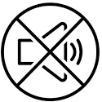 | Keep your phone on silent mode and only turn the volume on when needed
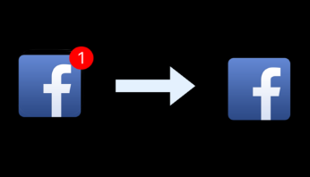 | Turn off all notifications except from people.  Notifications appear in RED dots because red is a trigger color that instantly draws our attention. But most notifications are generated by machines, not actual people. They keep our phones vibrating to lure us back into apps we don't really need to be in.  Visit Settings > Notifications and turn off all notifications, banners, and badges, except from apps where real people want your attention; e.g. messaging apps like WhatsApp, FB Messenger, Signal, Telegram, WeChat etc.
 | Go Grayscale.  Colorful icons give our brains shiny rewards every time we unlock. Set your phone to grayscale to remove those positive reinforcements. It helps many people check their phone less.  Go to Settings > General > Accessibility > Accessibility Shortcut (bottom) > Colour Filters. This allows you to quickly triple-tap the home button to toggle grayscale on and off, so you keep colour when you need it.
 | Keep your home screen to tools only.  Do you open apps mindlessly because they are the first thing you see when you unlock your phone?  Limit your first page of apps to just tools–the apps you use for quick in-and-out tasks like Maps, Camera, Calendar, Notes, or Lyft. Move the rest of your apps, especially mindless choices, off the first page and into folders.
 | Launch other apps by typing.  Swipe down and type the app you want to open instead of leaving bad habits on the home screen. Typing takes just enough effort to make us pause and ask, “do I really want to do this?”  On Android you can use the Search Box on your home screen.  iOS: For best results, turn off Siri Suggestions (Settings > Siri & Search > Siri Suggestions to off)
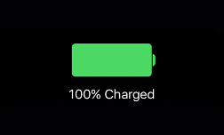 | Charge your device outside the bedroom.  Get a separate alarm clock in your bedroom, and charge your phone in another room (or on the other side of the room). This way, you can wake up without getting sucked into your phone before you even get out of bed.
 | Remove social media from your phone.  This one is tough, but effective! If you really want to use your phone less, we recommend removing all the major social media apps from your phone. It’s the easiest way to cut back, as these apps can easily gobble up so much of our time. Train yourself to use them from your computer only (if at all).  You can delete Facebook and still use Facebook Messenger.
 | Send audio notes or call instead of texting.  Studies show that it's common for people to misinterpret text messages, even from romantic partners, while voice is rich with tone and less vulnerable to misinterpretation. Recording a quick voice message is often faster and less stressful than typing out each letter. Plus, it doesn't require your full visual attention.  Note: Sometimes people are not in an environment where they can listen to context, giving a taste of the emotion that's often silently conveyed in a real, face-to-face conversation an audio note, so be patient with your expectations of response time.
 | Texting shortcut: Use quick reactions.  On iOS, press and hold on a text message and you'll see this menu of quick reactions. It's faster than crafting a response, and can also add some.

Download apps and extensions that help you live without distraction.

Flux (Mac, Windows)  Reclaim 15 mins of quality sleep by cutting the blue light from our screens |  | uBlock Origin (Chrome, Safari, Firefox)  Reclaim ~30-40% of your attention with every article you read | 
InboxWhenReady (Gmail)  Focus your inbox by only showing messages when you click "Show Inbox" instead of getting distracted as new emails arrive. |  | THRIVE (Android)  Set boundaries with your phone for set periods of time by turning your smart phone into a dumb phone. Automatically lets others know when you're taking a break. | 
Turn on NightShift (iOS)  Blue light from screens late at night tricks our body into believing it's still daytime, which disrupts our natural ability to sleep. |  | Freedom (Mac & Windows)  Temporarily block specific websites or apps on your desktop, tablet and phone for set periods of time. | 
Moment (iOS)  See how much time you spend on your phone. |  | RescueTime (Mac, Windows)  See how much time you spend on different apps on your desktop along with various websites. | 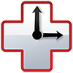
Enable "Send + Archive"  Gmail only. This archives the email right after you send it. The email will reappear in the inbox when the person replies. |  | Gboard  50% faster "swipe" typing than regular keyboards so you can respond to a message and get off your device more quickly. | 
Calm  Helps create calm and stress-free time in your day and reduces anxiety. Leading popular meditation app. |  | NoMoRoBo  Blocks robocalls and decreases the time you spend dealing with spam and telemarketers. | 
Calendly  Rapidly allows others to book time on your calendar by sending them a quick link. Helps each user save 10-15 minutes per meeting scheduled. |  | Facebook Newsfeed Eradicator  Removes the Facebook newsfeed and blurs the sidebars and notifications, allowing you to use some of the more utilitarian features of Facebook without getting sucked into the newsfeed. | 
Siempo  Siempo protects you from distractions & mindless use by letting you replace your home screen with an interface that allows you to batch notifications, unbranded icons, randomize their location, and set restrictions to prevent unconscious usage. |  | Distraction-Free YouTube  This company boasts that users have spent more than 100 million minutes distraction-free. The app protects you from distraction by temporarily locking you out of distracting games, social media, and other apps. (Apps temporarily disappear from your phone). | 

Special thanks to humanetech.com for content use. Visit humanetech.com for more information.

CHAPTER 2
HEART DISEASE PREVENTION

CORONARY HEART DISEASE

Healthy lifestyles help people live long, energetic and productive lives. Factors that contribute to a shortened life span, illness and premature death are often related to unhealthy lifestyle choices and can, in effect, lead to the development of Coronary Heart Disease (CHD). CHD is one of the leading causes of death in North America today.

CHD is usually the result of atherosclerosis. Atherosclerosis is a slow developing disease that occurs in the arteries of the heart, brain and kidneys. The disease clogs up or thickens the arteries by the progressive accumulation of plaques - fats, cholesterol, complex carbohydrates, blood products, fibrous tissues, and calcium deposits within the arterial wall. This thickening causes the arteries to narrow and lose their pliability and can restrict blood flow in its more advanced stages. If it affects the coronary arteries, the heart will not receive an adequate blood supply and a heart attack will occur. If blood flow to the brain is obstructed, a stroke will occur.

Heart Attack (Myocardial Infarction):
- The heart is deprived of adequate blood flow due to blockage in the coronary artery and, as a result, the heart muscle begins to die.
- The severity of the attack is determined by the degree of blockage.

Stroke:
- The brain is deprived of adequate blood flow due to cerebral artery occlusion or blockage and, as a result, the brain begins to die.

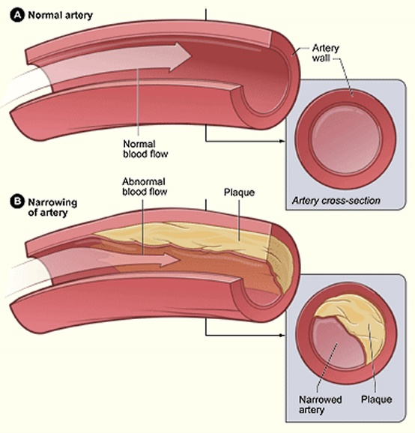

Atherosclerosis-1.jpg (1500×1566) (healthjade.com):

THE RISK FACTORS OF CORONARY HEART DISEASE

The American Heart Association (AHA) has identified a number of factors that increase the risks of obtaining this deadly disease. These risk factors have been statistically proven to predispose a person to CHD. The risk factors are classified as major/primary or contributing/secondary depending on the extent to which they have been found to contribute to the disease.

NOTE:
This does not necessarily imply a cause and effect relationship. Many of the risk factors associated with CHD are controllable through health lifestyle management, regular exercise and healthy eating habits. Understanding CHD and the associated risk factors will hopefully enable and motivate you to make healthy choices.

THE RISK FACTORS OF CORONARY HEART DISEASE
Controllable Risk Factors - Lifestyle Related

Major / Primary Risk Factors | Contributing / Secondary Risk Factors
- Smoking  - High Cholesterol (High LDL + low HDL levels)  - High Blood Pressure (normal 120/80 - high 140/90mmhg)  - Inactivity – Sedentary Lifestyle  - Obesity / Overweight  - Diabetes | - Stress  - Poor Eating Habits  - High Blood Fat Levels  - Excessive Alcohol consumption
Uncontrollable Risk Factors

Heredity - Age - Gender - Ethnicity

Did You Know?

9 in 10 Canadians over the age of 20 have at least one risk factor for heart disease!

4 in 10 have three or more risk factors.

REDUCE YOUR RISK
You can reduce your risk of developing heart disease and other chronic diseases like cancer by adopting a healthier lifestyle. Here are a few tips to help you get started:
- Talk to a healthcare professional about your risk factors for heart disease. Early detection and treatment of high cholesterol, high blood pressure, and diabetes can greatly reduce your risk of developing heart disease.
- Be a non-smoker. Free help is available to help you quit smoking.
- Exercise. Start by aiming for 30 minutes of moderate physical activity each day.
- Develop healthy eating habits by following Canada’s Food Guide. Eat the recommended daily number of vegetables and fruits, avoid trans-fat, and limit saturated fats and sodium by choosing fresh, unprocessed foods.
- Achieve and maintain a healthy weight by adjusting the amount of food you eat and by building physical activity into your daily life.
- Learn how to cope with stress in a healthy way.
- Teach your children about heart-healthy habits, and lead by example.
Heart Disease in Canada - Canada.ca

CONTROLLABLE RISK FACTORS

1. SMOKING

- Smoking is the largest preventable cause of illness and premature death in North America.
- Smoking has been associated with CHD, cancer, bronchitis, emphysema and atherosclerosis.
- Smoking in combination with taking the contraceptive pill drastically increases the risk of having a heart attack.
- After suffering a heart attack, a smoker has 3 times a greater chance of sudden death than does a non-smoker. Smoking more than a pack a day, doubles the risk.
- Smoking is also the major risk factor for peripheral vascular disease, in which the blood vessels that carry blood to the muscles of the legs and arms become hardened and clogged.

Effects of smoking in the body:

- Nicotine and other toxins are released into the bloodstream and cause damage to the arterial walls. As a result, cholesterol and fatty deposits can easily lodge themselves onto the walls of the arteries.
- Nicotine causes the blood vessels (arteries) to constrict which narrows the passage causing a decrease in blood flow and an increase in heart rate and blood pressure.
- Smoking has been found to enhance the formation of blood clots which also contributes to the blocking and obstructing of arteries and blood flow.
- The Carbon Monoxide (CO) which is a by-product of the smoke decreases the oxygen carrying capacity of the blood. As a result, the heart must work harder and beat more frequently in order to supply adequate amounts oxygen to the body and the heart.
- The decrease in oxygen in the blood, when delivered to the heart muscle, increases the risk of ischemia (lack of Oxygen to the heart), and possible tissue damage.
- Smoking has been found to decrease High Density Lipoproteins (the good cholesterol) and to increase Low Density Lipoproteins (the bad cholesterol).

2. HIGH CHOLESTEROL

Cholesterol, which is found in foods (such as meat) and produced in the body, is a compound with various important bodily functions. It is a part of bile, which helps in the digestion of fats. It is the starting material from which many hormones are made. With the help of sunlight, it is made into vitamin D, and is important in the structure of nerve and brain cells. Excessive amounts of cholesterol in the blood can cause plaque build-up which narrows the arteries leading to CHD.

Cholesterol:
- Cholesterol is a fatty waxy substance that is produced in the body from saturated fats.
- It plays a vital role in making vitamin D and some hormones.
- It is an essential part of the membranes that surround body cells.
- High cholesterol levels often occur with diets high in cholesterol (animal products) and saturated fats.
- Fats do not dissolve in the blood and are carried around by lipoproteins (cholesterol).
- Fats are carried in the blood stream by the lipoproteins HDL + LDL. The measurement of cholesterol in the blood is the most accurate indicator of the formation of plaques that builds up on the inner walls of the arteries.
High Density Lipoproteins - HDL (Good Cholesterol)

- HDL's have a high affinity for or attract cholesterol. HDL will transport excess cholesterol deposits to the liver where they are eliminated and/or metabolised.
- High levels of HDL cholesterol are good and will not contribute to increasing CHD risks
- Low HDL levels have a high relationship with CHD risk.

Low Density Lipoproteins - LDL (Bad Cholesterol)

- LDL's carry more cholesterol than do HDL's and LDL’s deposit the cholesterol on the walls of the arteries.
- A high level of LDL's in the body increases the risks of CHD and heart attacks.

How to increase HDL and lower LDL levels

- Exercise – cardiovascular, weight training, and sports will increase HDL production.
- Decreasing intakes of saturated fat, trans fat and total fat will help to decrease LDL production.
- Of the fat consumed, choosing polyunsaturated fats (Omega 3 oils, olive oil...) will help decrease LDL production.
- Increasing fibre intake (whole grains, bran, oats, fruits and vegetables...) will help decrease LDL production.
- Quitting smoking will help to prevent a reduction in HDL and decrease LDL production.
- Decreasing simple sugar intake – sodas, candy, juice, pastries… – will help decrease LDL production.
- Maintaining a healthy body weight will help to prevent a reduction in HDL and decrease LDL production.
- Stress Management will help to prevent a reduction in HDL and decrease LDL production.
- Avoid excessive consumption of alcohol and caffeine.

Healthy Cholesterol Level Readings (blood test results)
Triglycerides less than 150 mg/dl. | HDL "good" cholesterol over 40 mg/dl.
Total cholesterol less than 200 mg/dl. | LDL "bad" cholesterol less than 100 mg/dl

3. HIGH BLOOD PRESSURE / HYPERTENSION

High Blood Pressure is often referred to as the silent killer because there are no signs and symptoms of the disease. Blood pressure refers to the amount of pressure on the arteries while the heart is contracting. Blood pressure readings are represented as systolic/diastolic pressure. Systolic pressure refers to the force exerted on the walls of the arteries by the blood when the heart contracts. Diastolic pressure refers to the force exerted on the walls of the arteries by the blood between contractions, when the heart relaxes, dilates and fills with blood.

SYSTOLIC READINGS |  | DIASTOLIC READINGS
- 120 - 140 mmHg - Normal  - 140 - 150 mmHg - Borderline  - Over 150 mmHg - High * Medical clearance necessary to begin exercise program. |  |  | - 80 - 90 mmHg - Normal  - 90 - 100 mmHg - Borderline  - Over 100 mmHg - High * Medical clearance necessary to begin exercise program.
Normal Blood Pressure Reading = 120/80 mmHg
High Blood Pressure Reading = 140/90 mmHg
All adults should have their blood pressure checked at least once a year.
You will need to find out your blood pressure reading for the Fitness Appraisal.

High Blood Pressure occurs when the force exerted against the arteries as the blood flows through is greater than it should be. Plaque build-up causes the arteries to become narrower in diameter and less elastic and as a result blood pressure increases. The higher the blood pressure, the higher the risks of heart disease and stroke. The best way to treat high blood pressure is to prevent it. The most effective preventative treatments involve lifestyle changes. Weight loss and maintaining ideal body weight, following a well-balanced eating plan which is low in fat and salt, participating in regular aerobic exercise and controlling stress levels are all excellent methods. If blood pressure cannot be controlled or prevented by lifestyle changes, medications are often prescribed.

General Guidelines for Controlling Blood Pressure

- Aerobic exercise decreases blood pressure
- Weight reduction and maintenance of ideal body weight
- Lower salt intake (lowers blood volume)
- Increase potassium intake (decreases/regulates water retention)
- Quit smoking
- Stress reduction and control
- Decrease caffeine intake
- Lower alcohol intake (excessive alcohol intake increases triglycerides in the blood thereby contributing to artery blockages)
- Take prescribed medications
- Regular medical check-ups – All adults should have their blood pressure taken yearly. Record your result.

4. INACTIVITY / SEDENTARY LIFESTYLE

Inactivity is a major risk factor associated with CHD and many other diseases and illnesses such as:
obesity, high blood pressure, high cholesterol, strike, metabolic syndrome, Type 2 Diabetes, osteoporosis, increased anxiety and depression and certain cancers including colon, breast and uterine cancer.

The World Health Organization has reported that 60-85 % of the population worldwide does not engage in adequate amounts of physical activity? The increase of technology in our lives and in the workplace is the major cause of the increase in inactivity.

 | 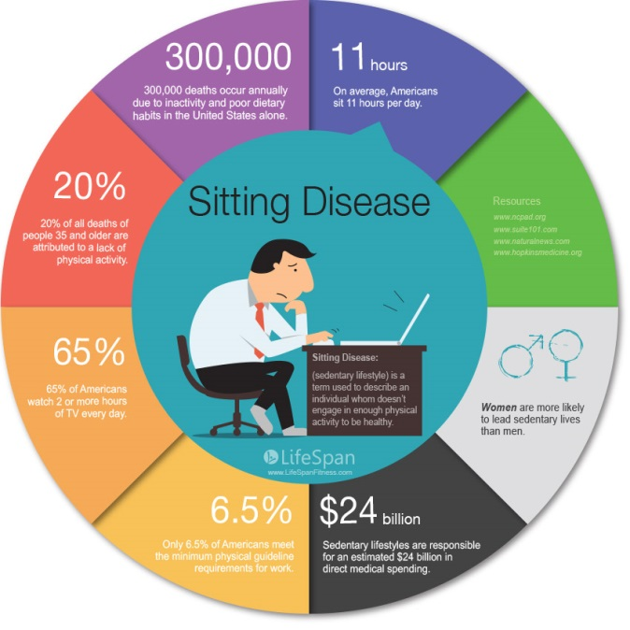

Regular physical activity will most definitely decrease the risk factors associated with heart disease. More importantly, regaining and maintaining a good fitness level will increase a person’s energy level making them able to do more. Increasing a person’s fitness level also has many psychological benefits such as increasing self-esteem, relieving stress, increasing social relationships, improving sleep habits, increasing self-awareness, self-care and healthy lifestyle awareness.
Put all that together and you have one great medicine that should be prescribed daily.

Benefits of an Active Lifestyle:
- Decreases LDL & increases HDL cholesterol levels
- Decreases fatty deposits in the arteries
- Aids in weight management, decreases body fat, decreases obesity, increases muscle and bone mass.
- Decreases and helps to control blood pressure
- Decreases stress and helps people to cope better with stress
- Improves mood
- Helps control diabetes - can prevent adult onset diabetes
- Improves and motivates participants towards healthy lifestyle habits
- Strengthens the immune system
- Aids in preventing diseases such as: heart disease, osteoporosis, hypertension, diabetes, cancer.
- Improves quality of life: social, intellectual, physical, psychological, spiritual health & environmental health
- Increases energy level
- Improves sleep habits

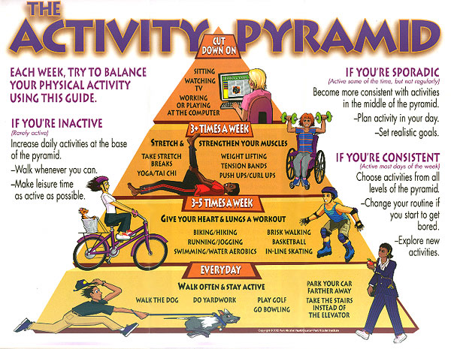

Prevention is the best medicine to control CHD risk.
Exercise is Medicine.

5. OBESITY

You will learn more about Body Composition and Weight Management in Chapter 8 and when you complete the Vanier Fitness Appraisal. Excessive fat accumulation, especially in the abdominal area (close to the heart) can impair health and can lead to many serious health risks and associated heart illnesses, risks and diseases such as high blood pressure, high cholesterol and diabetes.

Obesity in itself is a health risk, but it is also associated with many other risk factors which include:
- 5 - 6 times more likely to have high blood pressure.
- 2 times more likely to have high cholesterol
- 3 times more likely to have diabetes.
- more likely to have high blood fat levels and high blood sugar levels
- more susceptible to heart attacks and strokes

The keys to a healthy Body Composition and obesity prevention are:
- Healthy eating habits – balanced eating plan, water for thirst, nutrient rich food consumption, portion control …
- 60 -90 minutes of daily activity (walking, gardening, taking the stairs, housework...)
- Regular cardiovascular exercise - 30 minutes 3 - 5 times each week.
- Muscular conditioning exercises - 2 - 3 days each week
- Active living - active leisure time

6. DIABETES

Diabetes mellitus is a disease of the endocrine system in which the body does not produce or respond correctly to the hormone insulin. The hormone insulin is responsible for regulating carbohydrate and fat metabolism. When a person has diabetes, the pancreas, which produces the hormone insulin, does not function properly. This absolute or relative deficiency in the hormone insulin results in the inability to control blood sugar levels, and can damage almost every system in the body. Without sufficient amounts of insulin available, the glucose in the blood is unable to enter the cells, and thus fails to meet the cells' energy requirements. Persons with diabetes have a higher likelihood of obtaining high blood pressure and atherosclerosis, thereby increasing their risk of heart attacks and strokes. Once diabetes has been detected, the physician can prescribe a diet, a regular exercise program and medications if necessary. Risk factors associated with diabetes include: being overweight, heredity, elevated blood pressure, high blood sugar and blood fat levels. Diabetes is a powerful risk factor associated with CHD and it is extremely important to seek and follow medical advice. Up to 80% of Diabetics will suffer from CHD.

Statement from Diabetes Canada
“Regular exercise also has special advantages if you have type 2 diabetes.
It can also help prevent or delay type 2 diabetes from developing.
Regular physical activity improves your body’s sensitivity to insulin and helps manage your blood glucose (sugar) levels.”
http://www.diabetes.ca/diabetes-and-you/healthy-living-resources/exercise/physical-activity-diabetes

Type 1 - Juvenile Diabetes
Type 1 diabetes has been named juvenile diabetes (occurs before 20 yrs. of age) or insulin-dependent diabetes. Type 1 diabetes occurs when the hormone insulin is not produced by the pancreas and must be supplied by injections of insulin.

Type 2 - Adult Onset Diabetes
Type 2 diabetes has been named adult onset (over 40 yrs. of age, 80% due to obesity) or non-insulin dependent. With Type 2 diabetes, the pancreas is able to produce insulin, but the cellular tissues do not respond to the insulin and thus the blood sugar level is not regulated.

7. STRESS

Stress plays a definite role in the health and well-being of all individuals. It is not so much the actual stress that is of concern to us; it is how a person copes with, manages, and deals with the stressors in their lives. The inability to effectively cope with stress can lead to various illnesses such as high blood pressure, CHD, weight loss, obesity, ulcers, various stomach irritations, colds and flu and cancer. Refer to Chapter 9 for information on how to manage stress.

8. UNHEALTHY EATING HABITS

Good nutrition is definitely a major step to reducing the risks associated with CHD and many other diseases. Following a well-balanced eating plan, consuming appropriate amounts of calories for your body size and activity level, consuming foods low in fat - especially low in saturated fats, eating foods high in fibre and nutrient value, low in salt and simple sugars, more natural and less processed foods will definitely reduce the risk factors and produce a healthier, better functioning body.

9. HIGH BLOOD FAT LEVELS

High blood fat levels contribute to the narrowing and blocking of the arteries. High blood fat levels may be the result of high cholesterol (LDL), high fat consumption - especially saturated fats and triglycerides. Triglycerides are fats which flow through the blood after eating and have been linked with CHD, especially in women. Triglyceride levels tend to be high in those who consume diets high in calories, sugar, alcohol and refined starches such as white breads, cakes, cookies, donuts.

10. ALCOHOL CONSUMPTION

Alcohol is a central nervous system depressant. Consumption of alcohol slows reaction time, dulls alertness, impairs coordination, intensifies emotions, lowers inhibitions, and increases risk taking behaviours. On the positive side, alcohol is a social-lubricant on the negative side, alcohol is a drug and if abused even moderately, it can cause serious social, psychological and health problems. Alcohol addiction is a chemical dependence and is characterized by excessive use and preoccupation with the consumption of alcohol.

Consequences of Alcohol Abuse
- Increased risk of having a car accident – accounts for 50 % of deaths from car accidents.  - Associated with crime, assaults, suicide…  - Associated with absenteeism, poor work/school performance, and dropout rates.  - Associated with various psychological problems. | - Increased risk of heart attack and strokes.  - Increased risk of obesity and diabetes.  - Increases blood pressure and cholesterol.  - Increased risk of cancer (mouth, throat, liver, stomach, intestines and pancreas)  - Increased risk of liver failure – cirrhosis of the liver.

UNCONTROLLABLE RISK FACTORS

1. HEREDITY

It is impossible to control our family medical history and unfortunately, we cannot change it. If a parent, sibling and/or other close relatives have suffered from CHD before the age of 50 there is an increased risk of developing CHD. This is true with many other diseases such as high blood pressure, diabetes, high blood fat levels and heart attacks that may be passed down from generation to generation. Although we cannot control our family history, we can make every effort to minimise and prevent the controllable risk factors. By not smoking, following a regular exercise program and a well-balanced eating plan, learning to cope with and handle stress, not abusing drugs or alcohol and making educated, healthy decisions, we can lessen the potential risk of our heredity.

2. AGE

Higher Risks are associated with men over the age of 45 and Post-menopausal women.
As we age, cardiovascular function declines and the risks of CHD increase. It is very important to remember that many of the risk factors associated with heart disease are a result of choices made in the younger years. By preventing, eliminating and or controlling the risk factors throughout our lives, we can age with less risk and less deterioration of the cardiovascular system.

3. NATAL SEX – MALE / FEMALE

Males, particularly before the age of 40, have been found to have a higher incidence of heart disease and cardiovascular problems than do pre-menopausal females. Males are 2x more likely to suffer a heart attack. Males are newly diagnosed with heart disease at approximately 55 to 64 years, 10 years younger than Females at 65 to 74 years. Here are some of the possible reasons as to why:

- CHD tends to develop later on in the lives of females probably due to the fact that women have higher levels of heart healthy HDL cholesterol during their pre-menopausal years. The female hormone estrogen signals the liver to produce less (LDL) bad cholesterol; produce more HDL (good cholesterol); and makes blood vessels more elastic. After menopause, when the production of estrogen drops, the LDL levels will increase. Estrogen replacement treatments are being used during menopause to help lower CHD but the effects are still being researched.
- Location of fat stores. Males tend to store excess fat in the abdominal region (android - apple shape). Females tend to store excess body fat in the lower extremities, hips and buttocks (gynoid - pear shape). Higher fat storage in the abdominal region especially visceral (internal) fat is linked with heart disease. During the Fitness Appraisal, you will explore the Waist to Hip ratio test (waist hip circumference) which is used to determine a person’s risk for CHD.
- A higher concentration of visceral (internal) fat vs. subcutaneous (just under the skin - cellulite type fat) has been associated with higher CHD risk especially when the fat is located in the trunk region.
- Higher testosterone levels in males triggers the liver to produce more LDL cholesterol.

4. ETHNICITY

According to the National Library of Medicine, Blacks, Hispanics, Latinos and Southeast Asians, are ethnic groups with an increased risk of CHD.

Heart disease is a dangerous, life threatening condition that should be treated equally for everyone. Every person should be educated about the risk factors and healthy lifestyle choices that will help them reduce those risks.

Prevention is the best medicine to control CHD risk.
Exercise is Medicine.

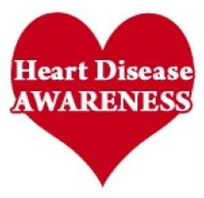 | Coronary Heart Disease  Risk Factors  Statistics Canada
CHD | 8.5 % of Canadians live with CHD  Heart disease in Canada: Highlights from the Canadian Chronic Disease Surveillance System, 2017 - Canada.ca
Smoking | Tobacco smoking remains the leading cause of preventable disease and death in Canada. Smoking is responsible for 16.6 % of all deaths in Canada. (Cancer, Heart disease, Respiratory Disease)  13 % of the Canadian Population smoke / 21 % of the Quebec population smoke. The smoking rate in Canada is highest in the 20-24 year age group, for both males and females.  15.1 % of Canadians 12 years and older were exposed to second-hand smoke at home.  % of Canadians, that smoke - Search (bing.com)  Which part of Canada has the most smokers? | CBC News
High Cholesterol | 28% of Adult Canadians have high cholesterol  Cholesterol levels of adults, 2016-2019 (statcan.gc.ca)
High Blood Pressure | 19 % of Adult Canadians have High BP readings  17 % of them are unaware that they have high BP!  High blood pressure found in 19% of Canadians | CBC News
Activity | According to Ipsos:  40% of Canadians aged 25-64 say they do less than thirty minutes of physical activity per day. 6% of Canadians get no exercise at all. 37% of Canadians exercise for 30-59 minutes every day, while 8% say they are physically active for over two hours each day. On average, people in Quebec get the least exercise, with 64% of the population in the province getting less than 30 minutes of exercise per day.  Fitness Industry Statistics in Canada for 2023 - Made in CA
Obesity | 26 % of Canadians are classified as Obese  36 % of Canadians are classified as Overweight  = 62 % of Canadians with excess weight which could lead to disease.  Overweight and obese adults, 2018 (statcan.gc.ca)
Diabetes | 8.1 % have diabetes  Diabetes in Canada in review, 2021 - Canada.ca
Alcohol | 19 % of Canadians consume Excessive amounts of alcohol  The highest proportion of heavy drinking for both sexes was among those aged 18 to 34.  Heavy Drinking, 2018 (statcan.gc.ca)
Stress  Mental Health | 20 % of Canadians reported that their lives were a bit or extremely stressful  Canadians life stress quite a lot percent 2003-2021 | Statista

Important Information  from the  Heart and Stroke Foundation | 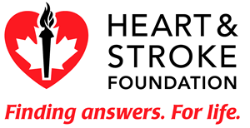  http://ottawaheart.ca/images/2.6-Heart-and-Stroke-logo.gif

Symptoms of a Heart Attack:
- Chest pain
- Pain in the arm or below the breastbone that can radiate to the back, jaw, throat, or arm
- Pain that may feel like heartburn
- Sweating, cool clammy skin
- Nausea, vomiting, or dizziness
- Difficulty breathing
- Rapid or irregular heartbeats
- Fear, anxiety, denial

If you are experiencing any of these signals, you should:

CALL 9-1-1 immediately, or have someone call for you.

Stop all activity and sit or lie down, in whatever position is most comfortable.

Rest comfortably and wait for an ambulance with emergency medical personnel to arrive.

Quick Action Saves Lives:

What is CPR?

Cardiopulmonary resuscitation (CPR) is an emergency procedure involving chest compressions (pressing down on the chest) and artificial respiration (rescue breathing). It has the power to maintain oxygenation to the vital organs of someone suffering cardiac arrest, until an ambulance arrives.

Why get trained in CPR?

You only have 4-6 minutes, after the heart stops, before the brain cells die from lack of oxygen. Learning CPR is fast, easy and inexpensive – just a few hours could make an important difference in someone's life.

Find out about CPR training here at Vanier or in your area at www.heartandstroke.ca.

Canadian Heart and Stroke Foundation. Retrieved from: www.heartandstroke.ca

CHAPTER 3
CARDIOVASCULAR EXERCISE

What is Cardiovascular Exercise?

Cardiovascular Exercise otherwise known as aerobic exercise (aerobic = burning energy in the presence of oxygen) is characterized as being continuous, non-stop movement; uses the large muscle groups such as the legs; and is performed at an intensity level that can be maintained for extended periods of time i.e. 5 - 30 minutes. Examples include: walking, jogging, swimming, biking, running sports etc.

The Benefits of Cardiovascular Exercise:

Health Benefits | - ↓ Disease risk – heart attacks, stroke, some cancers, high blood pressure, high cholesterol, diabetes, obesity.  - Improves the efficiency of the heart and lungs.  - Strengthens the immune system – less sicknesses  - Increases bone density - aids in the prevention of osteoporosis.  - Improves digestion and regularity – helps prevent constipation.
Changes in Body Composition | - In co-operation with healthy eating habits, aerobic exercise can assist in weight loss and weight maintenance and thus aid in the prevention of obesity.  - Increase in caloric expenditure – the more intense the activity, the more calories you will burn.  - Increases metabolism
Psychological Benefits | - Reduces stress levels.  - Improves sleep habits - more restful sleep  - Promotes a positive attitude, self-esteem, overall sense of well-being.  - Improves concentration, focus  - Decreases depression and improves mood
Quality of Life | - Increases energy levels  - Get more fun out of life  - Provides avenue for social interaction  - Improved sex life
FITT PRINCIPLE FOR CARDIOVASCULAR EXERCISE

The American College of Sports Medicine (ACSM) has developed the FITT principle to provide basic guidelines for exercise prescription. To use the FITT principle effectively, it is important to adjust the prescriptions based on individual differences, fitness levels, specific limitations, fitness goals and skill levels.

F | I |  | T |  | T
Frequency | Intensity |  | Time |  | Type
times / week | how hard |  | how long |  | mode of activity |  | Workout format
3 – 5  times / week  2 x / week for maintenance | 60-85% of Max HR  RPE: 2-4  comfortable to  moderately hard |  | 20 - 60 minutes of continuous activity at an intensity level appropriate for you  (HR 60-85% of max)  .OR  1-2 minutes of high intensity intervals HITT such as 1 min. Burpees  between muscle conditioning and or cardio exercises can also be effective.  (shoot for a total of at least 10 minutes)  HR may exceed 85 % =  Anaerobic intervals |  | Outdoor Activities: walk, jog, bike, x-country skiing…  Indoor Activities: treadmill, elliptical, bike, group fitness classes, bootcamp, dance, swim, body weight,  Sample Sports: soccer,  ball hockey, basketball etc.. |  | Continuous  Steady state workout  Intervals  Varying intensity  60 % 1 min, / 90 % 30 sec / 60 % 1 min / 80 % 1 min  HITT  Combining 1-2 min of high intensity cardio intervals with muscle conditioning
Putting Cardio Workout Theory into Practice -Cardio Workout Ideas
Daily Activity  Accumulate 60 minutes  Walk, stairs, escalator, play, garden, chores |  | Continuous workout  20 min jog  30 min swim,  45 min walk, bike, dance  60-minute hike, x-country |  | Interval Workout  30 min. walk-jog, jog-sprint  45 min. Elliptical, Spinning  45 Cardio Group Fitness  60 min. Basketball, soccer |  | Sample HITT Intervals  1 min Burpees  10 Box Jumps x 3 sets  200 m Run  High Knee Runs

1. FREQUENCY RECOMMENDATIONS

- Cardiovascular workouts should be performed 3 - 5 days per week.
- Frequency of exercise should increase gradually as fitness levels increase.
- Sedentary individuals with low fitness levels may experience gains in cardiovascular fitness from 2 days per week but for maximal benefits should work up to 3-5 days per week.
- Avoid performing too much too soon to avoid burn out and overuse injuries.
- Start out with more frequent lower intensity workouts and gradually increase time and intensity as your fitness level improves.
- Overweight participants may find it easier to do more frequent workouts (5- 6 days each week) at a low intensity. This will enable them to increase their calorie expenditure, increase metabolism and make exercise a daily habit.

2. INTENSITY RECOMMENDATIONS
- The intensity of the workout refers to the amount of stress that you are imposing on the cardiorespiratory system.
- Too intense a workout can lead to premature fatigue or even injury while too mild a workout may fail to achieve measurable fitness benefits.
- The idea is to monitor and adjust exercise intensity so that it falls between the lower and upper Heart Rate limits to achieve improvements in cardiovascular fitness.

Maximum Heart Rate Training Range

- When using the maximum heart rate method, we must first determine the person's maximum heart. Maximum heart rate is the highest heart rate a person can achieve during heavy exercise.

- The age predicted maximum heart rate formula is commonly used (220 - age). This formula assumes that 220 is the approximate maximal heart rate of a new born, and each year this rate decreases by one beat.

- Although this formula is very practical for individual and class settings, it is not always accurate because maximal heart rates can vary at any given age by +/- 10 - 12 beats per minute.

EXERCISE TRAINING RANGE USING MAXIMUM HEART RATE
220 - age = Max heart rate x .60 (60%) = Lower limit of heart rate training range
220 - age = Max heart rate x .85 (85%) = Upper limit of heart rate training range
AGE | PREDICTED  MAXIMUM | LOWER LIMIT  60 % |  | UPPER LIMIT  85 %
 | HEART RATE | bts / min | bts /10 sec | bts / min | bts /10 sec
20 | 200 | 120 | 20 | 170 | 28
25 | 195 | 117 | 19 | 166 | 28
30 | 190 | 114 | 19 | 162 | 27
35 | 185 | 111 | 18 | 157 | 26
40 | 180 | 108 | 18 | 153 | 25
45 | 175 | 105 | 17 | 149 | 25
50 | 170 | 102 | 17 | 145 | 24
55 | 165 | 99 | 16 | 140 | 23

My Heart Rate Training Range
maximum heart rate = | 220 - age | = _______________
lower limit 60 % = | max HR x .60 | = _______________
or  lower limit at 70 % = | max HR x .70 | = _______________
upper limit at 85 % = | max HR x .85 | = _______________
HOW HARD SHOULD YOU TRAIN?
The following guidelines should help you decide which training range is the most appropriate for you. A reminder that any cardio, is good cardio. Find what you like to do and will do.

Healthy Heart Zone - 50 - 60 % of Max. HR - An Easy, recreational activity
- Low calorie expenditure / minute of exercise
- Recommended for long duration activities > 40 – 60 minutes – recreational activities
- Limited cardiovascular improvement due to low intensity but still good for the heart, lungs, mind and body
- Health benefits ↓ body fat, ↓ blood pressure, ↓ cholesterol, ↓ CHD risk, ↓ stress
Fitness Zone - 60 - 70 % of Max. HR – Beginners Starting Point / Easy Day
- Low but increased calorie expenditure / minute of exercise
- Recommended for unfit / beginner exercisers as a starting point to build cardiovascular endurance.
- Good Cardiovascular and health benefits
Aerobic Zone - 70 – 85 % of Max. HR – Recommended Cardio Training Range
- High calorie expenditure / minute of exercise / ↓ body fat
- Greatest health benefits and greatest cardiovascular benefits
- Ideal intensity for increased functional capacity of the heart and lungs
Anaerobic Zone - 85 - 100 % of Max. HR – Intense Intervals, not for beginners
- Requires an existing strong cardiovascular endurance level – not for beginners, unfit participants.
- Involves performing high intensity intervals of 10 – 90 seconds followed by lower intensity recovery periods
- Highest calorie expenditure / minute of exercise
- High cardiovascular benefits
- Recommended for sport specific training – sports which involve high intensity sprints

TAKING ACCURATE HEART RATE READINGS

Pulse Sites:
1. Carotid pulse: (Carotid artery)
- Located on the neck, just to the side of the throat.
- Place the index and middle finger gently on the side of the neck. Pressing too hard may stimulate a reflex mechanism, which causes the heart rate to slow down.
2. Radial pulse: (Radial artery)
- Located on the thumb side of the wrist.

TAKING YOUR HEART RATE:

- Always use the index and middle fingers and press gently. (Do not use the thumb)
- The most accurate reading during exercise is the 10-second count, which is found by counting the pulse for 10 seconds and multiplying by 6.
- The first pulse heard should be counted as zero. Counting the first beat as 1 may overestimate the actual heart rate reading. For safety reasons, this may be preferred when working with unfit individuals.
- Heart rates will begin to drop soon after the exercise stops; therefore, heart rate readings need to be taken very quickly for accurate results. Heart rate readings should begin within 5 seconds of stopping.
- Try to keep moving while taking the pulse to avoid blood pooling in the lower limbs.
- In order to effectively monitor exercise intensity, heart rate readings should be taken every 10-15 minutes during an exercise bout.
RATING OF PERCEIVED EXERTION (RPE)

- The RPE scale devised by Borg popular method for measuring exercise intensity. The RPE scale allows you to measure your intensity based on how you feel. Rating charts have been developed that characterize how you feel. Once you have learned how to use the charts and correctly determine your intensity level, the RPE scale can be a very accurate and simple method of measuring exercise intensity.
- It is recommended to use the RPE scale in conjunction with heart rate to ensure that you are training at an appropriate intensity level. No matter what your heart rate reading, you should always feel comfortable.
- Simply ask yourself how you feel at regular intervals and adjust your intensity accordingly.
- Below is a modified RPE Scale used by the Vanier Physical Education Department.

VANIER MODIFIED RPE SCALE
RATING OF PERCEIVED EXERTION /  HOW YOU FEEL |  |  | RATING
Too easy, not hard enough to get a workout  Warm-up and cool-down intensity |  |  | 1
Easy, very comfortable, can continue for a long time,  Too easy for fit participants - OK for unfit |  |  | 2
Moderately hard, comfortable, good workout  OK for most participants |  |  | 3
Hard, cannot continue for too long,  Too difficult to continue for unfit participants - OK for fit |  |  | 4
Too hard, can’t continue for longer than a minute  OK for very fit as a high intensity interval. |  |  | 5
TRAINING INTENSITY
USING THE VANIER RPE SCALE
Heart Rate  Training Range  % of Max | “RPE”  Rating of Perceived Exertion Scale | For Best Results
Less than 60 %  of Maximum HR | 1 - too easy | Warm-up for 5 - 8 minutes (RPE 1-2)  Goal is to gradually increase intensity.  Cool-down 2 - 5 minutes (RPE 1-2)  Goal is to gradually decrease the intensity
60 – 85 %  of Maximum HR | 2 - very comfortable  3 - comfortable  4 - comfortable but hard | Cardiovascular Workout range  20 - 60 minutes  3 - 5 x/week
Greater than 85 %  of maximum HR | 5 - Too hard | Anaerobic Fitness Training  Sport specific / Sprints / Plyometrics / HITT  Work 10 sec - 1 min at RPE of 5  then Recover 30 sec – 3 min at RPE of 2-3

TALK TEST
- The talk test is a simple but effective method of determining exercise intensity.
- During aerobic exercise, you should be able to breathe comfortably, deeply and rhythmically without gasping for breaths.
- You should be able to talk while exercising at all times. If you have to gasp for air after saying three words you are exercising too hard
- At the same time, you should not be able to say more than 4 - 5 words without taking a breath!

In order to maximize your cardiovascular workout benefits it is important to train at an appropriate exercise intensity level. The following practical step test will help you to determine what intensity is appropriate for you.

III. TIME / DURATION RECOMMENDATIONS

- In order to improve cardiovascular fitness, it is recommended to perform a minimum of 20 minutes continuously within the appropriate training range of 60-85 % of max heart rate.
- These 20 minutes do not include the warm-up (5 minutes) or cool-down (5 minutes).
- Initially you may only be able to last 10 – 12 minutes. Gradually (1-2 minutes each week) increase the duration to a minimum of 20 minutes as your fitness level improves.
- Typical workouts last approximately 30 minutes = 5 min. warm-up – 20 minutes of exercise - 5-minute cool-down.
- The duration of the activity is highly dependent on the intensity of the activity. If you train at a higher intensity you will not last as long and vice versa. Unfit participants may be able to last 30 minutes at a low intensity, but only 10 minutes at high intensity.
- High intensity cardiovascular activities are not recommended for novice or high-risk participants. Better results are found with lower intensity, long duration as they carry lower risks of injury and enable participants to achieve a relatively high total caloric expenditure.

IV. TYPE OF ACTIVITY

The type of activity is not as important as Frequency, Intensity and Time.
What is important about the type of activity is that you choose an activity that:
- you enjoy and will do
- is appropriate for your fitness level
- that takes into account your personal goals, injuries and access.

Performing a variety of different activities will decrease the risks of overuse injuries, will allow you to work more muscle groups, increase motivation and increase exercise retention.

Aerobic / Adequate Oxygen Available / Cardiovascular activity is an activity that:
- can be continued for prolonged periods of time without having to slow down or stop i.e. 5-30 minutes.
- your heart rate will stay within the training 60-85 % training range.
- is rhythmical and aerobic in nature (uses oxygen to make energy) (walk-jog-swim-bike);
- uses large muscle groups such as the legs.

Anaerobic cardiovascular activity: (HIIT = High Intensity Interval Training)
- Involves high-intensity efforts of short duration (HIITs). Anaerobic exercises are stop and start, like sprinting, a hockey shift, or a squash rally where the heart rate can increase to near maximal levels followed by a recovery period and then another high burst effort.
- Performing anaerobic activities requires excellent cardiovascular endurance. If you are training for general health, anaerobic fitness is not necessary.
- Anaerobic training or intervals are usually prescribed for athletes and advanced exercisers.
Continuous Training:
Continuous type workouts involve performing steady-paced exercise at high, low or moderate intensity levels. Continuous training is highly recommended for beginners, overweight, pregnant, and high-risk individuals as they can set a pace that is comfortable for them and maintain it for the desired duration of the workout. Those new to fitness with low motivation levels may not enjoy being challenged and success rates are higher when continuous type training is used. Endurance athletes also use continuous training to simulate competition conditions.

Interval Training:
Interval training involves systematically increasing and decreasing the intensity level throughout the workout. The duration and intensity of the individuals need to be modified to suit the capabilities and training goals of the individual. Repeated exercise bouts with rest periods or relief periods can vary from a few seconds to several minutes or more depending on the desired outcome. Likewise, the intensity of the intervals can be modified depending on the training goals and fitness level of the individual.

Benefits of Interval Training:
- Allows individual to perform more work at higher intensity levels.
- Allows for greater caloric expenditure.
- Allows for improvements in both aerobic and anaerobic fitness levels.
- Decreases boredom, increases motivation.
- Can be modified to suit the goals and fitness levels of the individual.
- Can be implemented with any mode of training.
- Offers a greater variety in the workout
.
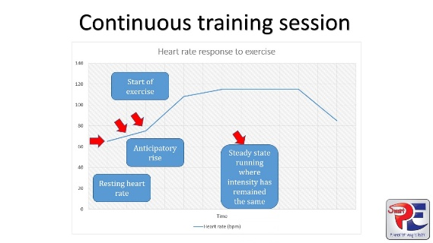 | 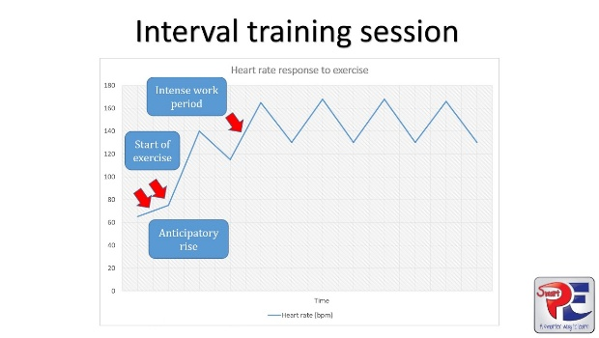
maxresdefault.jpg (1280×720)

Cardiovascular Activity Options
Sports Options | Fitness Centre Options |  | Outdoor Activity Options
Basketball, hockey, soccer, lacrosse, tennis, squash, badminton, swimming | Treadmill, elliptical, bike, rowing, Stairmaster  Group Classes: Bootcamp, Tabata, Spinning, dance/Zumba/Hip Hop, Boxing, Aqua fitness |  | Walking, hiking, jogging, rollerblading, biking, x-country skiing, skating, rowing, swimming
                - The type of activity you choose should fit with your preferences, what you are willing to commit to, your fitness level, training goals, ability, strengths and weaknesses.:
- Your likes and dislikes  - Accessibility - cost, location, climate, equipment  - Skill level – sport skills, level of activity  - Your present fitness level – appropriate intensity, duration, activity |  | - Impact stress of the activity  - Any health risks you may have such as obesity, high blood pressure, asthma.  - Any limitations or injuries that you may have such as low back pain, knee problems.

TRAINING REMINDERS for CARDIOVASCULAR EXERCISE
- Choose an activity you like and will do  - Try to do 3 - 5 workouts each week  - Workout at an intensity that you can maintain for 20 - 30 minutes  - During the workout, maintain an appropriate training intensity range (60 – 85 % of your maximum heart rate or an RPE of 2-4)  - The longer and harder you work out, the more calories you will burn | - Do a 5 - 8 minute low intensity warm-up before workout  - Do a 3-minute low intensity cool-down after the workout  - Vary your workout type to avoid overuse injuries and boredom.  - Once you can last 20 - 30 minutes at a continuous. Moderate intensity, try interval training to challenge your cardiovascular system even more or try adding High intensity intervals (HITTs) of short duration to pump up the intensity of your workouts.

CARDIOVASCULAR EXERCISE OPTIONS - NO EXCUSES! – JUST D0 IT!

Sample Walk / Jog progression:
- A 20 – 60 minute fast paced walk. Use your arms and take long strides.
- Walk 2 minutes, jog 30 seconds – for 20 – 30 minutes
- Walk 2 minutes, jog 1 minute – for 20 – 30 minutes
- Walk 2 minutes, jog 90 seconds – for 20 – 30 minutes
- Walk 2 minutes, jog 2 minutes – for 20 – 30 minutes
- Jog 3 minutes, walk 2 minutes - for 20 – 30 minutes
- Jog 3 minutes, walk 1 minute - for 20 – 30 minutes
- Jog 4 minutes, walk 1 minute - for 20 – 30 minutes
- Jog 5 minutes, walk 1 minute - for 20 – 30 minutes
- Eventually you will be able to jog for 20 – 30 minutes and then you can work on jogging longer or faster as you wish.

If you want to work out at home try:
- Following an exercise video – Tabata, Cardio HITT, Zumba, Just Dance
- Going for a walk or jog – walk with a friend – walk your dog or a friend’s dog
- Play sports with friends – soccer, ball hockey, basketball
- Circuit train – 2 minutes skipping, 2 minutes jogging, 2 minutes stairs …
- Dance in your living room – slow dancing does not count!
- Going for a walk or a jog
- Do Circuits – 10 Squat Jumps – 10 Push-Ups – 10 Mountain Climbers – repeat 3 times etc

If you can join a gym you can:
- Take Group Fitness Classes – Boot camp, Tabata, Cross-fit, Box fit, Dance, Spinning…
- Try the stationary bike, the recumbent bike, the treadmill, the Stairmaster, the elliptical, the rowing machine, the Step master - they are all great!
- Play soccer, ball hockey, basketball, squash, badminton
- Swim laps, take aqua fitness classes, jog in the shallow end of the pool, try deep water jogging

If we still haven’t tickled your fancy try outdoor activities like:
- Biking / Roller blading / Ice Skating – non-stop for 30 – 60 minutes
- Go hiking in the woods or on the mountain.
- Go cross-country skiing / Go tobogganing – climbing back up is a great cardio workout.

REMEMBER: - Every day you should spend at least 30-60 minutes doing physical activity
- 3-5 times a week you should engage in a vigorous cardiovascular workout.
CHAPTER 4
MUSCULAR CONDITIONING

What is Muscular Conditioning?

Muscle conditioning activities can vary in type and effectiveness – here are a few common examples:
- Weight training program in a gym using machines and/or free weights.
- Group fitness muscle conditioning or toning class which will focus more on muscle endurance and use dumbbells, and tubing etc.
- Bootcamp / HIIT classes combine High intensity cardio intervals and muscle conditioning exercises in a group setting.
- Manual labour such as digging, shovelling, lifting.
- Contact sports such as football, hockey, rugby, and wrestling.
- Sport specific training like plyometrics, sprinting, jumping

THE BENEFITS OF WEIGHT TRAINGING

Muscle conditioning should be an integral part of any fitness program.

Physical Benefits | Replace muscle tissue lost through inactivity  ↑ muscle mass  ↑ metabolism  ↓ body fat  ↑ muscle strength  ↑ muscle endurance  ↓ injury risk  Improve athletic performance  ↑ muscle tone  ↑ muscle definition  ↑ muscle firmness  ↑ joint range of motion  ↑ energy levels  Prevents loss of muscle mass
Disease Prevention | ↓ blood pressure  ↓ cholesterol  ↓ blood fat  ↓ risk of diabetes  ↓ risks of having a heart attack  ↓ risks of having a stroke  ↓risk and onset of osteoporosis
Psychological | ↓ stress  Provides a healthy stress outlet  ↑ energy levels  Improved sleep habits  ↑ self-esteem and self-confidence  Provides opportunity for social interaction

FITT PRINCIPLE FOR WEIGHT TRAINING

Before engaging in Weight Training, it is important to have a general understanding of the training guidelines for muscle strength and conditioning. A safe and effective workout program, is one that takes in to account your fitness needs and goals, your present abilities, mobility and training experience as well as your training environment and availability.
When following a muscular conditioning program, there are there are a variety of intensity options that you can follow. Ideally in order to maximize muscle growth and development you should vary the training intensity and exercises on a regular basis.

Muscular Strength & Muscular Endurance Guidelines
Training Goal:  ↓  Select your program goal. | Frequency  48-72 hrs rest / muscle | Intensity  # of sets /  # or reps (RM)  Reps Maximum | Time  10 – 60 minutes  Depends on the # of exercises, sets and reps you will be doing. | Type  A variety of equipment  can be used
General Fitness  Strength & Endurance  Development | 2 - 3 x’s / week / muscle group | 2 - 3 sets / exercise  Reach Fatigue by 10 - 15 RM  1-2 exercises /  major muscle group | - All major muscle groups should be trained weekly = Full Body Training.  - A Muscle conditioning workout should last no longer than 45 – 60 minutes.  - If your workout takes longer than 60 minutes it is recommended to split your program into 2 or 3 days  For example:  Day 1- Upper Body  (Mon. + Thu.)  Day 2 – Lower Body + Trunk  (Tue + Fri.) | Machines,  Cables,
Muscle  Endurance  (limited muscle strength gains) | 2 - 3 x’s / week / muscle group | 1 - 3 sets / exercise  Reach Fatigue by 15 – 25+ RM  2-3 exercises /  major muscle group |  | free weights,  dumbbells,  barbells
Muscle Strength  Advanced  (limited muscle endurance gains) | 1 - 2 x’s / week / muscle group | 2 - 5 sets / exercise  Reach Fatigue by 5 - 10 RM  2 - 5 exercises /  major muscle group |  | body weight,  tubing / elastics
Body Building  Advanced Lifters  VOLUME is KEY | 1 - 2 x’s / week / muscle group | 3 - 6 sets / exercise  Reach Fatigue by 8 - 20 RM  3 - 5 exercises / major muscle |  | Callisthenics

1. FREQUENCY RECOMMENDATIONS

- Each muscle group should be trained 2-3 times each week. There should always be a minimum of 48 hours rest between workouts sessions for the same muscle group. After being exercised, each muscle that was worked needs approximately 2 - 4 days of rest to recover and repair itself before it can be trained again.
- It is OK to work a different muscle group on consecutive days but ideally never the same muscle group/exercise. (I.e. lower body Monday, Upper body Tuesday, lower body Thursday, and upper body Friday).
- The frequency of training and the amount of rest required between workouts is very dependent on the intensity of the workout. The more intense the workout, the more rest/recovery time between workouts is required.
- For those following a very advanced program with a large amount of exercises and sets / body part less frequent training (1-2 times / week / muscles) will still be beneficial.

2. INTENSITY VARIABLES & RECOMMENDATIONS

A. Repetitions Maximum (RM) - # of times you perform the exercise (10 Push-ups)
- Using Repetitions Maximum (RM) as your guide will ensure constant overload. RM is a weight which allows the lifter to perform X but not X+1 repetitions. So, a 10 Reps Max set allows you to perform 10 but not 11 repetitions with good exercise technique. If proper technique cannot be maintained, the set is over, repetitions maximum or muscular fatigue has been achieved. If you can perform more than 10 reps you need to increase the amount of weight. If a program calls for 3 sets of 10 repetitions maximum, the lifter may be able to perform 10 reps in the 1st set, 9 reps in the 2nd set and only 7 reps in the 3rd set. But as soon as the lifter can perform 10 reps in all three sets, the weight is increased.
- Within the initial stages of the program, maximum lifts should be avoided in order to prevent the risk of muscle or joint injury as well as post-exercise muscle soreness. Proper technique must be achieved before attempting maximal lifts.
- The American College of Sports Medicine recommends that effective and safe strength and endurance gains will be achieved by performing 8 - 12 repetitions maximum for each muscle group.

How Many Reps Should I do?
The # or reps you should do, depends on many factors such as: your initial training level, your training goals, the amount of time you have and the equipment that you have available. The following chart details the training results for varying repetition ranges. Each individual must decide what will work best for them.

Estimated # of Max Reps based on % of 1 Repetition Max capability
Reps may vary depending on exercise
100% | 95 % | 93 % | 90 % | 87 % | 85 % | 83 % | 80 % | 77 % | 75 % | 70 % | 67 % | 65 % | 62 % | 60 %
1 | 2 | 3 | 4 | 5 | 6 | 7 | 8 | 9 | 10 | 11 | 12 | 15 | 18 | 20
Acefitness.org

REPETITIONS MAXIMUM | TRAINING RESULTS
1 - 5 RM  85-100 % of 1RM  Strength and Power  Advanced Lifters | Maximal Strength Gains  Muscle Growth  Specific training range for strength athletes
5 - 10 RM  75-85 % of 1 RM | Optimal compromise of maximal strength and  and muscle growth gains.  Recommended for experienced weight lifters.
Maximum Strength and Mass
Advanced Lifters
10 – 15 RM  65 - 75 % of 1RM | Optimal hypertrophy (muscle growth) gains.  Muscle strength and endurance gains  General Fitness Program
General Fitness
Strength and Endurance
15 – 25 + RM  < 65 % of 1 RM  Muscle Endurance | Optimal muscle endurance gains  Some but little muscle growth gains  Good range to start for beginners.  Sport specific training  Used when equipment is not available or using body weight as resistance

B. Time Under Tension

Achieve overload by completing max reps within a specific time period. Examples Include:
- Tabata – 20 seconds work + 10 seconds rest x 4-8sets.
- Tabata Variations: 20 seconds work + 10 seconds rest / 30 work:30 rest / 40 work:20 rest
- EMOM – Complete as many reps as you can in a minute (45-50 sec work + 10-15 sec rest)
- Time Cap: Complete as many sets of a group of exercises in a specific time period (i.e.: 12 DBell Squats, 10 Pull-Ups, 10 Combat Plank --- 8-minute Time Cap).

C. # of Sets: A set is defined as the number of successive repetitions performed without resting.

General Muscle Conditioning Training Guidelines:

FITNESS LEVEL  (WEIGHT TRAINING EXPERIENCE) | # OF SETS /  Body Part – Muscle Group
Beginner | 1 – 2
Intermediate | 2 – 3
Advanced | 3 - 5
Specialized Training (Elite athlete) | 6 - 12
Body Building | 10 - 24

- A beginning participant is advised to start with 1-2 sets of each exercise. As fitness and strength levels improve they can progressively increase the # of sets / exercise.
- More advanced participants with higher levels of muscle strength and mass may need to perform more sets (2-6 sets) to overload a given muscle group. The philosophy behind multi-set training is that once the initial fitness level is achieved, a repeated presentation of the stimulus will increase the overload to the muscle and superior strength gains will result.
- An increase in strength, power and muscle size can occur when one set of an exercise per training session is performed by a person who has never trained before. However, the majority of evidence supports the idea that multiple sets of an exercise result in greater gains in strength, power and muscle size than just one set. Most trainers agree that three sets of an exercise is the minimal number needed to bring about near maximal gains in strength, power and muscle size.

D. Rest Time Interval between Straight Sets
- The rest period between sets allows for the replenishment of energy.
- The amount of rest time required is dependent on the intensity and the goals of the training program.

TRAINING INTENSITY | REST BETWEEN SETS
Maximal Strength Program (< 5 RM) | 4 - 5 minutes
Strength Program (5 - 10 RM) | 3 - 4 minutes
Strength & Endurance Program (10-15 RM) | 1 - 3 min.
Endurance Program (15 – 25 + RM) | 30 - 60 sec.

Supersets:
Using Supersets involves moving from exercise to exercise without a rest between sets.
Supersets are classified as more of a circuit type workout, traditionally used for overall conditioning and muscle endurance.
Supersets often involve alternating between upper and lower body or opposing muscle groups.
Performing supersets allows you to increase the intensity of the workout and decrease training time.

Sample Supersets
Opposing Muscles  Bench Press + Lat Pull Down  Same Muscle (Harder)  Squats + Leg Press | Upper / Lower  Squats + Bench Press  Lunges + Seated Row | Upper-Lower-Trunk  Shoulder Press  Split Squats  Plank
Complete Exercises Back to Back (Superset) rest – Repeat – rest – Repeat …

Circuits:
Using circuit format involves moving from one exercise to the next without a rest between exercises. Similar to supersets, but you group more exercises together.
Great way to add a cardio HIIT into your workouts.
CULT Circuit Example:
Cardio Exercise – Upper Body Exercise – Lower Body Exercise – Trunk Exercise / 4-Rounds of different exercises.
Full Body Circuit Example: Select 1 exercise for each major muscle. Complete 1 set of each and then repeat for 2-4 sets.

E. Lifting Speed - Tempo
- The speed of contraction during an individual repetition is referred to as the tempo of the movement.
- In general, both raising and lowering the weight should take at least 2 seconds to ensure that the force of the muscular contraction and not momentum does the work.
- Most fitness professionals recommend a 2-0-4 (lift 2 seconds / lower 4 seconds) or 3-0-3 (lift 3 seconds / lower 3 seconds) tempos as the average lifting speed.
- Performing fast repetitions is a very common error in weight gyms. This can be dangerous if the weight is thrown rather than lifted by the muscle.
- Exercise technique should never be compromised for speed.

F. # of Exercises: Muscular Conditioning training programs should include at least one exercise for each of the major muscle groups to ensure balanced muscular development. Training only a few muscle groups can lead to muscular imbalance, injury and poor posture.
- In order to ensure muscular balance, programs should always include exercises for the opposing or antagonist muscle groups.
- Chest / Upper back
- Front of Shoulder / Back of Shoulder
- Biceps / Triceps
- Abdominals / Lower back
- Front of Thighs (Quads) / Back of Thighs (Hamstrings and Glutes)
- Inner Thigh / Outer Thigh
- Work large muscle groups before small muscle groups. Working smaller muscle groups may inhibit maximal overload of the larger muscle group.
- It is generally recommended to work the trunk and lower back muscles at the end of the workout as they are required to stabilize and support the body during all exercises.

Options for Exercise Order:

- Alternate between upper, middle and lower body. Referred to as Peripheral Heart Action (PHA) training.
- Alternate between agonist and antagonist (opposing muscle groups).
- Overload one muscle group (multi-set training) and then apply either of the above options if so desired.
- Do a combination of the above options.

3. TIME / DURATION OF THE WORKOUT RECOMMENDATIONS

- The length of the workout is dependent on the # of exercises, set and reps for each muscle group.
- A weight training session should last no longer than 60 minutes – fatigue can increase injury risk.
- All major muscle groups can be trained in as little as 15 minutes (1 set / major muscle) but it could take up to 3 hours for advanced body building programs. If workouts last longer than 60 minutes than you should split your workout into 2-3 days. For example: Train Upper Body 2x / week (Mon + Thu) and Lower Body and Trunk 2 x / week (Tue + Fri).

EXERCISE SELECTION

A balanced weight training program should work all major muscle groups – and all opposing muscle groups as identified below:

Body Part | Muscle Groups | Opposing Muscle Groups  If I work one, I need to work the opposite
Legs: | Quadriceps (Front of Thigh)  Hamstrings (Back of Thigh)  Gluteals (Buttocks)  Hip Adductors (Inner Thigh)  Hip Abductors (Outer Thigh – Glute)  Gastrocnemius + Soleus (Calves) | Quadriceps / Hamstrings and Glutes  Inner Thigh / Outer Thigh  Calves / Shins (Anterior Tibialis Muscle)
Upper Body | Pectoralis Major = Chest  Latissimus Dorsi = Upper Back (sides)  Rhomboids = between shoulder blades  Upper Trapezius = Neck  Middle and lower Traps = between shoulder blades | Chest / Rhomboids and Lats  Upper Trapezius / Lower Trapezius
Upper Body | Shoulders:  Anterior Deltoid = front of shoulder  Middle Deltoid = middle of shoulder  Posterior Deltoid = Back of shoulder | Anterior / Posterior deltoid
Upper Body | Arms:  Biceps (front of arm)  Triceps (back of arm)  Forearm flexors (front or forearm – palm up)  Forearm extensors (back of forearm – palm down) | Biceps / Triceps  Forearm flexors / extensors
Trunk /  Core | Rectus Abdominus = Abdominals  Obliques = side of waist  Erector Spinae = Lower Back  Transverse Abdominus = Posture Muscles | Abs / Low back  Right Oblique / Left Oblique

Full Body Workout Routine - All muscles trained on the same day:
- This style of programming is most often used with the novice exerciser, or with individuals with time constraints, general fitness goals or other training requirements. It involves performing one or two exercises for the major muscle groups of the upper body, lower body and trunk. It is very important that the trainer develop a balanced program that remains functional in nature.
- The full body routine should be repeated 2 - 3 times a week with at least 48 hrs. rest between sessions.

Split Routines:
- Split routines involve training muscle groups on different days and can be modified to suit the needs and time constraints of the beginner to advanced lifter.
- When designing split routines, it is important to remember that each muscle trained requires an adequate rest/recovery period - the amount of recovery needed is dependent on the intensity / volume of the training, the muscle group being trained and the individual.
- It is also important to carefully select which muscles will be trained on which days to ensure that specific muscle groups do not get over trained.

SAMPLE 2 DAY SPLIT ROUTINE
Monday | Tuesday | Wednesday | Thursday |  | Friday | Saturday | Sunday
Day 1 | Day 2 |  | Day 1 |  | Day 2
Day 1: Chest, Front & Middle Shoulder, Triceps, Abdominals, Quadriceps
Day 2: Upper Back, back of Shoulder, Biceps, Lower back, Hamstrings
Day 1: Upper Body |  |  |  | Day 2: Lower body & Trunk

SAMPLE 3 DAY SPLIT ROUTINE
Monday | Tuesday | Wednesday |  | Thursday | Friday |  | Saturday | Sunday
Day 1 | Day 2 | Day 3 |  |  | Day 1 |  | Day 2 | Day 3
Day 1: Chest, Triceps, shoulders, |  |  | Day 2: Upper back, Biceps, Lower Back |  |  | Day 3: Legs, Abs, Obliques

4. TYPE

A. Type of Equipment:

MACHINES VS. FREE WEIGHTS
THE ADVANTAGES OF EACH
Weight Stack Machines | Free Weights
- More control over the direction and pattern of resistance.  - Less risk of injury from tripping, stacking, getting trapped, falling weights.  - Requires less skill  - Machines can be designed to work muscles that are difficult to isolate with free weights. (i.e. lat pull down machine).  - Quicker to use  - Easier to use  - Requires no spotting | - While machines tend to isolate muscle groups, free weights involve more co-ordination of several muscle groups that act as stabilisers and assistors in the movement.  - Exercises simulate real life activities to a greater extent.  - Recruitment of more muscle groups to perform the movement.  - More weight bearing load on more muscle groups thereby increasing the promotion of bone density.  - Develops co-ordination and balance.  - More exercise variety - joint angles and positions can easily be modified.

TRAINING GUIDELINES FOR BEGINNER WEIGHT TRAINERS

- Overall general conditioning should be the emphasis of the first training stage.
- Include at least one exercise for each of the major muscle groups and ensure that all opposing muscle groups are included to prevent muscular imbalance and the possible loss in range of motion.
- Focus on the core of the body (Abdominals, Obliques, Erector Spinae) to develop good posture and trunk strength in order to prevent future injury and poor training form.
- Beginners should perform multi-joint and closed chain exercises which develop functional strength and endurance with a gradual progression to muscle isolations. For example, squats, lunges and leg press are closed chain exercises, while leg extension and leg curl machines are open chain. A bench press is also named a closed chain (multi-joint) exercise while a fly is an open chain (isolation) exercise.
- In the beginning stages of the program, maximum lifts should be avoided.
- When beginning a new exercise, emphasize technique. Once the technique is perfected, increase the intensity.

Sample Workouts using FITT and Training Goals
Goal: General Fitness (Strength and Endurance)
Level: Beginner to Intermediate
Type: Full Body Workout / Straight Sets
Frequency | Intensity |  | Time of Workout |  | Type
Monday and Thursday | 2 sets / Exercise  10-15 Reps / Exercise  45 sec rest btw sets |  | 45 Minutes to complete  11 exercises |  | Free Weights  Machines / Cable  Body Weight
Upper Body Exercises  2 sets 12-15 Reps /Max  45 sec rest btw sets |  | Lower Body  2 sets 12-15 Reps /Max  45 sec rest btw sets |  | Trunk / Core Exercises  2 sets /exercise  30-45 sec time / set
1. Chest Press  3. Chest Flyes  5. Lat Pull Down  7. Seated Cable Row  9. Shoulder Press |  | 2. Leg Press  4. Leg Curl  6. Split Squat |  | 8. Plank  10. Side Plank  11.Superman Hold
Goal: Muscle Endurance
Level: Intermediate
Type: Full Body Workout / Supersets
Frequency | Intensity |  | Time of Workout |  | Type
Tuesday and Friday | 3 sets / Exercise  20 Reps / Exercise  Superset Rounds :  1-2-3 / 1-2-3 / 1-2-3  4-5-6 / 4-5-6 / 4-5-6  7-8-9 / 7-8-9 / 7-8-9 |  | 30 Minutes  10 minutes / Round |  | Free Weights  Body Weight
Upper Body Exercises |  | Lower Body Exercises |  | Trunk / Core Exercises
1. Push-Ups (20)  4. Barbell Row (15)  7. Seated Dbell Shoulder Press (15) |  | 2. Forward Lunges (20)  5. Barbell Squats (15)  8. Elevated Hamstring Bridge (15-20) |  | 3. Oblique Twists (20)  6. Combat Plank (15)  9. Kbell Swing (15-20)

Goal: Strength
Level: Intermediate to Advanced
Type: 3 Day Split Workout (Push-Pull-Legs and Core) / Straight Sets
Frequency | Intensity |  | Time of Workout |  | Type
Mon-Tue-Thu-Sat  Wk 1: Day 1-2-3-1  Wk 2: Day 2-3-1-2  Wk 3: Day 3-1-2-3 | 4-5 sets / Exercise  6-10 Reps Max / Exercise  1-2 min rest btw sets |  | 45 Minutes / Day |  | Free Weights  Body Weight
Day 1 – Push  Chest, Triceps, Shoulders |  | Day 2 – Pull  Back and Biceps |  | Day 3  Legs and Core
Barbell Bench Press 4 x 6 -10  Incline Dbell Chest Press 4 x 10  Dbell Shoulder Press 5 x 8  Triceps Push-Ups 3 x12  Triceps Skull Crusher 3 x 10 |  | Barbell Row 4 x 8-10  Pull-Ups 4 x 10  One Arm Row 4 x 8  Barbell Biceps Curls 5 x 8-10  Weighted Back Extension 4 x 12 |  | Barbell Squats 5 x 8-10  Bulgarian Split Squat 3 x 8-10  Barbell Deadlift 5 x 8-10  Weighted Plank 3 x 1 minute  Leg Raises on Incline 4 x 12
BASIC WEIGHT TRAINING PRINCIPLES:

I. OVERLOAD PRINCIPLE

- In order to for gains in strength, mass or endurance to be achieved, the muscle must be forced to do more work than it is presently capable of doing at some point in the workout. If you can do 15 push-ups, you need to try to do 16. If you can do 10 repetitions of biceps curls with 15-pound dumbbells, you need to try and do 11 or 12 repetitions to overload the biceps muscle.
- In order to see muscle fitness improvement, it is important that muscular conditioning exercises be performed with adequate resistance (overload) to produce muscular fatigue by the last repetition.
- Higher intensity effort or higher overload will produce greater strength development.
- To ensure constant overload, use Repetitions Maximum (RM) as your guide. RM is a weight that allows the lifter to perform X but not X+1 repetition. So, a 10 RM set allows the lifter to perform 10 but not 11 repetitions with good exercise technique. If proper technique cannot be maintained, the set is over; repetitions maximum or muscular fatigue has been achieved.
- If a program calls for 3 sets of 10 repetitions maximum, the lifter may be able to perform 10 reps in the 1st set, 9 reps in the 2nd set and only 7 reps in the 3rd set. But as soon as the lifter can perform 10 reps in all three sets, the weight is increased.

Progressive Overload

- Progressive overload refers to the gradual and continual increase in overload placed on the muscles as they become capable of producing greater force.
- Increasing the load placed on the muscle too quickly can lead to overuse of the musculoskeletal tissues and joint injury.
- As a muscle adapts to a given overload, a gradual increase in resistance is required for continual muscular development.
- The most common method of progressive resistance is to begin with an increase in repetitions, followed by an increase in the weight lifted. For example, have the client begin with 10 reps for a given exercise. Once the client can perform 15 repetitions, increase the resistance (weight) by approximately 3-5% so that the client will go back to performing 10 repetitions and so on.
- Improvements in strength will usually be achieved within 2-4 weeks of the initial start date depending on the frequency, intensity and initial fitness level of the client.

II. REST PRINCIPLE

- Adequate rest periods between workouts are needed so that the muscles trained can recover.
- Training adaptations occur during this rest / recovery period especially while you sleep!
- If adequate rest is provided, (not too much, not too little), you should be stronger at the next training session.
- 48 hours rest for a specific muscle group is the general rule - some muscles require more, some muscles require less, longer recovery is needed if training intensity is high, less recovery is needed if training intensity is low.

III. DETRAINING / REVERSIBILITY PRINCIPLE

- If exercise is stopped, any adaptations made will begin to erode.
- In general, one will lose the benefits of training at approximately one third the rate that they were gained. For example, strength gains made in a one-month period will be lost within 3 months of detraining.
- A short detraining period (i.e. 2 weeks) may show small decreases in some and small increases in others depending on the intensity of the training prior to the detraining period. If the training period was intense enough, the detraining period will act as recovery.
- It is possible to reduce the amount of training without significantly compromising fitness level. This is referred to as maintenance. If during the period of reduced training (1-2 days/week) the training sessions are performed at the same intensity level, the fitness level can be maintained for up to 2-3 months. This will allow exercisers to focus more on one component of fitness (i.e. cardiovascular) during set periods and perform less of another (i.e. strength training 1x / week) without significant losses.

IV. SPECIFICITY PRINCIPLE

All types of training programs must be goal specific.

- If the goal is to improve cardiovascular endurance, the exercise must overload the cardiovascular system through some form of aerobic conditioning.
- If the goal is to increase muscle mass or muscle endurance or muscle strength or muscle power, weight training programs must be designed to do so by selecting appropriate intensity training variables.
- If the goal is to improve athletic performance, specific exercises, lifting speeds and intensities must be selected that will improve the specific skills and components of fitness required in that sport.
- The Specificity Principle is often referred to as the SAID Principle = the specific adaptations to imposed demands.

V. INDIVIDUAL DIFFERENCES

- People respond differently to the same training program due to individual differences.
- Genetic factors such as muscle fibre make-up, hormonal levels, limb length, joint structure, co-ordination, and motivation all play a role in explaining why different people respond and adapt differently even when the same training program is followed.
- What may produce an increase in strength for one person may not for another.
- Women and men respond differently to strength training programs due to hormonal differences. Testosterone, a male hormone, stimulates muscular growth. Estrogen, a female hormone, inhibits muscular growth. As a result, most women are unable to develop large, bulky muscles to the same extent as men.

VI. VARIABILITY

- In order for adaptations to occur the overload must be varied at regular intervals (i.e. every 4 - 6 weeks)
- For constant progression to occur, it is necessary to develop the most efficient and variable program possible.
- The time it takes to reach a plateau is dependent on the intensity and experience of the program. While a novice lifter may continue to see improvements for up to 6 weeks on the same program, an experienced lifter may need to vary the intensity variables more frequently (every 2-3 weeks).

Major Muscles of the Body

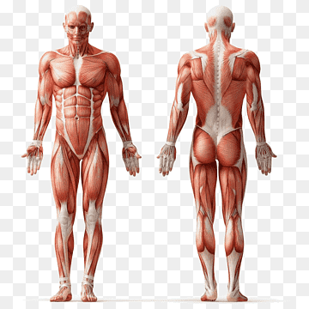
Gastrocnemius
And Soleus
“Calves”
Hamstrings
Gluteus Maximus
Erector Spinae
Latissimus Dorsi
Triceps
Middle Trapezius and Rhomboids
Quadriceps
Upper Trapezius
Obliques
Anterior and Posterior Deltoid
Abdominals
Biceps
Pectoralis Major

Photo retrieved from: https://www.pngwing.com/en/free-png-bkcvo
Muscle Conditioning Exercise Options for the Legs
Multi Muscle/Functional Leg Exercises – Work the Quadriceps, Hamstrings and Gluteals
Air Squats  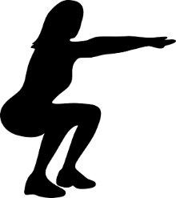 | Goblet Squat  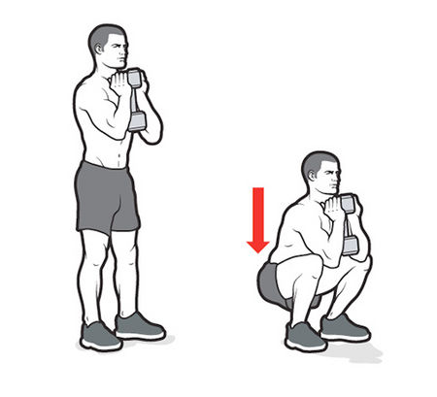 | Barbell Back Squat  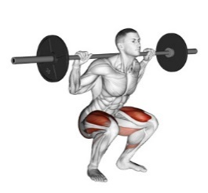 | Barbell Front Squat  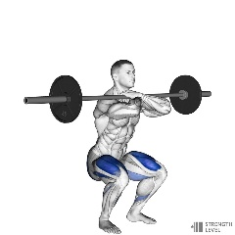 | Dbell Front Squat  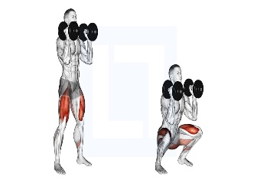
Wall Squat – Isometric  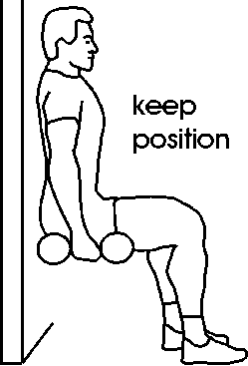 | Leg Press Machine  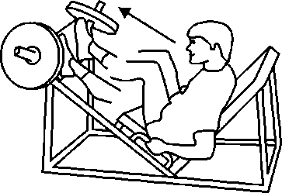 | One Legged Leg Press  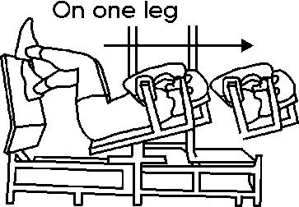 | Smith Squat  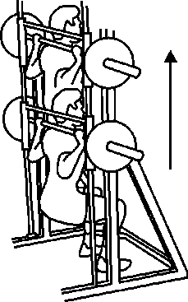 | 1 Leg Bench Squat  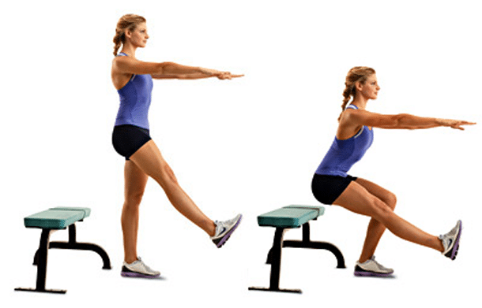
One Legged Pistol Squat  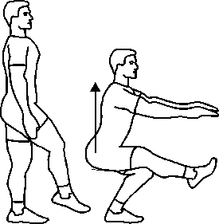 | Forward Lunge  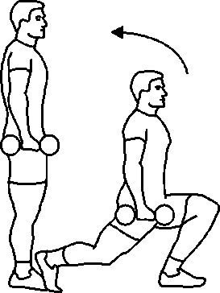 | Backward Lunge  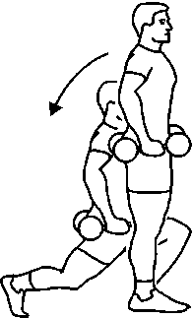 | Walking Lunges  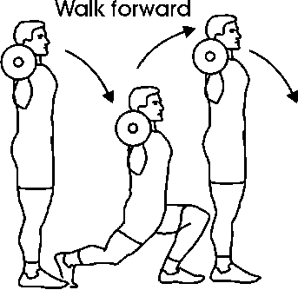 | Side Lunges 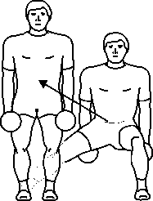
Split Squats  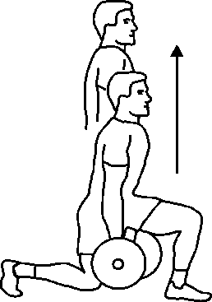 | Split Squat  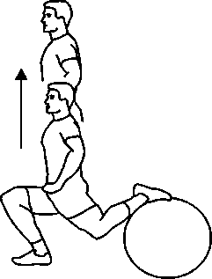 | Bulgarian Split Squat  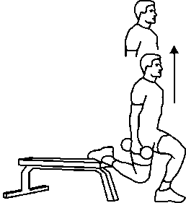 | Step Ups  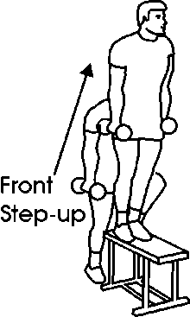 | Side Step Ups  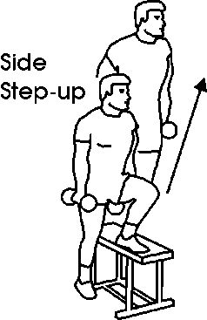
Deadlift  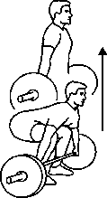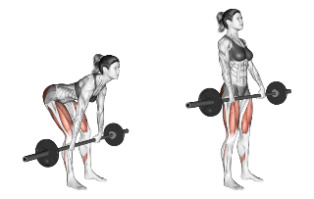 |  | One legged Deadlift  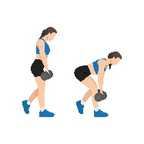 | Jump Squats  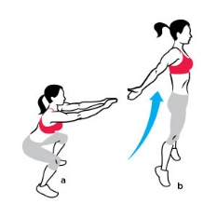 | Box Jumps 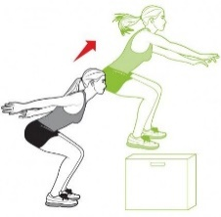

Exercise Options for the Hamstrings and Gluteals
Hamstring Bridge  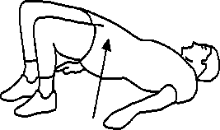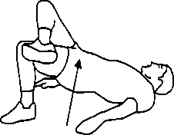  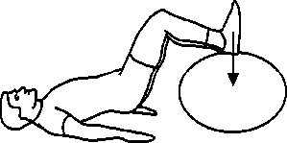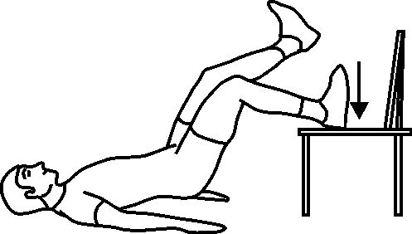 |  |  | Barbell Glute Bridge  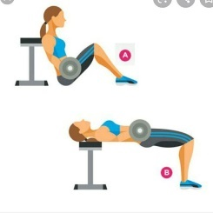 |  | Hamstring Roll 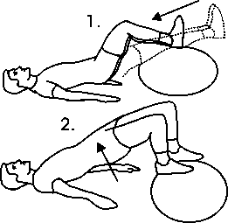 |  | Straight Leg Hip Raise  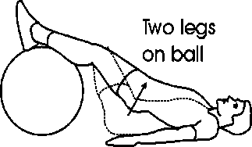
Hip Extension  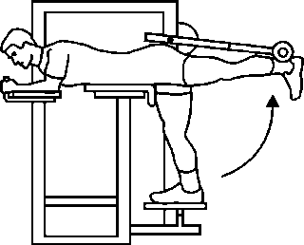 | Gluteal Press 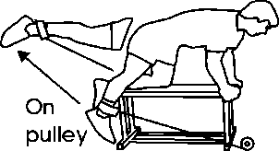 |  | Leg Curl  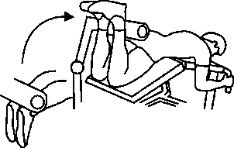 |  | Hamstring Cable Curl  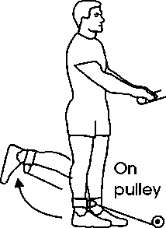 |  | Straight Leg Deadlift  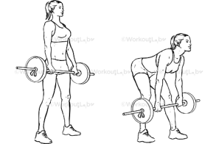
Quadriceps |  | Exercise Options for the Calves
Knee Extensions  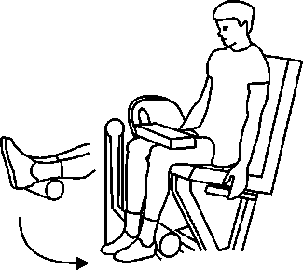 |  | Calf Raises (Gastrocnemius)  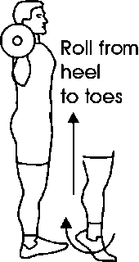 |  | Seated Calf Raises (soleus)  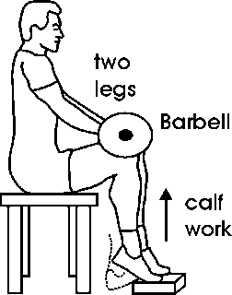 |  | Ballet Squat & Calf Raise  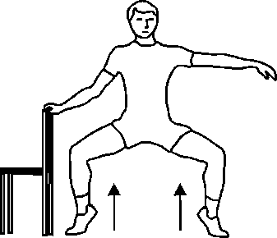
Exercise Options for the Inner Thighs (Hip Adductors)
Inner Thigh Cross-over  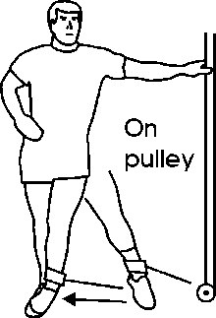 |  | Adduction Machine  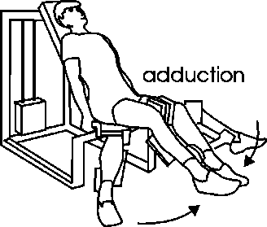 |  | Side Lying Inner Thigh Raise  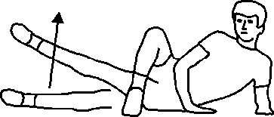 |  | Inner Thigh Ball Squeeze  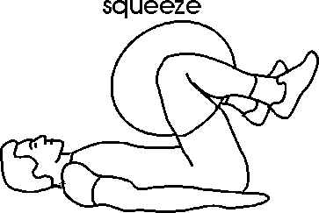
Exercise Options for the Outer Thighs (Hip Abductors)
Outer thigh raises  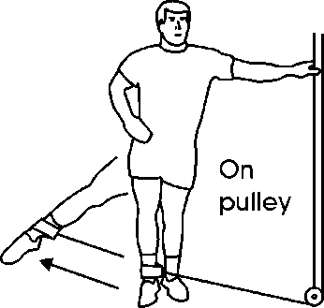 |  | Abduction Machine  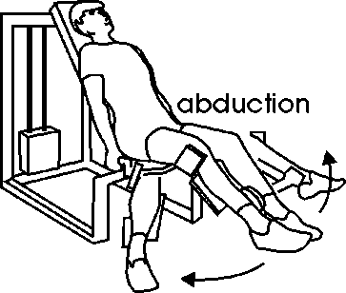 |  | Side Leg raise  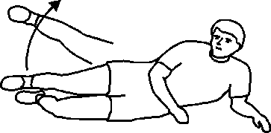 |  | Outer Thigh Squeeze  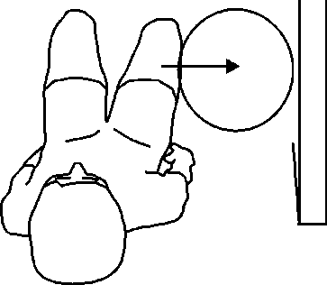

Body Weight / Plyometric / Power, Strength and Endurance Exercise Options
The ½ Burpee = The Hurpee = The Squat Thrust 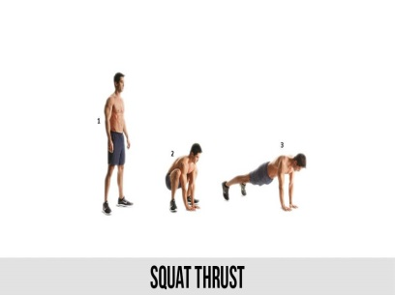 | The ¾ Burpee – no push-up  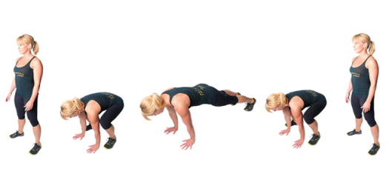 |  |  | The Full Burpee – with push-up  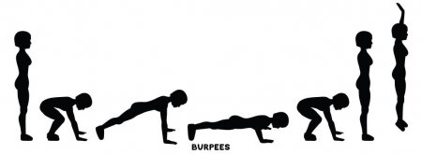  .
Full Burpee + Push-Up = Squat – legs out –1 push-up – squat legs in – jump up
8 count –Burpee = Squat down – legs out – push-up – open close legs - squat legs in - jump up
Travelling Burpees: Do a Burpee and jump forward
Inchworm  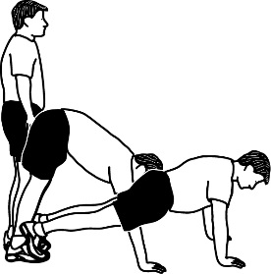 |  | Mountain Climbers  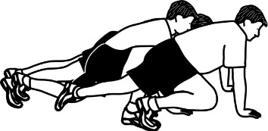 | Skater Leaps  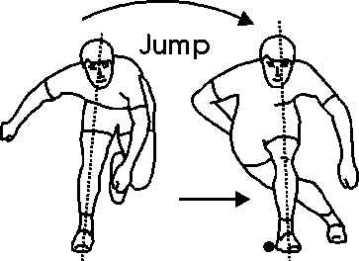 |  | Lateral Leaps  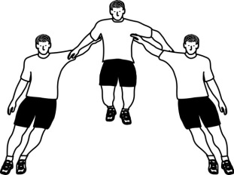
Squat Jumps  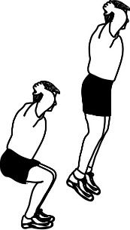 |  | Tuck Jumps  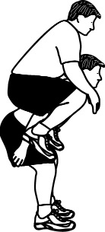 | Split Squat Jumps  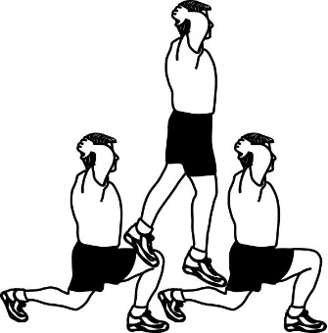 |  | Box Jumps  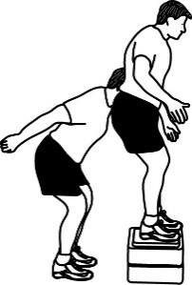
Squat and Press (Thrusters)  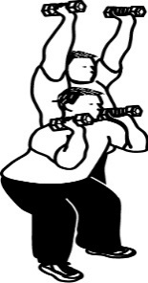 |  | Lunge + Raise  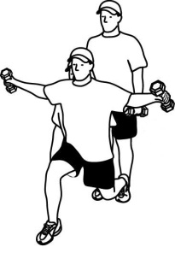 | Clap Push-Ups  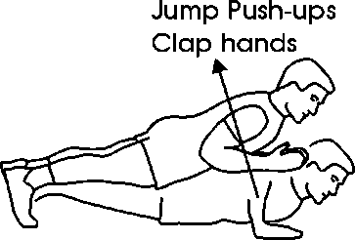 |  | Power Push-Ups  On floor or Box  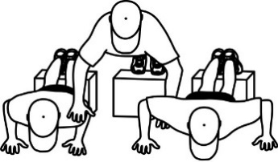
TRX Triceps Dips 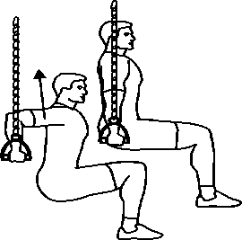 |  | TRX Push-Ups 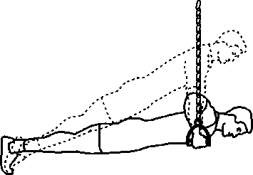 | TRX Rows  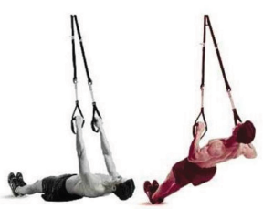 |  | Search  Bodyweight Exercises for more options and workouts!

Exercise Options for the Chest - Pectoralis Major and Anterior Deltoid
Bench Press  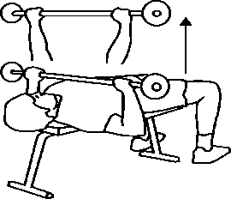 | Dumbbell Press  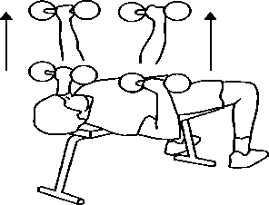 |  | One Arm Bench Press  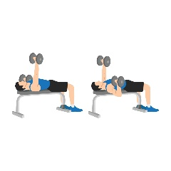 |  | Incline Bench Press  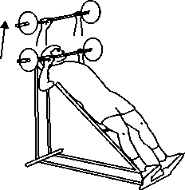 |  | Incline Dumbbell Press 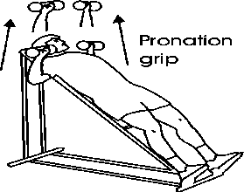
Chest Flyes  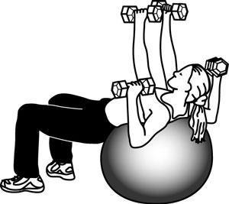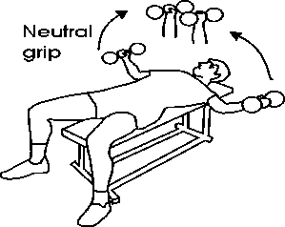 |  |  |  | Incline Flyes  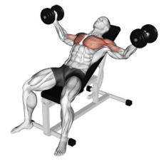 |  | Decline Flyes  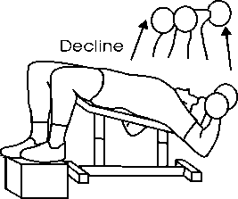
These exercises can be done with the cable machine  or with elastic tubing. |  | Cable Cross-over / Flye Variations  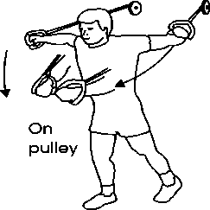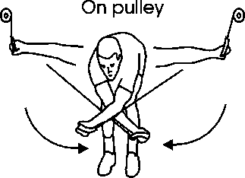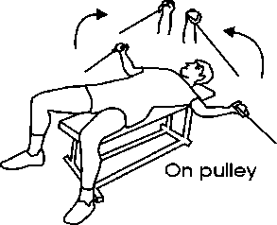
Chest Press  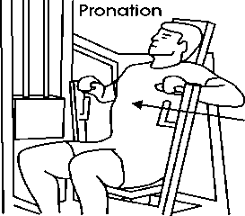 |  | Chest Flye Machine Options  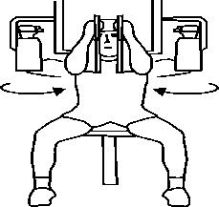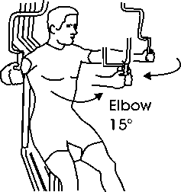 |  |  |  | Chest Dips  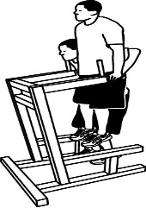
PUSH-UP INTENSITY VARIATIONS – from easy to hard
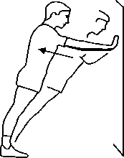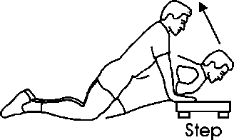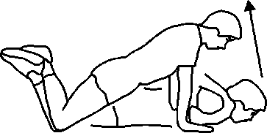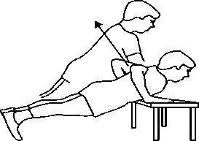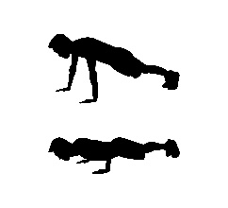
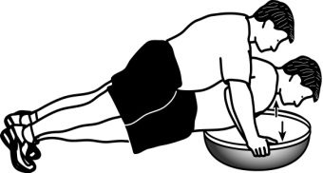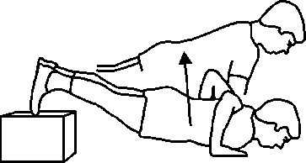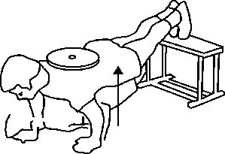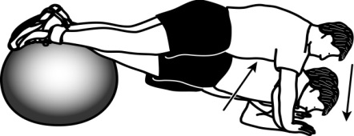
Exercise Options for the Upper Back
Latissimus Dorsi – Rhomboids – Trapezius – Posterior Deltoid and Biceps
Pull-Ups (Lats)  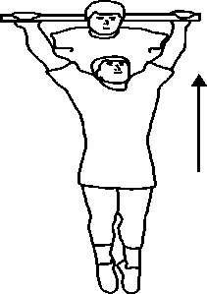 | Gravitron Pull-Ups (Lats)  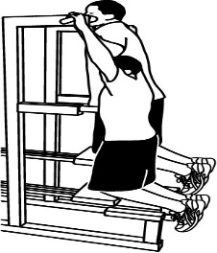 |  |  | Lat Pull-Down  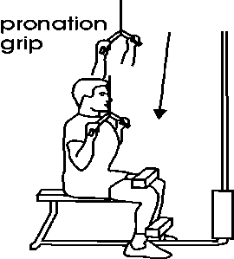 |  |  | Straight Arm Pull  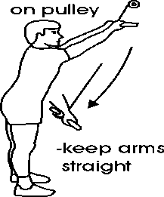 |  | Tubing Lat Pull  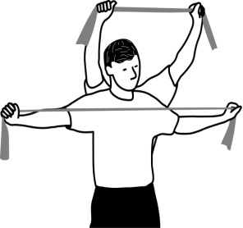
Cross-over Lat Pull  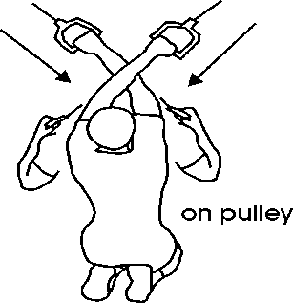 |  |  | Seated Row  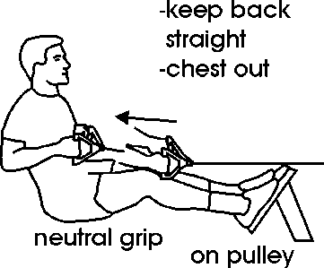 |  |  | Decline Seated Row  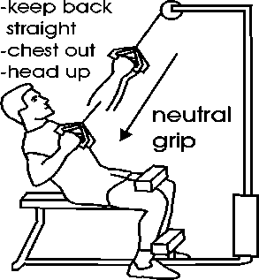 |  | Machine Row  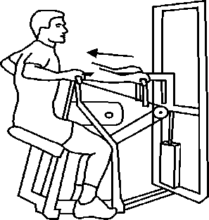
Bent-Over Barbell Row 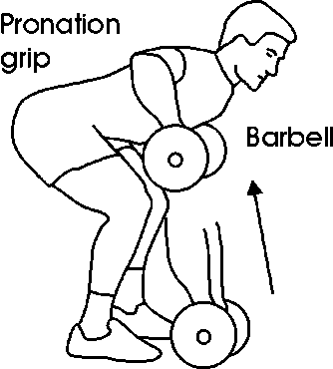 |  | Barbell Row on Ball  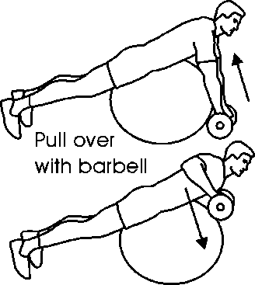 |  |  | One-Arm Dumbbell Row  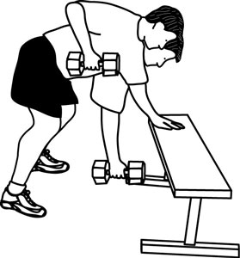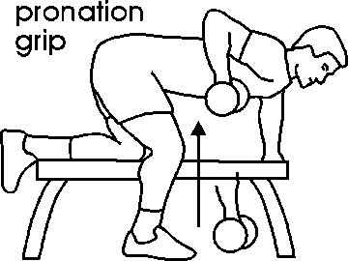
Bent-Row on Ball  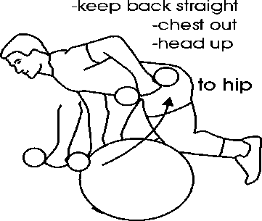 |  |  | Tubing Row  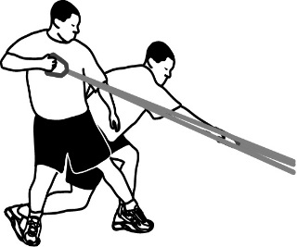 |  |  | Bent-Over Tubing Row  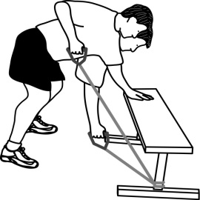 |  | Chin-ups (Biceps) 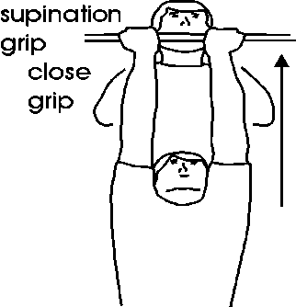
Exercise Options for the Shoulders
Upper back – Posterior Deltoid (Shoulder)
Bent-Over Flyes  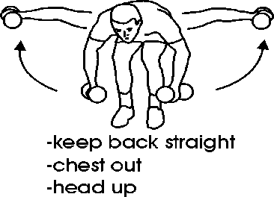 | Incline Wide Rows  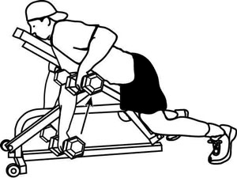 |  | Seated Posterior Flyes  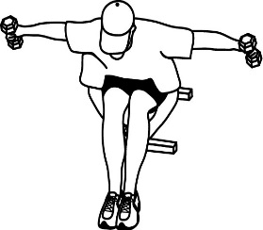 |  | Post. Flyes on ball  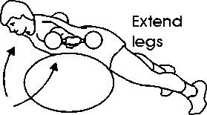  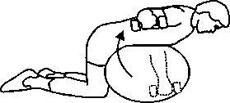
Tubing Posterior Flyes | Tubing Posterior Flye  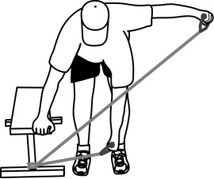 |  | Side Lying Raise  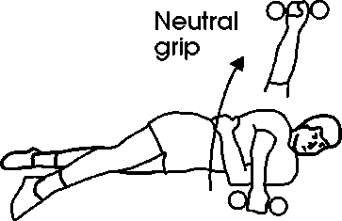 |  | Bent-Over Raise  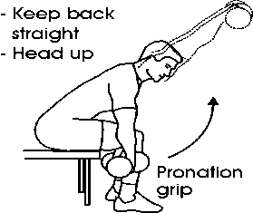
Middle Deltoid (Shoulder) Exercise Options
Barbell Shoulder Press  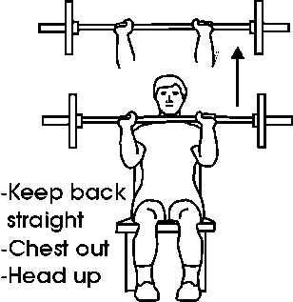 |  | Shoulder Press Machine  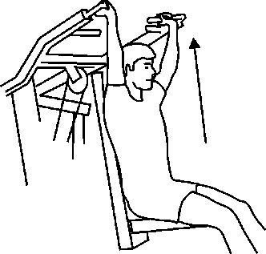 |  | Dumbbell Shoulder Press  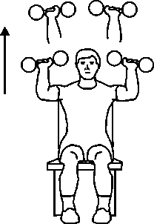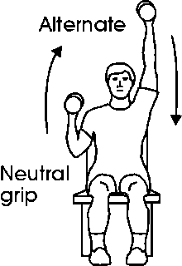
Lateral Raise  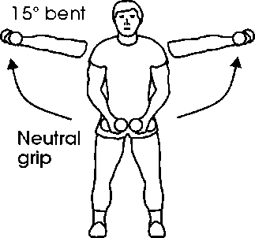 |  | Tubing / Cable Lateral Raise  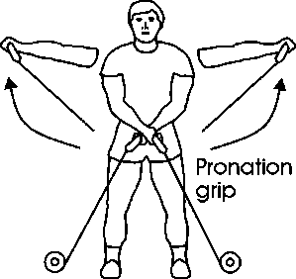 |  | Machine Lateral Raise  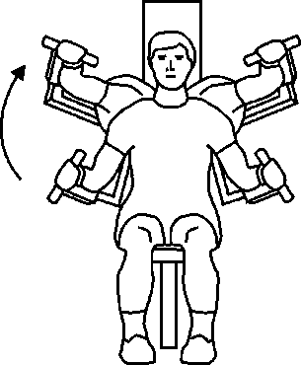 |  | Upright Row  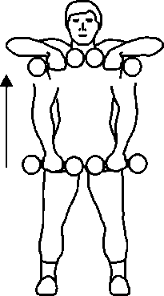
Anterior Deltoid (Shoulder) Exercise Options
Barbell Front Raise  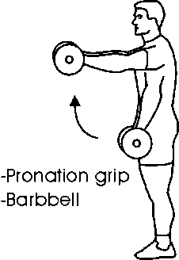 |  | Dumbbell Front Raise  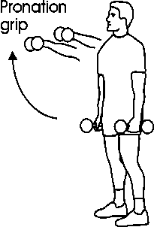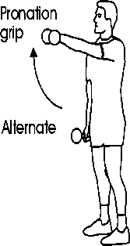 |  | Decline Front Raise  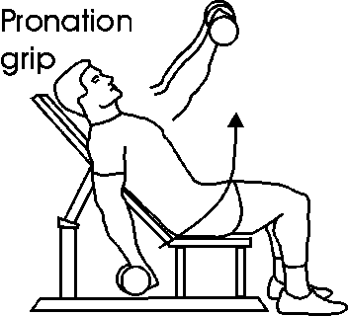 |  | Tubing/Cable Front Raise  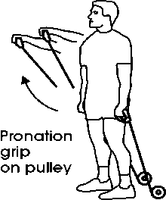

Exercise Options for the Trunk (Abs, Obliques, Lower back)
Curl-Up Options from Easy to hard (Abdominals)
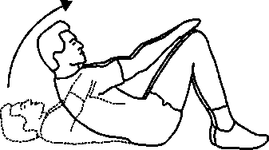 | 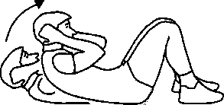 |  | 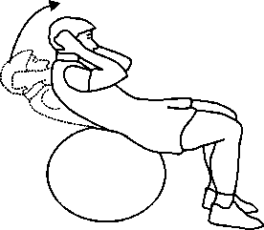 |  | 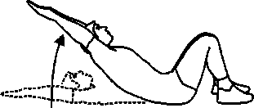 |  | 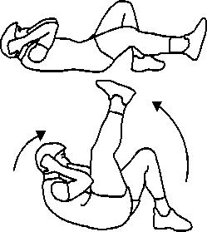
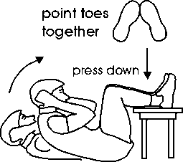 | 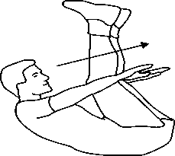 |  | Dead Bug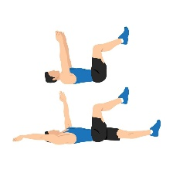 |  | 1 Leg V-Raise  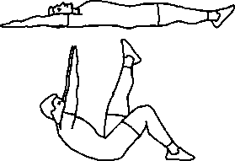 |  | V-Raises  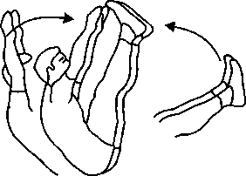
Reverse Curl-Up Options from Easy to Hard (Abdominals)
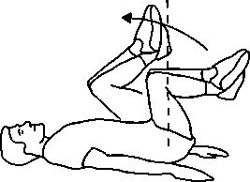 | 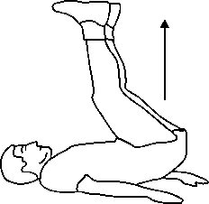 |  | 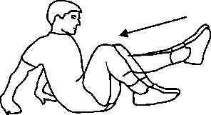 |  | 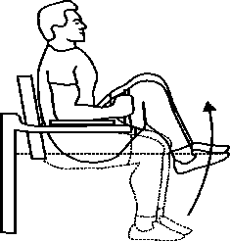 |  | 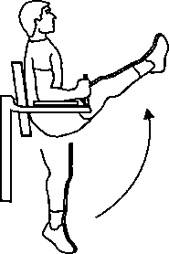
Side Curl-Up Options from Easy to Hard (Obliques)
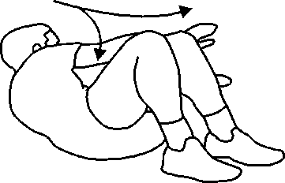 |  | 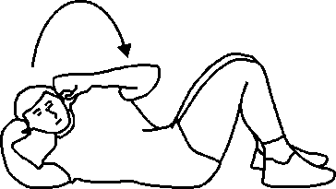 |  | 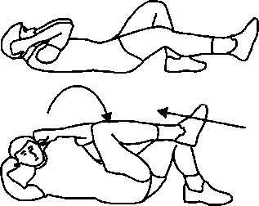 |  | 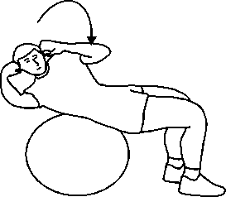
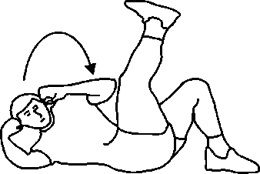 |  | 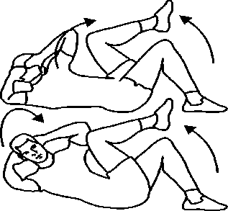 |  | 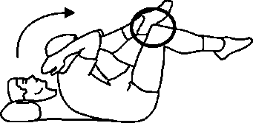 |  | 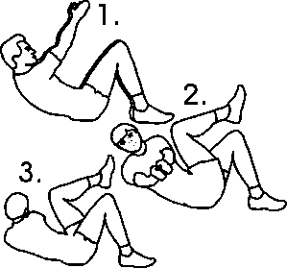
Other Exercise Options for the Obliques
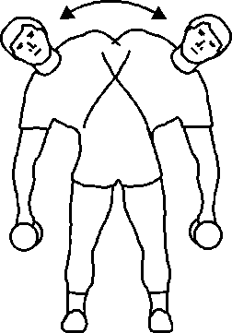 | 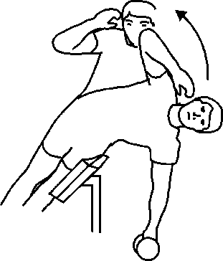 |  | 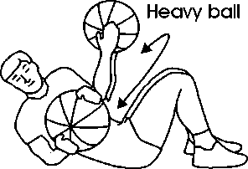 |  | 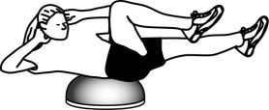 |  | 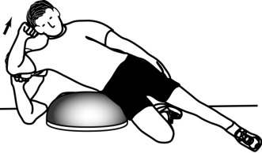

Plank Options from Easy to Hard (Posture / Abs & Lower Back)
Bird Dog  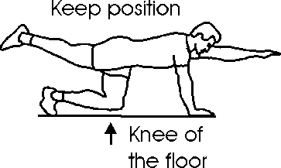 |  | Plank – Elbows or Knees  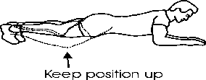  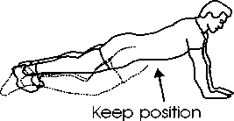 |  | Arm Raises – Circles  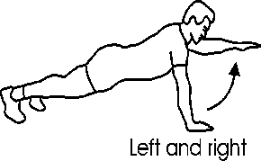 |  | Arm + Leg Raises  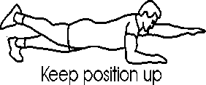  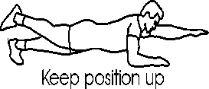
Plank Jacks  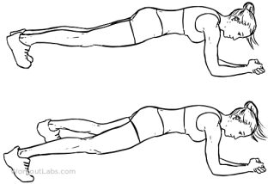 |  | Plank Hip Dips  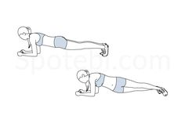 |  | Mountain Climbers  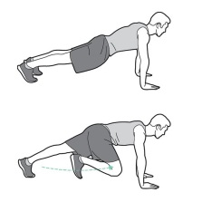 |  | Down-Up Planks  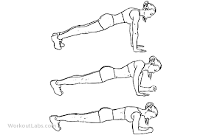
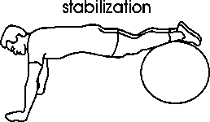 |  | 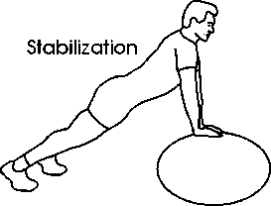 |  | Ball Roll Outs  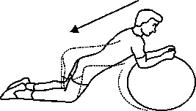 |  | Ball Roll Ins  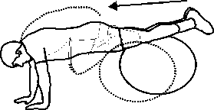
Side Plank Options from Easy to Hard (Posture / Abs + Obliques + Lower back)
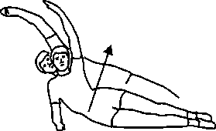 | 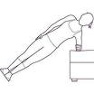 |  | 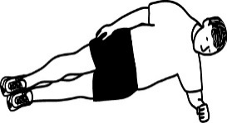 |  | 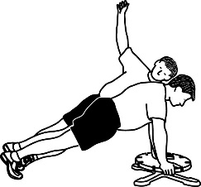 |  | 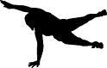
Lower back Exercise Options from Easy to Hard (Erector Spinae)
Superman  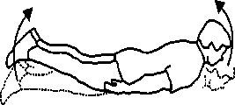 | Superman  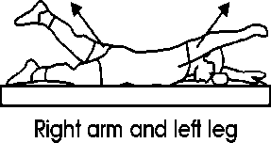 |  | Superman  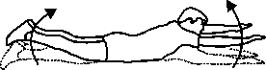 |  | Back Extension  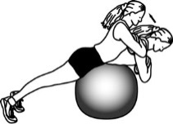 |  | Superman  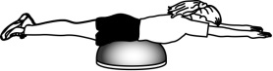
Back Extension  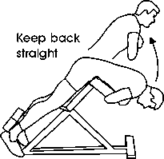 |  | 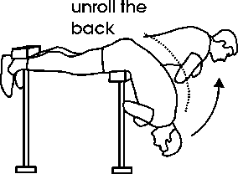 |  | Seated Deadlift  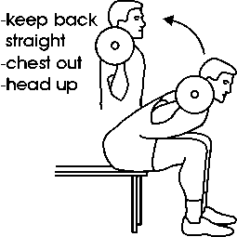 |  | Deadlifts  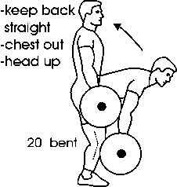
Medicine Ball Exercise Options for the Abs/ Obliques
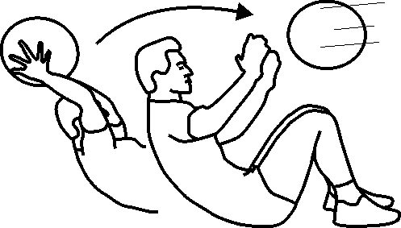 |  | 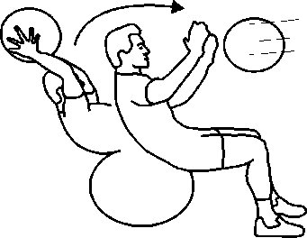 |  | 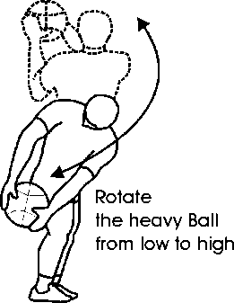 |  | 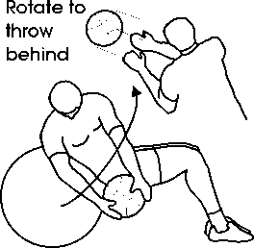
Exercise Options for the Arms
Triceps Exercise Options
Closed grip Bench Press  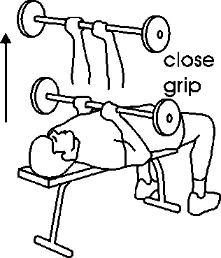 | Barbell Skull Crushers  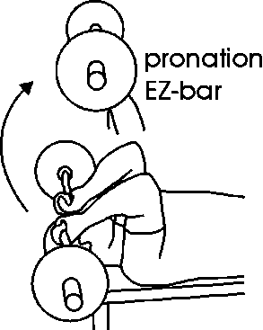 |  | Dumbbell Skull Crushers  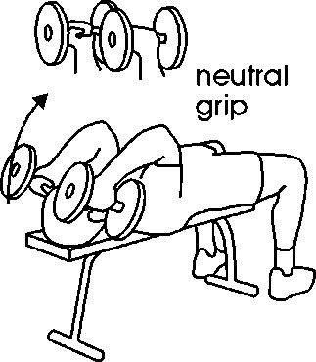 |  |  | Triceps Kickbacks  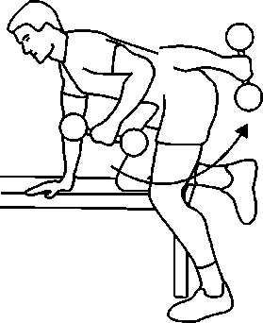
Overhead Extension  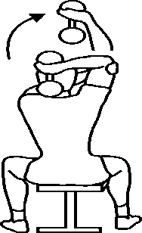 | Triceps Dips  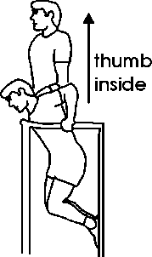 |  | Triceps Press Down  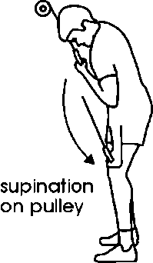 |  | Overhead Cable Extensions  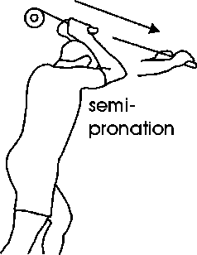
Triceps Dips from easy to hard
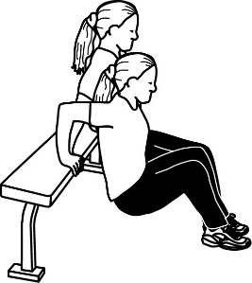 |  | 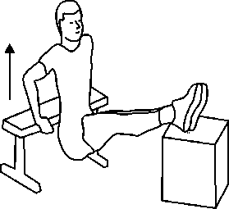 |  | 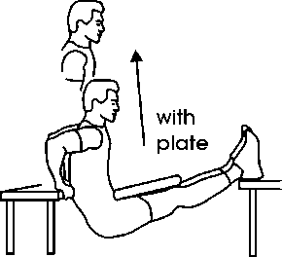 | Triceps Push-Ups  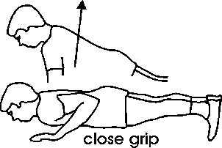
Biceps Exercise Options
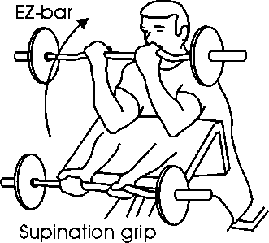 | 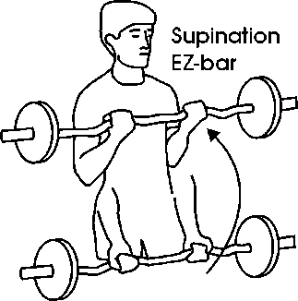 |  | 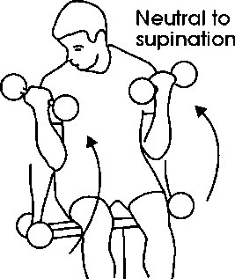 |  |  | 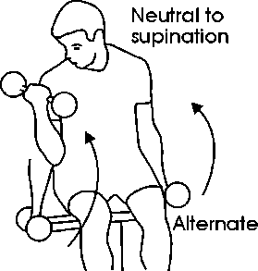
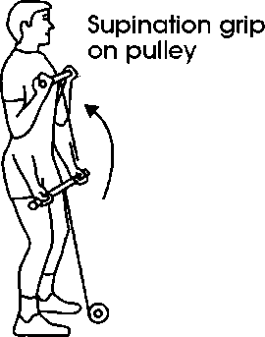 | 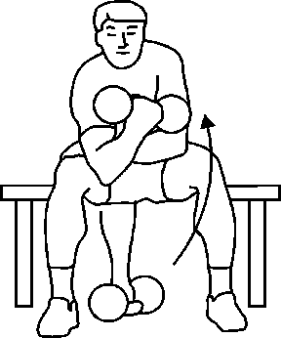 |  | 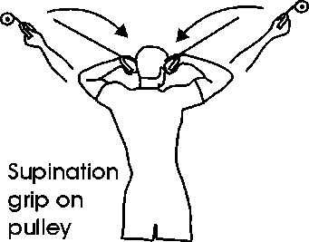 |  |  | 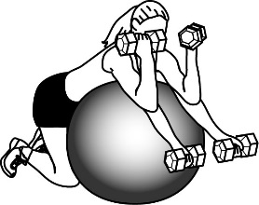

MUSCULAR CONDITIONING PROGRAM DEVELOPMENT GUIDELINES –

Step 1: Determine your personal training goals:
    - Muscle Strength / Muscle Endurance / General Fitness / Body Building
    - Sport Specific Training / Rehabilitation
Choose the appropriate training intensity (frequency / # sets and reps / # of exercises) that will enable you to effectively achieve your training goals (refer to FITT Table).

Step 2: Choose the exercises that you will do. Take into consideration the equipment you have available and your personal likes and dislikes.

EXERCISE SELECTION for a FULL BODY WORKOUT
- Choose exercises from each of the Major Muscle Groups
- Be sure to work opposite muscles (chest / upper back etc.) for muscle balance.
- Focus on large muscle groups
- Train large muscle groups first and smaller muscle groups after.
Legs | Muscles = Quadriceps, Gluteals, Hamstrings, Inner Thigh, Outer Thigh  Exercise Options:  a) Train all leg muscles together – (squats, lunges - work all leg muscles simultaneously)  +/ or  b) Isolate each muscle –  Quadriceps (knee extensions) – Hamstrings (leg curls / hamstring bridge / dead lifts) Gluteals (hamstring bridge / gluteal press / dead lifts),  Inner Thigh (inner thigh raises) - Outer thigh (outer thigh raises) - Calves (heel raises)
Chest | Muscles = Pectoralis Major, Anterior Shoulder (sometimes triceps are used as well)  Exercise Options: Push-Ups, Bench Press, Flyes
Upper Back | Muscles = Latissimus Dorsi, Rhomboids, Trapezius, Posterior Shoulder (Biceps are also used)  Exercise Options:  a) Bent-over Row, Seated Row, Barbell Row  b) Pulls-Ups / Chin-Ups, Lat Pull Down
Shoulders | Muscles = Anterior Deltoid / Middle Deltoid / Posterior Deltoid  Exercise Options:  - Anterior = Front shoulder raises / also used when working the chest  - Middle = Lateral shoulder raises / Overhead Shoulder Press  - Posterior = Posterior Flyes / also used when working the upper back
Biceps | Muscles = Biceps / Forearm Muscles  Exercise Options: Biceps Curls / Chin Ups
Triceps | Muscles = Triceps  Exercise Options: Triceps Dips / Kickbacks / Press Down / Skull Crushers / Push-Ups
Trunk | Muscles = Abdominals, Lower back, Obliques, Stabilizers (posture exercises)  Exercise Options:  - Abdominals – curl-ups / crunches  - Lower Back – superman / back extensions / dead lifts  - Obliques – side curl-ups / side bends  - Stabilizers – leg raises / plank / side plank

MAKING AN EXERCISE PROGRAM – GUIDE

Step 1: Decide when and how long you have to work out

Workout | Mon | Tue |  | Wed | Thu |  | Fri | Sat |  | Sun
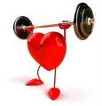
General Cardio Guidelines
Frequency  3-5 days per week |  | Intensity  Moderate  60-85 % of max HR |  |  | Time  20 – 60 minutes  1-minute HIT Intervals |  |  | Type  Continuous training,  Interval Training or HIT

General Muscular Conditioning Guidelines
Frequency  Train each muscle 2-3 days each week |  |  | Intensity:  # sets/reps  Circuit, straight sets... |  |  | Time =  Depends on # of exercises you chose |  |  | Type:  Free wts. / machines / Body weight

Step: 2: Muscle Conditioning Guidelines:

1. List the exercises you would like to do (take into consideration equipment available)
a) It is important to train all major muscle groups (* = Major Muscle)
b) It is important to train opposing muscle groups

UPPER BODY |  | LOWER BODY
Chest * |  | Thighs *  Quads, Hams, Glutes
Upper Back * |  | Quadriceps *
Shoulders * |  | Hamstrings *
Biceps |  | Gluteals *
Triceps |  | Inner Thigh
 |  | Outer Thigh
 |  | Calves
TRUNK
Abdominals * |  |  | Obliques *
Lower Back * |  |  | Posture  Exercises *
CHAPTER 5
WARMING UP - MOBILITY, RANGE OF MOTION FLEXIBILITY TRAINING FITT
POSTURE

RELATED TERMINOLOGY:

Flexibility:
Flexibility refers to the passive range of motion (movement without external assistance) about a joint. Flexibility is the ability to stretch and is determined by the length and elasticity of the muscles, tendons and ligaments that cross a joint. It is possible to have good flexibility in one area, but poor flexibility in another. As a result, it is important to assess various movement patterns to determine which areas require more flexibility and range of motion training. Poor flexibility has been associated with acute injury from strenuous activity, injury in daily life activities, poor posture and body alignment, immobility and soreness during and after exercise.

Static Stretching:
Flexibility exercises are typically static which involves holding a stretch position with the aim of elongated the surrounded muscles. For example, seated toe touch is a static hamstring stretch. Flexibility stretches are usually performed at the end of a workout session or as part of a flexibility and mobility workout when muscles are appropriately warmed up.

Warm-Up:
Before engaging in any form of physical activity, it is important to warm-up to prevent injury. An effective warm-up will increase blood flow to the muscles and joints, improve elasticity of the muscles, improve joint range of motion and mobility and will psychologically prepare the exerciser for the activity to follow.
.
Dynamic / Range of Motion Stretching:
Range of motion refers to the degree of movement at a joint.
Dynamic / range of motion stretches are movement-based types of stretching where the stretch is not held. In dynamic stretching, the muscles are used to actively stretch the desired muscle. For example, straight leg kicks are dynamic hamstring stretches. Dynamic stretches are usually performed at the beginning of the workout as part of the warm-up.

Mobility: Movement Preparation Exercises
Mobility refers to the range of movement about a joint. Mobility exercises are dynamic movements and be defined as the ability to move freely and actively through a joints full range of motion. Mobility for a specific movement pattern requires flexibility, range of motion, strength, balance and coordination. For example, the ability to perform a proper squat requires mobility in the ankles, knees, hips and spine. Poor mobility can lead to stiffness and injury while moving

Cool-down:
After engaging in physical activity, it is important to cool-down and gradually bring the body back to its pre-exercise state.
After Cardio workouts (cardio cool-down):
It is recommended to take gradually (2-3 minutes) decrease the intensity to below 60 % of training range. This will prevent blood pooling in your lower limbs which can leave you feeling light headed and nauseated. The fitter you are, usually the faster your body will recover. Keep moving until your heart rate and body temperature have decreased.
Stretching in the cool-down:
It is very important to stretch after each and every workout. Stretching after workouts will allow your muscles to return to their original length, will prevent post exercise soreness and stiffness and help you to maintain or improve your flexibility level. Static stretching is recommended in the cool-down. For each muscle worked perform at least one static stretch. Hold each stretch for 20-30 seconds. To improve flexibility, repeat each stretch 2-3 times.

Flexibility and mobility are both important components in a fitness plan. Both are important for effective movement and injury prevention. A combination of flexibility exercises (static and dynamic stretching) as well as mobility exercises are an important part of workouts.

The Warm-Up:
Before engaging in any form of physical activity, it is important to warm-up.

Purpose of the warm-up:
- To prevent muscle and joint injury.
- To increase body temperature muscle elasticity and joint mobility.
- To increase oxygen supply to the muscles.
- To prepare the body for the workout and improve athletic performance

Warm-Up Components
The focus, time and exercise selection for a warm-up are dependent on the activity. (Activity Specific)
Thermal Warm-Up | Joint Range of Motion /  Dynamic Stretching | Movement Preparation and  Mobility Exercises
Low intensity cardiovascular activity such as walking, light jogging, biking or rowing to increase body temperature and muscle elasticity. | Dynamic movement to improve range of motion and to prepare the joints, muscles, tendons and ligaments for the workout (arm circles, knee lifts, shoulder rolls, butt kicks...). | Workout/activity specific movements and mobility exercises to ensure preparation and proper movement patterns. (warm-up sets,  squats, push-ups, plank, inchworm) Sport Specific movements: serves, passes, shots, swings, kicks.

The following chart identifies exercise options for each component of the warm-up. When designing a warm-up, select exercises and movements specific to the activity to follow. The exercises and stretches used should be selected to warm-up the muscles and joints that will be challenged in the workout and to emulate the movements that will be performed.

Thermal Warm-Up Options (2-5 Minutes)
Walking, Jogging, Skipping, Stairs
Rowing, Elliptical, Stair Master, Biking, swimming
Side Shuffles, Butt Kicks, Knee Lifts, Front Kicks
Range of Motion Movements / General Joint Preparation (2-5 minutes)
3-5 reps / exercise - Focus on joints that will be used in the workout
Neck
Flexion / Extension  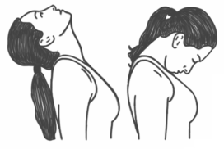 | Lateral Flexion  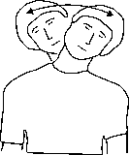 |  | Lateral Rotation  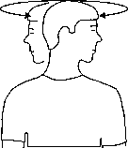
Scapula (shoulder blades)
Elevation (shrug) / Depression (lower)  Both directions |  | Protraction (Open)  Retraction (Close – squeeze together)
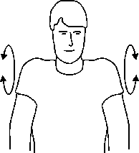 |  | 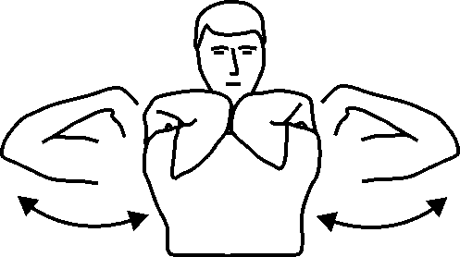

Shoulders and Elbows
Flexion / Extension  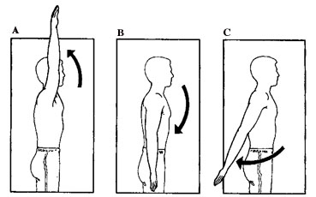 |  |  |  | Internal / External Rotation  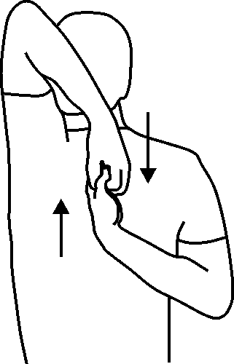 |  |  |  | Horizontal  Flexion / Extension  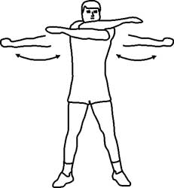 |  |  |  | Circumduction  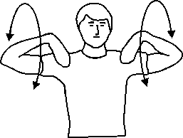
Spine
Flexion / Extension  Cobra to Child  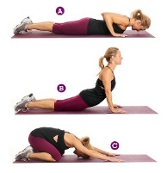 |  |  | Lateral Flexion  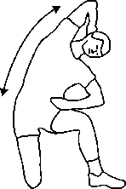 |  |  |  | Lateral rotation  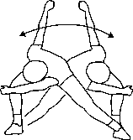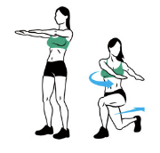
Hips
Flexion / Extension  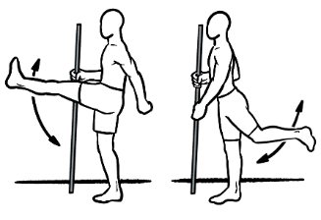 |  |  | Internal / External Rotation  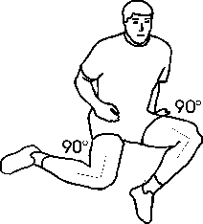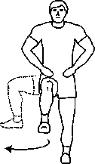 |  |  |  |  |  |  | Abduction / Adduction  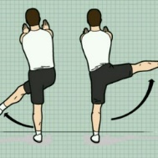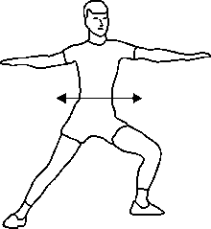
Ankles |  |  |  |  |  |  |  |  | Wrist
Plantar Flexion  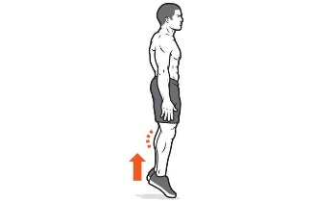 | Dorsi Flexion  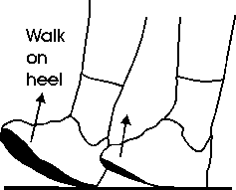 |  |  |  | Rotation  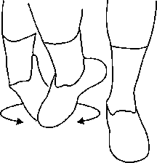 |  |  |  | 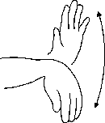 |  |  |  | 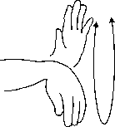
Movement Preparation and Mobility Exercises (2-10 minutes)
3-5 reps / exercise
Air Squats  \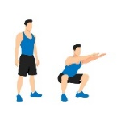 |  | Snatch Squat  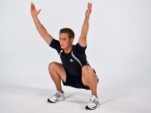 |  |  |  | Squat to Stand  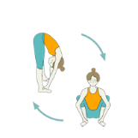 |  |  |  |  | Lunge to Stand  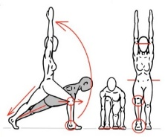
Lunge and Rotate (Goat)  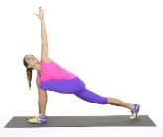 |  | Inch Worm  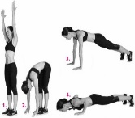 |  |  |  | Scorpion  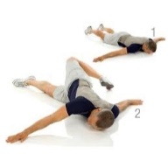 |  |  |  |  | Plank + touch  (shoulder/hip/shin)  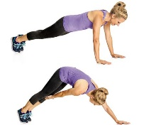

Sample Workout Preps

Elliptical Workout  Cardio | Bootcamp Workout  Cardio / Muscle | Weight Training –  Legs and Chest Day | Soccer Game
Warm-Up
3 min Thermal:  Elliptical  2 min. ROM:  ankles, knees, hips, lower back  2 min Mobility:  Lunges, plank, Supermans | 3 min Thermal:  Skip, Jacks, butt kicks  2 min ROM:  Leg swings, arm swings,  Spinal rotation  3 min Mobility:  Squats, Lunges, Inchworm, push-ups | 2 min. Thermal:  Rowing Machine  2 min ROM:  Knees, Hips, Shoulders  4 min Mobility:  Lunges, Squats, Toe Touches, Lunge and Rotate, Plank  Light Weight Sets | 5 min Thermal:  Shuffle, jog, butt kicks, karaoke, high knees  3 minutes ROM:  Ankle, knee, hip, lower back, shoulders  3 min Mobility:  Squats, Fwd Lunges, Lateral Lunges, Plank  5 min Movement Specific:  Passing, game simulation, shooting
Workout
20 minutes Elliptical  Interval Workout  60-85% HR Range | Round 1: Lunges –  Push-Ups – Ball Slams – Skipping  Round 2:  Pull-Ups – Box Jumps – Strict Press - Plank | 4 x 10-12 RM  Legs: Lunges, Squats, Deadlifts, 1 legged Bridge  Pectorals: Bench Press, Incline Dbell Press, Dbell Flyes, | Play  5 min mini warm-up if coming from bench
Cool-Down
2 Minute low intensity Elliptical ↓ HR | 2 Minute walk around Cardio Cool-down ↓ HR |  | 2 Minute light jog across field ↓ HR
5 Minutes Static Stretching: 2x30 sec  Calves, Quads, Hamstrings, Glutes, Hip Flexors | 5 Minutes Static Stretching: 2x30 sec  Quads, Hamstrings, Glutes, Pectorals, Abs, Obliques, Lower Back | 5 Minutes Static Stretching: 2x30 sec  Quads, Hamstrings, Glutes, Pectorals, Triceps | 5 Minutes Static Stretching: 2x30 sec  Quads, Hamstrings, Glutes, Inner Thigh, Calves, Lower Back, Abdominals

FITT PRINCIPLE FOR FLEXIBILITY
Flexibility may be defined as the ability of the muscles, tendons and ligaments to move freely through the full range of motion at a specific joint. It is a very important component of physical fitness that can have a positive or negative affect on injury risk, mobility, strength and posture. Unfortunately, flexibility and stretching exercises are often neglected.

F | I | T | T
Frequency | Intensity | Time | Type
days / week | how hard | how long | mode of activity
3-5 days / weeks  and/or  after each workout | hold the stretch  at the point of tension | Hold for 20 - 30 sec.  Repeat each stretch 2-3 times | Static stretches  after workouts.

Rules of Thumb
Muscles respond better to stretches when they are warm - so warm up before stretching.
Always stretch at the end of your workout.

FREQUENCY
- Stretching exercises can be performed everyday but it is important to remember that stretching is most effective when performed after the body has been warmed up through aerobic exercise.
- Stretching exercises should be performed at the of each workout. Select static stretches for each of the muscles that was used in the activity. This will help to prevent post-exercise soreness and loss of flexibility.

INTENSITY
- Stretches should be held without any bouncy jerky movements. Excessive bouncing movements especially of momentum or an external force is applied can increase the risk of injury (muscle strain, sprain).
- Static stretches should be held at the point of tension do not force the stretch. Breathe through the stretch and try to relax the muscle. Once you feel the muscles and tissues relax and lengthen, try stretching a little further.

TIME
- In order to improve flexibility, stretches should be held for at least 20 - 30 seconds / 2- 3 sets.
- Stretches for all muscle groups should be included in the routine, but especially those that were stressed in the exercise session.

TYPE
- Static, non-moving stretches held for 20-30 seconds are the safest and most effective stretches and should be done after any physical activity.
- Assisted static stretches are also very effective. Have a partner gently apply pressure while in a stretch position or use a towel or strap to help you isolate the position.
- Controlled range of motion exercises (Dynamic Stretches) are very effective for warming up muscles and joints and to prepare for any physical activity.
- Ballistic stretches – bouncing while stretching, is not recommended as they can overstretch the muscle, tendons and ligaments.

Flexibility - Static Stretching Exercise Options

LEGS
Hamstrings – Back of Thigh
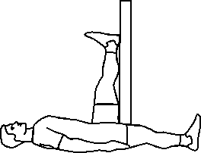 |  |  | 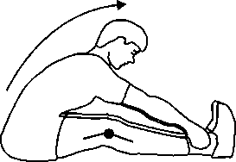 |  |  |  |  | 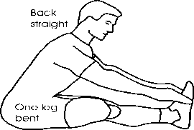 |  |  |  |  |  |  | 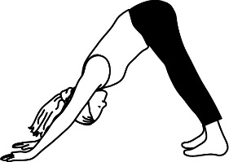
Quadriceps and Hip Flexors – Front of Thigh
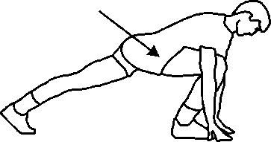 |  | 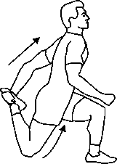 |  |  |  |  | 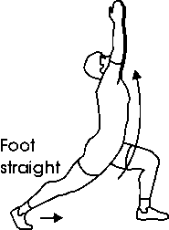 |  |  |  |  | 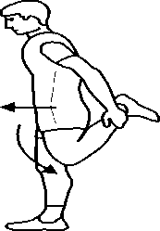 |  |  |  |  | 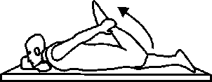  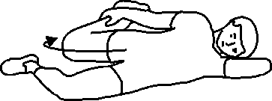
Gluteals (Buttocks) and Outer Thigh (Hip Abductors)
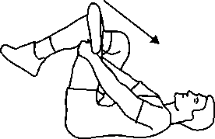 | 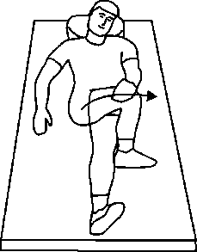 |  |  |  |  | 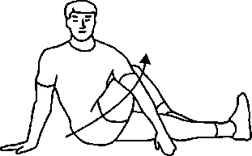 |  |  |  |  | 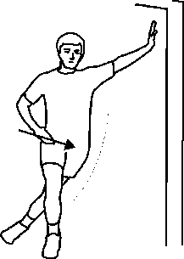 |  |  |  |  | 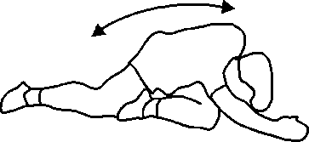
Inner Thigh – Hip Adductors
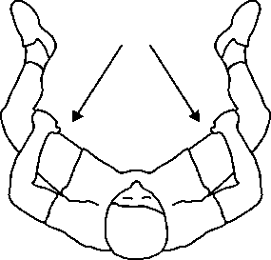 |  |  |  | 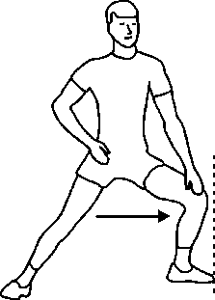 |  |  |  |  | 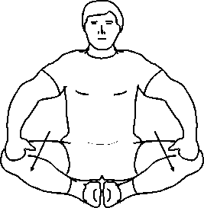 |  |  |  | 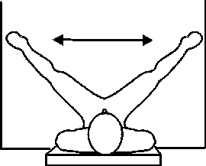
Calves – Gastrocnemius / Soleus / Achilles Tendon
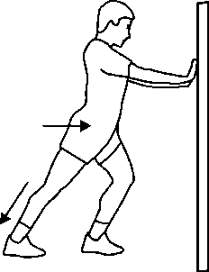 |  |  |  |  | 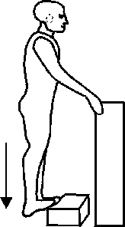 |  |  |  |  | 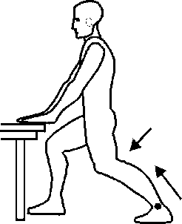 |  |  |  | 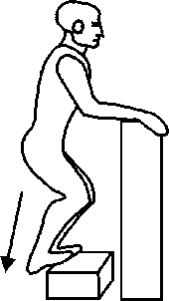

Options for the Upper Body
Chest – Anterior Deltoid and Biceps (front of shoulder)
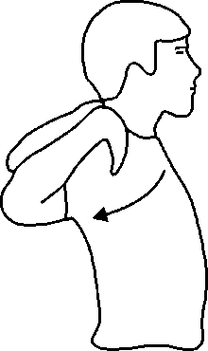 |  | 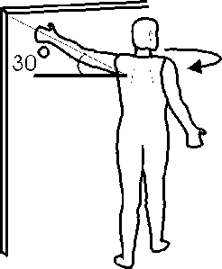 |  | 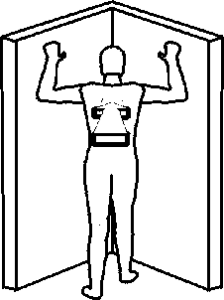 |  | 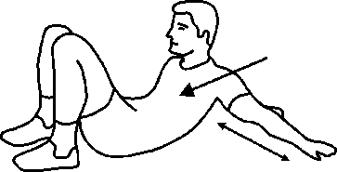
Triceps + Chest → |  |  |  | 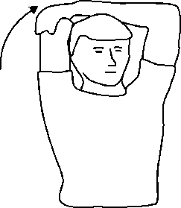 |  | 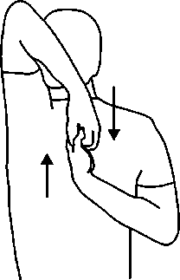
Upper Back – Posterior Deltoid, Lats
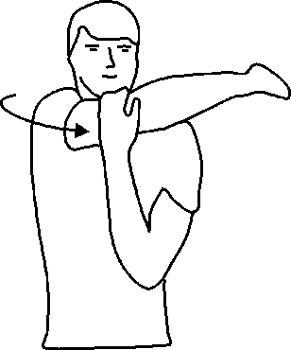 |  | 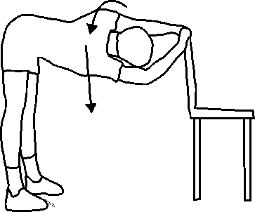 |  | 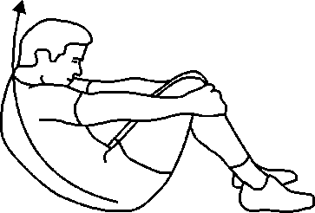 |  | 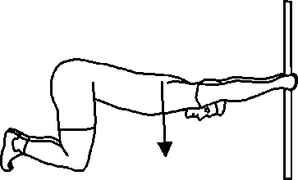
Forearms / Wrists
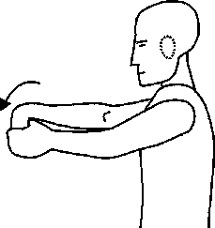 |  | 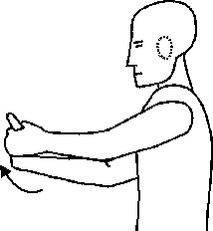 |  | 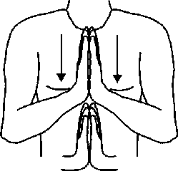 |  | 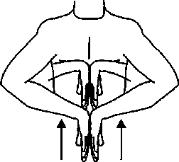
Neck – Upper Trapezius
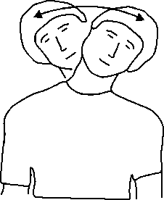 | 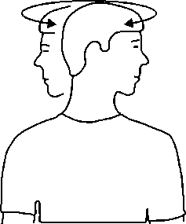 |  | 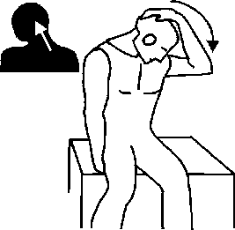 |  | 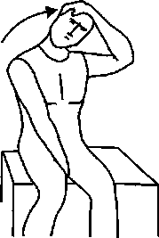 |  | 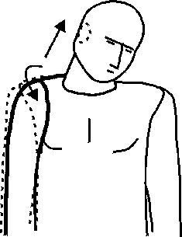

Options for the Trunk / Core
Abdominals
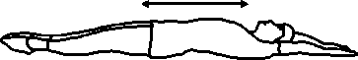 |  |  | 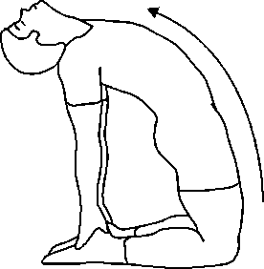 |  |  | 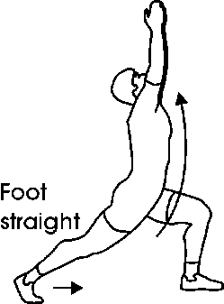
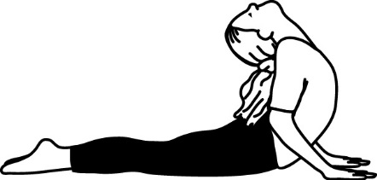
Lower Back
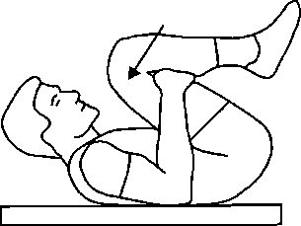 | 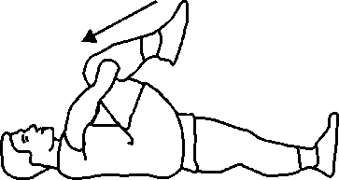 |  | 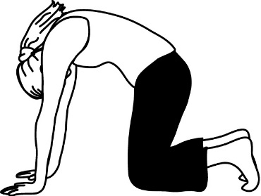 |  |  | 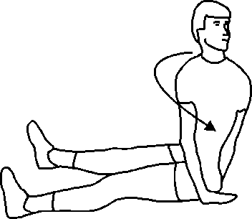
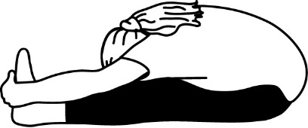 | 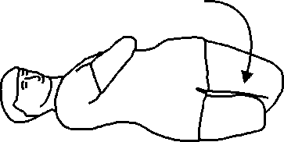 |  | 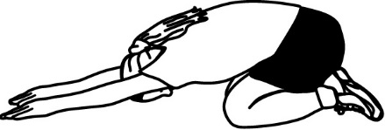 |  |  | 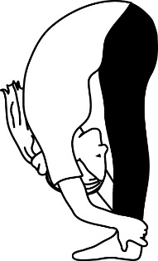
Obliques – Waist
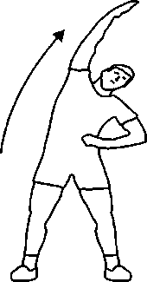 |  | 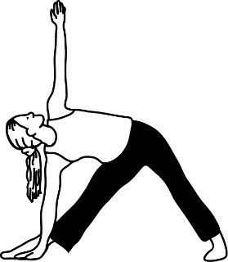 |  | 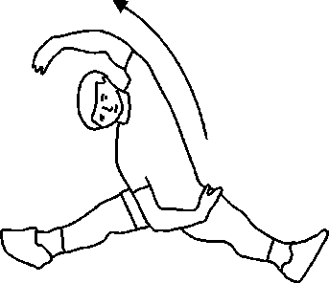

POSTURE

Posture may be defined as the ability to maintain our centre of gravity over our body’s base of support. Maintaining proper posture requires the recruitment and strength of stabilizing muscles, flexibility, mobility and kinaesthetic awareness. Both static and dynamic posture is important to maintain alignment and to prevent injury when moving.

Benefits of Good Posture
↓ risk of neck and back problems  ↓ risk of arthritis  ↓ risk of strains and pains  ↓ stress on ligaments of the spine | ↓ risk of nerve impingement  ↓ repetitive stress overload  ↓ headaches and fatigue Improved Better sleep | Improved breathing  Improved movement efficiency Improved coordination  Improved balance
Correct Sitting Posture  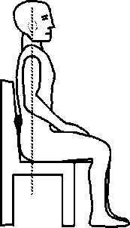 | Proper Standing Posture  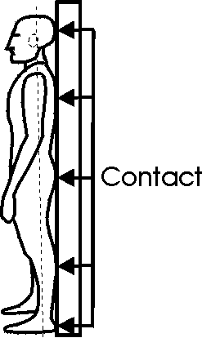 | Correct Lifting Posture  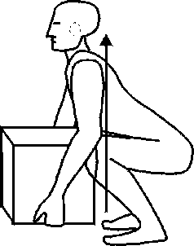
Correct Sleeping Posture  Zzz…  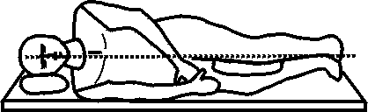 |  | Correct Bending Posture  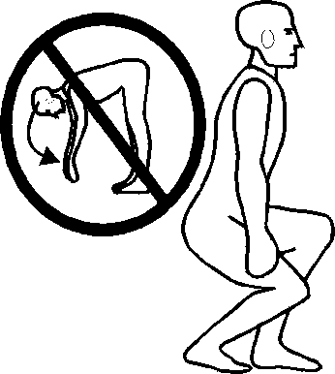
Common Postural Errors
Rounded Shoulders  Shoulders rounded forward  While standing or sitting Caused by tight chest muscles and weak upper back muscles. | 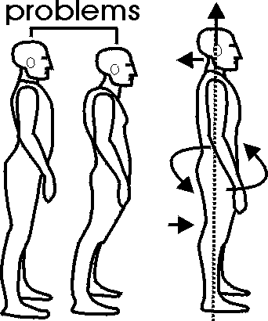 | Head forward posture  Holding your head and neck forward and down while standing or sitting. Caused by weak neck and upper back muscles and tight chest muscles
Lower Back Arch  Allowing pelvis and abdomen to protrude to the front. Caused by: tight lower back, gluteal, hip flexor and hamstring muscles; weak abdominal and postural muscles. |  | Uneven Shoulders / Head Tilt  Caused by tightness in the neck and upper back
Stretch the following muscle groups to Improve Posture
(refer to stretching exercises)
Chest / Anterior Shoulder / Neck Lower Back / Hamstrings / Gluteals / Hip Flexors and Quads
Muscle Conditioning Exercises to Improve Posture (refer to Chapter 4)
Posterior Flyes, Rows and Pull-downs for the Upper Back
Curl-Ups and Side Curl-Ups for the Abdominals and Obliques
Squats, Lunges, Supermans and deadlifts for the Lower Back
Front Plank / Side Plank for Posture development
CHAPTER 6
NUTRITION – HEALTHY EATING

WHY DO WE NEED TO EAT?

In order to provide the body with the "nutrients" that it needs in order to function properly.
- For energy (calories). A calorie is defined as “an energy producing unit of food.”
- For tissue growth and repair.
- For regulation of metabolic functions that are continuously taking place within the body.

THE 6 ESSENTIAL NUTRIENTS

Not only do we need food for energy; we also need a specific amount of the 6 essential nutrients in order for our bodies to function properly. A deficiency in any one of these nutrients can cause serious health problems. Selecting the right amount of different foods to supply our bodies with the recommended amount of nutrients is essential in order for our bodies to function well.

Micronutrients | Macronutrients
1. Water | 4. Protein
2. Vitamins | 5. Fat
3. Minerals | 6. Carbohydrate

The MICRONUTRIENTS

1. WATER - provides no calories / no energy

- One of the most important and often overlooked essential nutrients is water. We can live for weeks on our bodily reserves of energy but we can only live a few days without water. Water makes up about 60% of our total body weight, 70% of muscle weight, and 80 % of blood. Water is the most essential nutrient and second to oxygen for sustaining life. Water provides no calories and no energy.

The functions of water in our body:
- The fluids in our body are made up mostly of water. These fluids are responsible for transporting nutrients to the various body systems.
- Water is a necessary component in energy production.
- Water is necessary for body temperature control. As our body temperature increases, our bodies begin to sweat. The sweat then evaporates and the body's internal temperature lowers. It is necessary to replenish all fluid that is lost in order for this process to continue effectively.
- Water is responsible for the elimination of waste products through the urine.

ACSM Guidelines for Meeting Fluid Needs: (American College of Sports Medicine)
- The general recommendation 2000 ml. or “8 glasses a day” but active individuals should consume at least 2500-3000 ml. per day. This is all fluid intake of which includes water, juices, milk, soups etc.
- During physical activity drink 600-1200 ml per hour of a cool, non-carbonated drink. This can be accomplished by drinking 150-300 ml. of fluid every 20 minutes. (30 ml. = 1 gulp).
- After physical activity drink at least 500 ml. per kg. of body weight lost during the activity.
2. VITAMINS – provide no calories / no energy

Facts about vitamins:

- Vitamins are organic substances found in foods and vitamin supplements.
- Vitamins cannot be produced in the body, they must be provided by the foods that we eat.
- Vitamins are components of the enzymes in our body that acts as the spark plugs/catalysts to energize and regulate metabolism.
- Inadequate intakes of vitamins will provide malfunctions in the body.
- Vitamins provide no calories and no energy.
- 13 Vitamins have been identified thus far. Each vitamin has its own specific functions and often works together with other vitamins.

Vitamins are required in minute quantities. The RDA (recommended daily allowance) for each vitamin has been identified. The RDA represents the absolute minimum amount of each vitamin necessary in order to maintain normal bodily functions. More vitamins may be necessary during periods of illness, pregnancy, menopause, old age, stress, and for those who exercise.

WATER SOLUBLE VITAMINS - Vitamins C and B – Complex

- Water soluble vitamins are not stored in the body and must be replenished each day.
- Any excess intake of these vitamins will be eliminated through the excretion of urine.
- RDA for Vitamin C: 75mg (equivalent to 1 orange).

FAT SOLUBLE VITAMINS - Vitamins A, D, E, K

- Fat soluble vitamins are stored in the fat cells of the body and thus need not be replenished each day.
- Although it is very unlikely, excess intakes and accumulation of fat-soluble vitamins may result in vitamin toxicity. Nausea and diarrhea are common symptoms.

Adequate intakes of all vitamins can easily be achieved by following the Canada Food Guide four food groups eating plan, avoiding restricted low-calorie diets, and eating a variety of foods each day.

If the above actions are followed, vitamin supplements should not be necessary. Vitamin supplements can be taken as a safeguard, but natural, unprocessed foods are the best sources of vitamins.

3. MINERALS - provide no calories / no energy

- Minerals are inorganic compounds that along with protein are necessary for repairing body tissues.
- Minerals also contribute to various other regulatory functions.
- Like vitamins, each mineral has its own functions and works in combination with others.
- Minerals provide no calories and no energy.
- Adequate mineral intake can easily be achieved by following a well-balanced eating plan, eating a variety of foods from the four food groups each day and avoiding calorie restrictive diets.

Common Mineral Deficiencies:

A. Iron deficiency (Anaemia):

Symptoms: Chronic tiredness, irritability, headache, difficulty concentrating, …

- Women need more iron in their diet due to blood/iron loss during menstruation. Pregnancy and lactation impose even greater iron requirements.
- Women and dieters are also susceptible to iron deficiencies as a result of calorie restricted diets and inadequate food intakes.
- Exercise may cause iron loss and increase the risks of iron deficiency in both men and women. (Iron loss may be the result of sweating, red blood cell destruction from impact stress).
- Vegetarians are also at risk as meats are excellent sources of iron. Vegetarians must be well educated as to non-meat iron sources. (Iron enriched or fortified cereal/grain products, beans, peas, split peas and some dark green leafy vegetables are good vegetable iron sources).
- For those with low iron, animal iron sources should be emphasized, since the iron from animals is absorbed better than the iron from vegetables.
- Combining an animal and vegetable product increases the absorption of iron from the vegetable source.
- Vitamin C also increases iron absorption. High vitamin C foods should be consumed with each meal of vegetable source.
- It is always best to get the vitamins and minerals by eating foods but if you lack iron, supplements can correct the deficiency. Iron supplementation should not exceed the Recommended Daily Allowance (RDA).

Sources of Iron:

Meats: | Red meats, liver and kidney, poultry, seafood, egg yolks
Non-meats: | Legumes (kidney beans, chickpeas), wholemeal breads and cereals, nuts, green leafy vegetables, dried fruits.
B. Calcium Deficiency (Osteoporosis):
- Both men and women lose calcium from their skeletons as a result of the aging process.
- Women suffer more calcium loss during menopause due to the absence of estrogen that aids in calcium absorption. As a result, women have a higher incidence of bone fractures and osteoporosis.
- The denser the bones are the lower the risk of developing osteoporosis.

In order to keep bones dense, it is recommended to:
- Eat adequate amounts of calcium throughout life.
- Greatest calcium requirement is between the ages of 14 to 18 when the RDA is 1300mg/day.
- Perform weight-bearing activities throughout life.
- Weight bearing exercise has been found to strengthen bones.
- Avoid excessive weight loss or extreme thinness.
- Vitamin D has been found to increase the absorption of calcium.
- High caffeine consumption has been found to interfere with calcium absorption.

Good Sources of Calcium:
Dairy products: | Milk, cheese, yogurt. Lower fat options have the same amount of calcium.
Non-dairy | Almonds, figs, fish with the bones (sardines, canned salmon), green leafy  Vegetables (broccoli, kale, dandelion greens), oranges.

The MACRONUTRIENTS
4. PROTEIN – 1 gram of protein = 4 calories
- Protein intake is an essential for good health.
- Protein is a necessary requirement for the growth and repair of cells including muscle, organs, hair, nails, skin, teeth, bones, connective tissue, antibodies, enzymes and more.

Daily Protein requirements: (grams of protein for each kilogram of metabolically active body weight)
The Recommended Daily Allowance (RDA) for adults is a modest 0.8 grams of protein/kg of body weight. This is the minimum amount of protein that should be eaten daily to prevent illness, muscle loss. The value of .8 – 1.2 g/kg could possibly satisfy the protein needs of a sedentary adult. It does not represent the amount that the average adult should consume as protein requirements will vary depending on your age, gender, activity level and health status.
Sedentary Adults:  .8-1.2 g/kg | Optimal Health:  1.2-1.8 g/kg | Endurance Athletes  1.2-1.8 g/kg (↑ with level of training) | Strength Athletes:  1.2-2 g/kg (↑ with level of training)
Summary of protein requirement research: How Much Protein Do Athletes Really Need? (scienceforsport.com)

Aiming for 20-30 grams of protein at each meal and/or or spaced out within your snacks is a good way to ensure that you are getting enough to keep you full and energetic.
4 oz. Chicken / Beef  Palm of Hand  30 grams | Eggs  6 g each | 2 cups Beans Black, kidney, lentils | 1.5 cups Tofu  1 scoop Protein powder (≈20g) | 5 oz. (Handful)  Salmon, Shrimp, Tuna | 1.5 cups Greek Yogurt  1 cup Cottage Cheese

Protein sources:
- Protein is converted into amino acids for the body to use.
- Some of these amino acids cannot be made in the body and therefore must be consumed in food; they are called Essential amino acids. These Essential amino acids are found in all animal protein but are incomplete in plant protein.
- Many nutritionists recommend that vegetarians combine a vegetable and grain (pasta and tomato/vegetable sauce); grain and nuts (bread and peanut butter); grain and dairy (macaroni and cheese) at each meal to make a complementary protein.
- Non-meat protein sources are equally as effective as meat proteins as long as enough of them and a variety of them are eaten.
- Most easily digested & absorbed protein is found in milk and eggs because they are the most complete.
- The quality of protein consumed is extremely important as high protein intake may inadvertently be high fat as well.

Animal Protein / Meats | Beef, poultry, pork, game, organ meats, seafood  Eggs (whites),  Milk proteins (whey and casein)
Non-meat Protein Alternatives | Legumes (kidney beans, chick peas, lentils, tofu) - low fat, high in protein & fiber  Whole grains (whole grain breads, pasta, quinoa, brown rice) - low fat, high in protein & fiber  Nuts and seeds - high in healthy fats, high in protein & fiber

Protein supplements:
- Protein requirements can easily be achieved by following a well-balanced eating plan.
- Many weight trainers believe that excess protein will increase the growth of muscle tissue and subsequently, they consume a variety of protein supplements and shakes. Protein alone however, cannot build muscle tissue. Protein in conjunction with strength training can help improve muscle strength and increase muscle mass.
- Protein supplements can be used when a person cannot consume adequate amounts from their diet.
- Excessive protein may increase the risk of high cholesterol, high blood pressure, obesity and possible kidney disorders.

5. FATS - 1 gram of fat = 9 calories

- Fat is necessary for the growth and maintenance of skin cells.
- Fat is the only source of linoleic acid (Omega-3 and Omega-6 fatty acids).
- Fat is necessary for insulation and protection of vital organs.
- Fat is necessary for the absorption and transport of fat-soluble vitamins (A, D, E, K).
- Fat may be converted into fatty acids and used for energy as long as glucose is available.

Fat facts
- Fat is an essential part of the body’s' functions.
- Any excess calories, whether it is fat, protein or carbohydrates will be stored in the body as fat.
- Studies have shown the average North American diet to be too high in fat, specifically saturated fat.
- Diets high in fat have been associated with various conditions and diseases such as: CHD, obesity, diabetes, high blood pressure, and high cholesterol.
- Excess fat intakes are usually the result of high meat consumption and high consumption of processed/fast foods, overuse of oils, butter and cream dressings.

3 TYPES OF FATS

1. Saturated Fats
Saturated fat has been "bad listed" in recent years as being associated with various health conditions. Health and Welfare Canada has recommended a decrease in total fat consumption with a special emphasis on lowering saturated fat intake. Saturated fat intake should be limited to 10% of total daily calories. Here's why.
- Saturated fats are solid at room temperature. Solid in a cold pan, solid in your arteries, blocking the passage of blood.
- Saturated fats are found in all animal products (meats, lard, high-fat dairy products and eggs) as well as in tropical oils (coconut, palm).
- If you follow a well-balanced food plan, exercise regularly and stay active, your body can process the average cholesterol intake.
- High saturated fat intake has been found to increase LDL (“bad” cholesterol) levels which are associated with increased risk of CHD.
- A healthy, low fat diet should include no more than 30 % of the total daily calories coming from fat, with a maximum of 10 % coming from saturated fats.

2. Unsaturated Fats

It is important that most of the fats in our diet come from unsaturated fats as this is the only food source that provides the three essential fatty acids: linoleic (Omega-6), linolenic (Omega-3), arachidonic. A deficiency in any of these essential fatty acids can cause skin disorders (eczema, acne, dry skin, and hair), heart disease, gallstones, and a low level of prostaglandins (involved in the contraction of smooth muscle, the control of inflammation, the control of body temperature, and many other vital functions).

a. Polyunsaturated Fats
- Fat that is liquid at room temperature.
- Found in vegetable oils, nuts and some fish.
- Found to lower both LDL and HDL cholesterol levels in the blood.
- Although polyunsaturated fats do not place as much of a health risk as saturated fats, it is still necessary to maintain a low-fat eating plan in order to minimize the fat level of the blood, and to maintain healthy body composition levels.

In recent years, there has been a controversy about whether or not butter is healthier than margarine. Here are some of the arguments and findings.
- Both butter and margarine contain saturated, unsaturated and monounsaturated oils.
- Butter is a more natural product, but it contains a higher content of saturated fat and cholesterol.
- The unsaturated fat used in margarine is usually hydrogenated. Hydrogenated fat has been found to be even more harmful than saturated fat.
- Choosing a margarine made from canola oil is a wise choice.
- The Canadian government has passed legislation to ban the use of hydrogenated fats and many organizations are encouraging the government to ban their use altogether. (See statement below from the Dieticians of Canada)

b. Monounsaturated Fats
- Monounsaturated fats are more recommended by nutritionists.
- Monounsaturated fats have been found to lower LDL (bad cholesterol) but maintain HDL levels (good cholesterol).
- Found to reduce blood pressure and blood sugar levels.
- Populations that consume most of their fats from monounsaturated sources have been found to have lower rates of heart disease and high cholesterol.
- Some monounsaturated oils include olive oil, canola oil, and avocados.

3. Hydrogenated Fats / Trans fats
- Hydrogenation is the process of adding hydrogen atoms to unsaturated fat to make it saturated.
- Hydrogenated oils are often found in margarine, packaged foods, crackers, baked goods, and chips.
- Food producers like using saturated and hydrogenated fats as it helps food taste better and keep longer. Due to the chemical process, hydrogenated oils have been found to be as equally damaging if not more damaging than saturated fats.
- Hydrogenated fats also referred to as trans-fats have been found to increase the production of free radicals. Free radicals weaken the immune system and increase the risks of heart disease and cancer.

Statement from Dieticians Canada 2018
“Studies show that industrially produced trans-fat can increase the risk of heart disease. Trans-fat is known to raise ‘bad’ cholesterol and lower ‘good’ cholesterol levels. Intake of trans-fat should be reduced as low as possible. Most trans-fat comes from partially hydrogenated oils, which can be found in products such as vegetable oil shortening, “stick” [hard] margarine, commercially prepared baked goods, potato and corn chips, crackers, microwave popcorn and deep-fried foods.”
Health Canada has banned the use of artificial trans fats in foods sold in Canada.
6. CARBOHYDRATES – 1 gram of carbohydrate = 4 calories

- Carbohydrates are the most readily available sources of energy.
- They are converted into glucose - the glucose is taken to the liver and muscles where it is stored as glycogen.
- Plenty of carbohydrate consumption promotes high glycogen storage that is beneficial to exercisers.

TYPES OF CARBOHYDRATES

Simple Sugars / Simple Carbohydrates --- Carbs to limit
- Straight sugar, glucose fructose, galactose
- Candies, sugar drinks, chocolate.
- Simple sugars provide empty calories and very little nutritional value.
- Digested reasonably quickly, simple sugars are released into the blood stream at a fast rate giving the body quick energy. The rush of sugar stimulates the pancreas to release the hormone insulin and as a result, sugar is then quickly removed from the blood to regulate sugar levels.
- High intakes of simple sugars are associated with obesity, cancer, diabetes, cavities and other illnesses.

Complex Carbohydrates ---- Carbs to include more often
- Whole grain breads, cereals, grains, rice, fruits and vegetables.
- These carbohydrates are also high in dietary fiber.
- Provide nutrients with their calories.
- Complex carbohydrates take longer to digest and the glucose is released gradually into the blood stream. Those highest in fiber provide glucose at a slower rate and last longer.
- Any calories in excess of the daily requirements will be stored as fat, whether they come from simple or complex carbohydrate sources.

Dietary Fiber
- Foods containing high fiber (grains, bran, cereals) are filling, not fattening. Dietary fiber is a natural obstacle to overeating.
- Diets high in fiber have been found to reduce the risks of cancer, diabetes, gallstones, heart disease, obesity and high cholesterol.
- Fruit juices have very little fiber and are high in simple sugar providing “empty” calories. Eating the fruit itself has more fiber, more vitamins and minerals and less simple sugar.
- Many weight loss fad diets encourage you to decrease your intake of carbohydrates and thus dietary fiber. Restrictions in complex carbohydrates high in fiber result in large losses of water in the body that shows on the scale as weight loss.
- High fiber, complex carbohydrate foods often make you feel temporarily bloated due to the absorption of water in the digestion process.

Macronutrient Summary
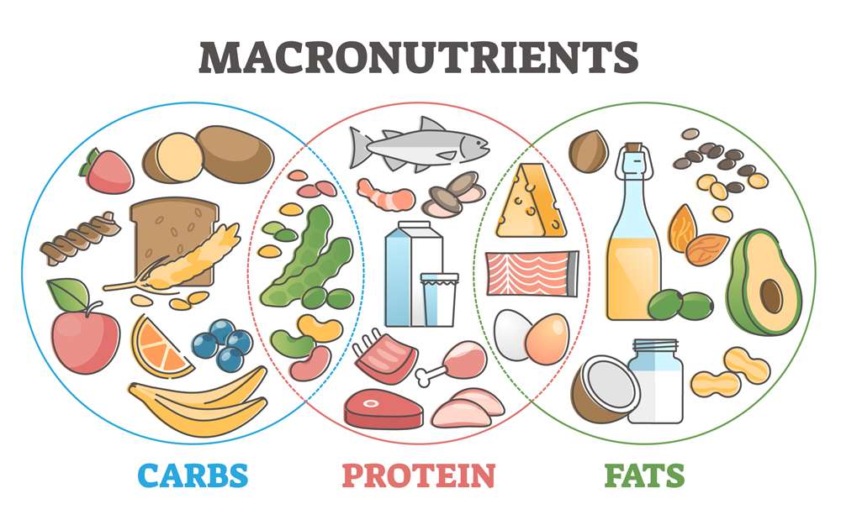
Get a Macro Meal Plan Designed for You By Nutritionist (bodybuildingmealplan.com)
Carbohydrates | Proteins | Fats
Energy: 4 calories / Gram | Energy: 4 calories / Gram | Energy: 9 calories / Gram
Function  Provide Energy  Facilitate Fat Metabolism  Prevent Protein Breakdown | Function  Provide Energy  Build and Repair Tissues  Provide Essential Amino Acids | Function  Provide Energy  Absorb Vitamins  Regulate Body Temperature  Provide Essential Fatty Acids
Recommended Intake  45-65 % of Total Calories | Recommended Intake  10 – 35 % of Total Calories | Recommended Intake  20-35 % of Total Calories
Complex Carb Sources  (Recommended)  Whole grains, Wheat, Flour, bran, Cereal, Oats, Quinoa,  Rice, Potatoes, Pasta  (Limit refined flour / grains)  Fibers:  (Recommended)  Fruits, vegetables  Simple Sugars  (Not recommended  - limit intake)  Sugar, Honey, Syrups, Fructose,  Refined flours and grains | Meat Sources  Beef, Fish, Poultry, shellfish, pork, eggs, duck, lamb.  Non-Meat Sources  Nuts, seeds, whole grains, quinoa, beans, legumes, tofu, tempeh  Yogurt, cheese, milk | Food Sources  Meats, Dairy, Cream,  Avocado, Coconut,  Oils (canola, olive, flaxseed, sunflower, peanut)  Deep fried foods  Butter, peanut butter  nuts, seeds, Egg yolks
Popular Macronutrient Recommendations
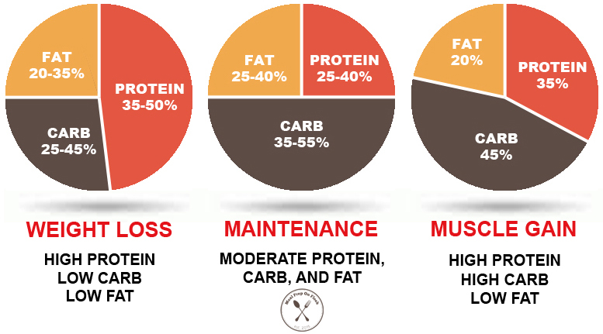
hMacros-diet-calculator-official2.jpg (777×431) (mealpreponfleek.com)

HELP! WHAT DO I EAT?

Nutrition information can be overwhelming, confusing, misleading and contradictory.
Food producers often preach misleading facts to sell their products.
Advertisers make you think that the food you are eating is healthy but in reality it is not even real food!
Reading food labels is the key to truly understanding what you are eating.

The Healthy Eating Plate created by the Harvard Chan School of Public Health (an excellent nutrition resource) is one example of a simple way of looking at meal planning.By following the guidelines and creating a healthy eating plate for each meal, you will be able to meet your daily nutirion requirements. A simple, yet very healthy way of balancing your food intake.

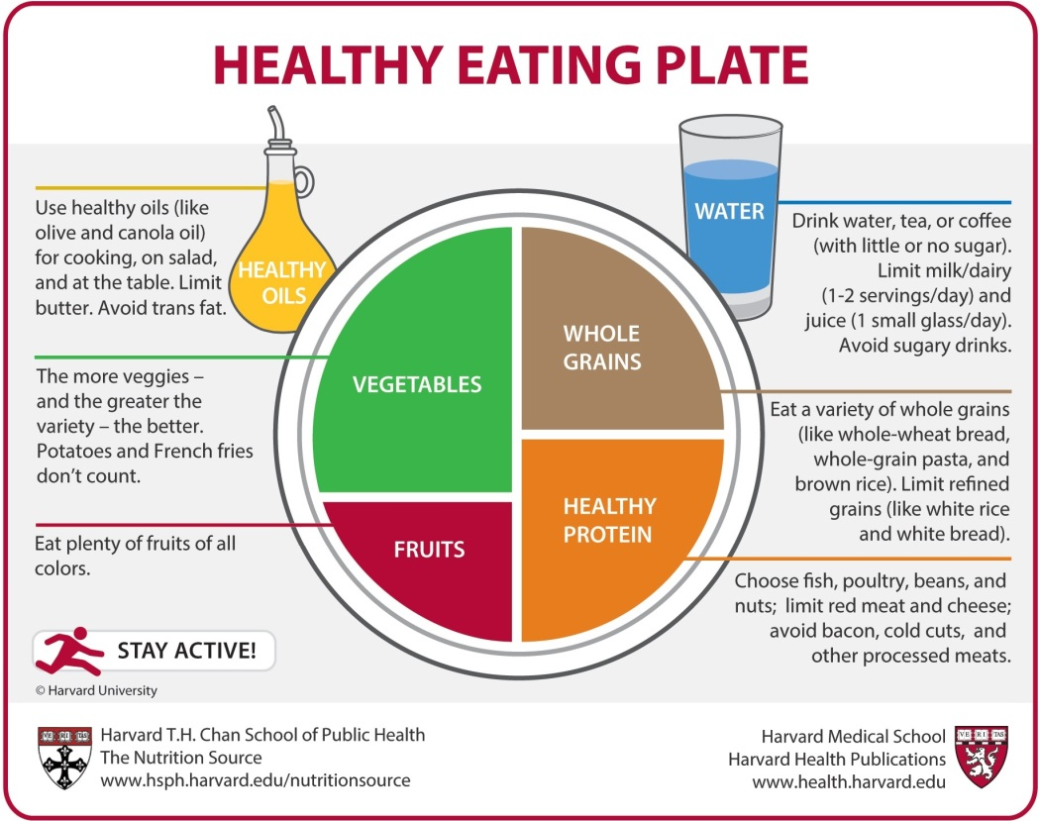

HEALTHY TIPS TO EAT BY:
Look at these tips to get ideas on ways to eat well every day. Try one of the tips each month over the next year and see what a difference a small change can make.
- Have breakfast every day. It may help control your hunger later in the day.
- Have a high-quality protein serving with each meal.
- Benefit from eating vegetables and fruit at all meals and as snacks.
- Use the Nutrition Facts table on food labels to find the amount of calories or nutrients in the stated amount of food. Choose products that contain less fat, saturated fat, trans fat, sugar and sodium (salt). Select products with more fibre.
- When eating out, order smaller portions or share with a friend. Request nutrition information about the menu items to help you make healthier choices.
- Enjoy eating with family and friends.
- Take time to eat and savour every bite.
- Spread your meals throughout the day to keep you energized and satisfied. Avoid skipping meals which may cause you to eat more than you need later in the day.
- Drink water to satisfy your thirst and limit your intake of high calorie sweetened beverages.
- Snack smartly.
Canada’s Food Guide 2019 – Things to think about before you bite!
- Eat a variety of healthy foods.
- Healthy eating should be a daily habit, a lifestyle not a short-term fad or diet.
- Eat vegetables and fruits, whole grain foods and protein foods often to ensure that you are getting the required nutrients and thus health.
- Try making half of your plate vegetables and fruits (colorful, variety of textures/shapes) with as many meals as you can each day.
- Choose protein foods that come from plants more often. Plant-based protein foods can provide more fiber and less saturated fat than other types of protein foods.
- Choose foods with healthy fats (nuts, avocadoes, salmon etc.) and limit saturated fats (fatty meat, high fat dairy, processed food) for a healthier you.
- Enjoy a variety of whole grain foods (quinoa, brown rice, whole wheat bread/pasta).
- Limit highly processed foods and drinks. Processed foods have added/excess sodium, sugars and/or saturated fat.
- Make water your drink of choice.
- Be mindful of your eating habits. Focus your attention on eating, where you are eating, why, with whom, how much, how you feel before during and after your meal.
- Cook more often / plan what you eat / involve others in planning and preparing meals.
- Planning what you eat makes it easier to cook more often.
- Make time to enjoy meals with others at home, school and/or work.
- Include cultures and food traditions as part of healthy eating.
- Use food labels to help you compare and choose products. Focus on grams of sugar, fibre, sodium and protein content.
- Be aware of marketing because it can influence your food choices. Low fat often means higher sugar. No cholesterol often means that there was never any cholesterol to begin with.

CHAPTER 7 –
BODY COMPOSITION + WEIGHT MANAGEMENT

FITT PRINCIPLE FOR BODY COMPOSITION (Muscle/Fat ratio)
KEY to Weight Management and a Healthier Body Composition
Body Composition /  Weight Management  Key=  Balance Energy In vs. Energy out | Do Cardio FITT  Goal=  Caloric Expenditure | Do Muscle FITT  Goals=  Caloric Expenditure  ↑ muscle mass  ↑ metabolism | Follow the Canada Food Guide for healthy eating.  Protein, grains, fruits and vegetables. Quality Food Portion control and control of caloric intake. | Daily Activity (30-60)  Follow an active lifestyle daily  = Increase in caloric expenditure

Body composition refers your body’s ratio of fat compared to muscle and bone. Our body weight is determined by our fat weight and lean body weight (muscles, bones, skin and blood). A person can be overweight and extremely fit due to a high lean body weight (muscle mass) just as a person can be of low body weight but unfit with high body fat levels. As a result, using body weight as the sole indicator of health is ineffective and inaccurate. A look into your body composition can give information in relation to your nutrition, activity and lifestyle needs and habits as well as your health status and risk for disease. It should be noted that Body Composition is only one component of physical health. As we have learned through the previous chapters it is also extremely important to consider overall health, blood pressure, resting heart rate, cardiovascular fitness, mental health, nutrition, muscle strength and endurance, hygiene and heredity.

Components of Lean Body Weight: Muscles, bones, skin, organs, water
Components of Body Fat Weight: Blood fat, adipose tissue (subcutaneous and visceral)

A recommended amount of body fat is necessary in order for our bodies to function properly. Too little or too much fat can cause various health risks.
Health risks associated with high body fat:
- High blood pressure, diabetes, heart disease, low back + joint problems.
Health risks associated with low body fat:
- Low blood pressure, malnutrition, low energy levels, stress on the heart, Amenorrhea
Health risks associated with low muscle mass:
- Muscle and joint injury, poor muscular strength endurance, low metabolism.

General Body Fat Guidelines for Males and Females
Group | Males | Females
Essential Fat | 2 - 5 % | 10 - 13 %
Elite Athlete (depends on sport) | 6 – 13 % | 14 – 20 %
Healthy | 10 – 15 % | 18 – 25%
Average Population | 16 – 24 % | 25 – 31 %
Obese (medical terminology) | > 25 % | > 32 %

Body Composition Analysis:

There are a variety of tests designed to determine a person’s body composition (% body fat / muscle mass) The most accurate tests are not available at home as they require specialized equipment and can be very expensive. These types of tests include: Hydrostatic (underwater) weighing, Dual-Energy X-Ray Absorptiometry, Bod Pod air displacement tests, Bioelectric Impedance testing (the home/gym versions are less accurate). Skinfold measurements can be administered by qualified personal trainers at low cost. This type of testing involves using calipers to measure skinfold thickness at various sites on the body (thighs, abdomen, upper back, triceps). The measurements are then used to estimate body fat percentage.

Body composition testing without specialized equipment is possible but not as accurate.

These tests use body measurements to estimate body fat percentage, fat distribution and body mass to give you some insight to your present body. You will be asked to complete a variety of these tests in the Chapter review homework and the Fitness Appraisal. Understanding the purpose of the tests can help you better understand your body composition and the validity of the test results.

One of the tests that you will be asked to do in your homework is the Body Mass Index test. The BMI test uses Body weight and height to determine health risk. This test is simple to use and has been widely used in the Fitness industry but has been subject to much controversy. Understanding the downfalls of the test can help us to understand how to effectively analyse body composition.

Some things to consider about the BMI Test:
- The BMI Test does not distinguish between bodyfat and fat-free mass.
- The BMI Test does not take Gender, Age, Ethnicity and Physical Characteristics into account.
- At the same BMI, females tend to have more body fat than males.
- At the same BMI, the amount of body fat may be higher or lower depending on the racial/ethnic group and gender.
- At the same BMI, older people, on average, tend to have more body fat than younger adults.
- The BMI does not take into the density of your bone mass.
- At the same BMI, athletes tend to have less body fat than do non-athletes.
- Students should be aware of the inaccuracy of just looking at body weight to determine health risk.

Body Mass Index = Weight (kg) ÷ Height (m)² BMI Calculator – use link if you are not on the chart.
NHLBI OBESITY EDUCATION INITIATIVE. NATIONAL INSTITUTES OF HEALTH, 1998.
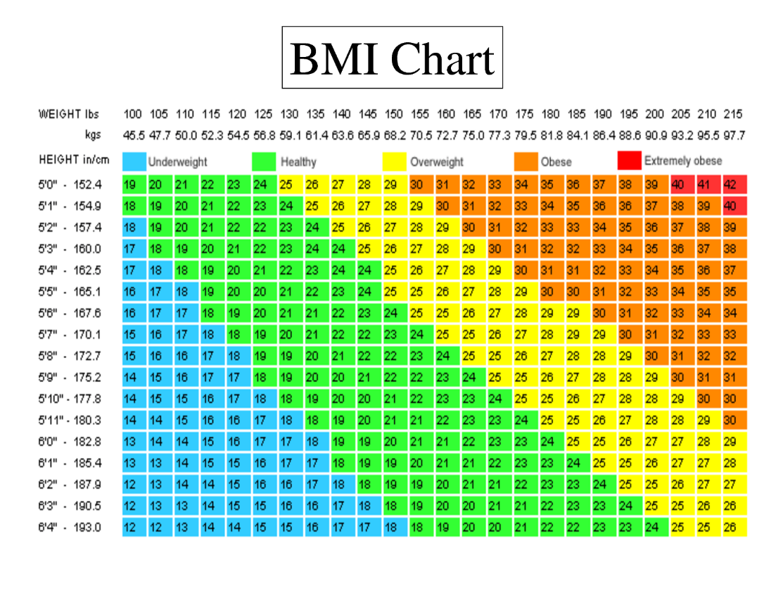
Less than 18.5  Underweight | 18.5 – 25  Healthy Weight | 26 - 30  Overweight /  possible risk | 31 - 40  High Risk | More than 40 Extremely High Risk
May be associated with health problems for some people.  It may be a good idea to consult a dietician and/or physician for advice. | This range is associated with the lowest risk of body composition related illness for most people.  This is the range you want to stay in – for life! | A BMI of over 25 due to high body fat levels, can be associated with health problems for some people.  Corresponds to 10 % over ideal body weight. | A BMI over 30 (30 lbs. or more overweight) due to high body fat levels especially with fat storage in the abdominal area is associated with increased risk of developing health problems such as heart disease, high blood pressure and diabetes. It is recommended to evaluate your present lifestyle and consult a dietician or physician for advice.

HIGH BMI - MUSCLE OR BODY FAT???
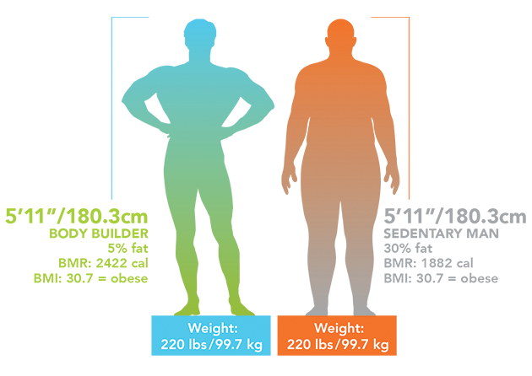

When analyzing Body Composition, it is important to consider that muscle mass, body fat distribution and metabolism may vary from person to person. There are many different body shapes and many different body types as all bodies are special and unique. One aspect of what makes them unique is their shape and how they carry weight and muscle. Regardless of body type and/or shape, health improvements can be made with regular physical activity and healthy nutrition. Regardless of your body type, achievements and improvements in strength, flexibility, and body composition can be achieved by following an exercise program, active living and healthy eating plan to reach their goals.

Somatotypes
Individuals genetic physical predisposition to a certain body shape, fat to muscle ratio and stature.
It is possible to be a mix of somatotypes as we are unique and come in all shapes and sizes
Ectomorph | Mesomorph |  | Endomorph
- Slight frame and bone structure  - Narrow shoulders  - Naturally lean  - Flat chest  - Fast metabolism  - Finds it difficult to gain weight  - Finds building muscle mass challenging | - Medium frame  - Athletic and toned body  - Muscle definition  - Generally rectangular-shaped body  - Strong  - Gains muscle easily |  | - Soft body with minimal natural muscle definition  - Tends towards a round body shape  - Prone to gaining fat  - Usually, have a larger bone structure  - Slower metabolism  - Finds it more difficult than the other body types to lose fat
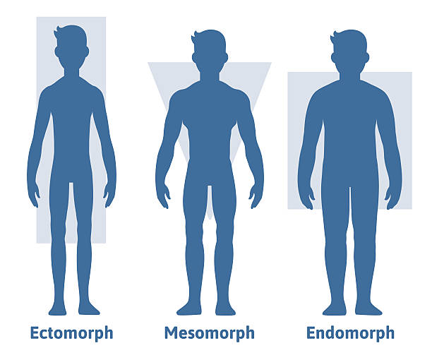 |  | 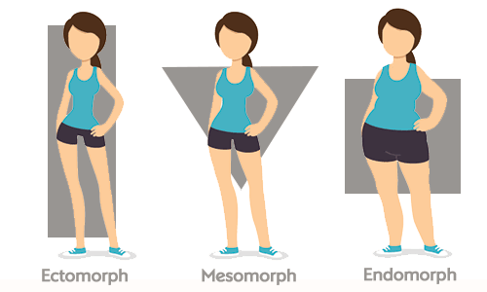

THE KEYS TO HEALTHY WEIGHT MANAGEMENT AND BODY COMPOSITION
For years we have focused on caloric balance to understand weight management. If caloric intake equals caloric expenditure then a person will not gain weight or that 3,500 calories equals one pound of weight. The latest research shows that the math may not be that simple. There are other factors that need to be considered as not everyone burns calories at the same rate. Two people can eat the same number of calories but not have the same result on the scale. This is due to how quickly each person is able to burns calories (metabolic rates), a persons’ set point body weight (the weight at which your hormones like you to be at) and the types of food that are eaten. The quality of the food that you eat can have a large impact on the number of calories consumed and metabolized. Studies have shown that individuals who intake larger quantities of processed foods and simple sugar will consume more calories and metabolize less calories than those who consume quality foods like fruits, vegetables, whole grains and quality protein.
Weight Management Top 10 Considerations
# 1 | Daily Activity: Accumulate a minimum of 30-60 minutes each day.  Walk – shovel – rake – vacuum – bike  Contributes to caloric expenditure, ↑ muscle mass, ↑ metabolism, stress management, disease prevention, ↑ energy, improved sleep and so many more benefits
# 2 | Do Cardiovascular Exercise - follow FITT guidelines  - 2-5 x / Week Cardio Exercise – 15-60 minutes – HR RANGE  - Contributes to caloric expenditure, ↑muscle mass (depending on the activity, ↑ metabolism  - Increases caloric expenditure and thus will help in the reduction of body fat.  - Increase daily metabolism (daily caloric expenditure).  - Aim to get at least 150 minutes of moderate-intensity exercise each week. Moderate intensity is like walking up a long hill.
# 3 | Weight Train - follow FITT guidelines  - 2 x / Week – Muscle Conditioning for All Major Muscle Groups  - Increases caloric expenditure and thus will help in the reduction of body fat.  - Increases muscle mass which can increase your metabolic rate.  - 1 pound of muscle can increase metabolism up to 50 calories / day  - Increase daily metabolism (daily caloric expenditure).
# 4. | Follow a well-balanced eating plan - Canada food Guide - My Plate.  - Caloric intake and nutrient intake have the greatest impact on weight management.  - Balance caloric intake and output.  - Practice portion control by following My Plate proportions as much as possible.  - Eat frequent smaller meals vs. less frequent large meals.  - Do not skip breakfast.  - Choose your food and drinks wisely. Avoid high calorie, low nutrient foods like sodas, candy, doughnuts etc…  - Eating processed foods and foods high in simple sugar seems to spur people to eat more calories compared with eating unprocessed foods.  - Focus on choosing unprocessed foods, including lean meats, whole grains, and lots of fruits and vegetables in their natural form.

# 5. | Lower Sugar Intake - (straight sugar, soda, syrup, glucose) as:  - They are empty Calories – High Calories – with little nutrient value  - Increase blood sugar which decreases insulin and leptin resistance.  - Insulin is released from pancreas to move sugar to where it should be stored (muscle, glycogen) if insulin does not work, sugar will be stored as fat.  - Leptin is a (hunger hormone) which makes us feel full – high sugar intake decreases leptin and this our appetite increases (we will crave more sugar!) High sugar intake has been found to cause more fat storage in the abdominal region.  Decrease refined Carbohydrates:  - White flour, pastries, cookies, cakes, minute rice are just some examples.  - High sugar intake – fast absorption which increases blood sugar levels
# 6 | Increase Quality Protein Consumption: Have a protein serving with each meal (20-30g / meal)  - Slows digestions – regulates blood sugar – regulates hunger hormones – helps you feel full after eating  Quality Protein =  Legumes (lentils, peas, beans), Nuts and seeds, whole grain (kamut, wheat, oats, quinoa, rice),  Poultry (chicken, turkey, duck), Seafood (fish, crustaceans), Red meat (limit consumption)  Poor quality Protein =  Processed meats which have been salted, cured, smoked, fermented to improve preservation.
# 7 | Increase Fiber Intake:  - Fruits, vegetables, whole grains, seeds = high in fiber  - Refined grains, juice, sugar = low in fiber  - Higher fiber intake allows for slower absorption of nutrients which helps regulates blood sugar levels.  - High fiber foods have a high nutrient value  - Increases fullness to prevent overeating
# 8 | Decrease processed foods as much as possible and eat fresh – whole foods as much as possible:  Processed foods have:  - Higher sugar intake – raises blood sugar levels  - Higher fat content = higher calories  - High salt intake = water retention and increases blood pressure
# 9 | Eat frequent small meals and (avoid missing meals)  Regulates blood sugar levels  Prevents overeating  Keeps metabolism steady
# 10 | Drink Water when Thirsty  No calories and quenches thirst.  Avoids consuming excess calories from sugar drinks.  Helps regulate hunger which aids in controlling caloric intake.
Respect your Body type and Health
Mesomorph – Endomorph – Ectomorph
Focus on Fitness not Fatness
Value Fitness and Health over Body Weight and Appearance

Weight Management Program Considerations

- A moderate reduction in food intake (decreasing caloric intake by 300-500 calories per day) combined with increased physical activity (increased caloric expenditure) is the most effective means of permanent weight management, fitness and health.

- The bottom line for weight control and weight loss is that there must be a negative balance between caloric intake and caloric expenditure. Again, the most successful weight loss and weight gain methods for that matter come from a combination of calorie intake and caloric expenditure.

- A common guideline is that to lose one-pound of fat, one needs to expend approximately 3500 calories more than consumed. This can only be used as a general guideline as studies have shown that people who are leaner (more muscle mass) who are close to their ideal weight will lose weight at a slower rate (say .5 pounds at a 3500-calorie deficit) and that people with higher fat levels will lose weight at a faster rate (say 2-3 pounds at a 3500-calorie deficit). The rapid weight loss often experienced by obese people is caused by the initial loss of water weight. As their body stabilizes the rate of weight loss will decrease.

- Trying to lose weight too quickly is not recommended. A weight loss of 1-2 pounds per week is the general recommendation for successful weight management. Trying to lose more than 1-2 pounds per week will result in loss of muscle mass and not fat weight. Losing muscle mass will cause a decrease in metabolism and this is an undesired effect of weight loss programs.

- A balanced diet with adequate protein is also important in weight management to prevent muscle loss.

- Low carbohydrate diets often result in rapid weight loss due to water loss.

- Muscle weighs more than fat for the same volume. In effect, some individuals may find that they do not lose weight in the initial stages of their exercise program. It is important to remember that the fit of your clothes and body composition rather than their weight on the scale is a better indicator of fat loss.

When designing fat-loss programs, caloric intake should never go below 1000 calories because:

- One must have adequate food intake to meet the minimum nutritional requirements in order to maintain regular bodily functions and overall health.
- Trying to exercise without adequate caloric can cause fatigue, dizziness, nausea and lethargy.
- Weight loss in dieting is often lost in the form of water. When the diet is over, the weight is quickly regained
- Sustained reduction of calories causes the body to lower its BMR, thus making it harder to lose weight/fat over time.

The following examples will illustrate how exercising at a low or high intensity burns calories:

How the Body Burns Energy / Calories

Example 1
Exercise Time | 45 minutes
Exercise Intensity | 50 % of maximum capacity / maximum heart rate
% of calories from fat | 50 %
Calories Expended / minute | Approximately 8 calories per minute
Total Calories Expended | 45 minutes x 8 cal/min = 360 calories
Fat Calories | 50 % x 360 = 180 fat calories
Grams of Fat | 180 fat calories / 9 calories per gram = 20 g of fat
Example 2
Exercise Time | 45 minutes
Exercise Intensity | 70 % of maximum capacity / maximum heart rate
% of calories from fat | 40 %
Calories Expended / minute | Approximately 11 calories per minute
Total Calories Expended | 45 min x 11 cal/min = 495 calories
Fat Calories | 40 % x 495 calories = 198 fat calories
Grams of Fat | 198 fat calories / 9 calories per gram = 22 g of fat

CALORIES BURNED PER MINUTE OF EXERCISE
Activity | Body Weight in Pounds
Sedentary Activities | 100 | 110 | 120 | 130 | 140 | 150 | 160 | 170 | 180 | 190 | 200 | 210
Lying | .99 | 1.1 | 1.2 | 1.3 | 1.4 | 1.5 | 1.6 | 1.7 | 1.8 | 1.9 | 2.0 | 2.1
Sitting | 1.2 | 1.4 | 1.5 | 1.7 | 1.8 | 1.9 | 2.0 | 2.2 | 2.3 | 2.4 | 2.5 | 2.7
Standing light work | 2.7 | 3.0 | 3.3 | 3.5 | 3.8 | 4.1 | 4.4 | 4.6 | 4.9 | 5.2 | 5.4 | 5.7
Physical Activities
Aerobic Dance | 6.0 | 6.7 | 7.3 | 7.9 | 8.5 | 9.1 | 9.7 | 10.3 | 10.9 | 11.5 | 12.1 | 12.6
Badminton | 3.6 | 4.0 | 4.4 | 4.7 | 5.1 | 5.4 | 5.8 | 6.2 | 6.6 | 6.9 | 7.3 | 7.6
Basketball | 4.9 | 5.5 | 6.0 | 6.5 | 7.0 | 7.5 | 8.0 | 8.5 | 9.0 | 9.5 | 10.0 | 10.5
Bicycling 10 mph | 4.2 | 4.6 | 5.1 | 5.5 | 5.9 | 6.4 | 6.8 | 7.2 | 7.6 | 8.1 | 8.5 | 8.9
Bicycling 15 mph | 7.3 | 8.0 | 8.7 | 9.5 | 10.0 | 10.9 | 11.6 | 12.4 | 13.1 | 13.8 | 14.5 | 15.3
Bicycling 20 mph | 10.7 | 11.7 | 12.8 | 13.9 | 14.9 | 16.0 | 17.1 | 18.1 | 19.2 | 20.3 | 21.3 | 22.4
Jogging 12 min. mile | 6.0 | 6.6 | 7.3 | 7.9 | 8.5 | 9.1 | 9.7 | 10.3 | 10.9 | 11.6 | 12.2 | 12.8
Jogging 10 min. mile | 7.2 | 8.0 | 8.7 | 9.5 | 10.2 | 10.9 | 11.7 | 12.4 | 13.1 | 13.8 | 14.6 | 15.4
Jogging 7.5 min. mile | 9.7 | 10.7 | 11.6 | 12.6 | 13.6 | 14.6 | 15.6 | 16.6 | 17.6 | 18.5 | 19.5 | 20.5
Jogging 6 min. mile | 12.1 | 13.3 | 14.5 | 15.7 | 17.0 | 18.2 | 19.4 | 20.7 | 21.9 | 23.1 | 24.2 | 25.4
Squash (normal) | 6.7 | 7.3 | 8.0 | 8.7 | 9.5 | 10.1 | 10.8 | 11.5 | 12.2 | 12.9 | 13.5 | 14.2
Walking 20 min. mile | 2.7 | 3.0 | 3.3 | 3.5 | 3.8 | 4.1 | 4.4 | 4.6 | 4.9 | 5.2 | 5.4 | 5.7
Walking 15 min. mile | 4.2 | 4.6 | 5.1 | 5.5 | 5.9 | 6.4 | 6.8 | 7.2 | 7.6 | 8.1 | 8.5 | 8.9
Walking 12 min. mile | 5.4 | 6.0 | 6.5 | 7.1 | 7.7 | 8.2 | 8.7 | 9.2 | 9.8 | 10.4 | 10.9 | 11.5
Weight Training | 5.2 | 5.7 | 6.2 | 6.8 | 7.3 | 7.8 | 9.3 | 8.9 | 9.4 | 9.9 | 10.5 | 11.0
Adapted from: Williams, Melvin H. Lifetime Fitness & Wellness, (1996).
Madison, WI: Brown & Benchmark Publishers, p. 331-337 of 368 pages.
Energy Balance Scales

If, Energy in = Energy out = weight maintenance
When energy intake = energy output body weight should remain stable.
But be careful!!!!
If you simply restrict your caloric intake, your metabolic rate will drop and you will end up burning less calories.
It is ok to decrease caloric intake, but not too such an excessive amount that it will affect your metabolic rate. Which is why there are maximum weight loss recommendations of 1-2 lbs / week.
If, Energy in < Energy out = weight loss
In order to lose weight, energy intake must be less than energy output. (Negative energy balance).
One pound of fat = 3500 calories
To lose weight we need to eat fewer calories and increase daily activity to burn more calories.
If the energy balance equation is upset by 500 calories per day, 1 pound can be lost in one week.
200 calories less in food and 300 calories more in daily energy expenditure will attain this goal.
This is a realistic and healthy weight loss regiment.
If, Energy in > Energy out = weight gain
In order to gain weight, energy output must be less than energy input. (Positive energy balance).
This can and should be achieved by following a well-balanced eating plan. Start by increasing the number of servings from the various foods and try to maintain the same balance or proportions from fat, carbohydrates and protein.

Energy In = Caloric Intake

- A calorie is defined as “an energy-producing unit of food”.
- Age, sex, body size, body composition, climate, physical condition (pregnancy, illness, fitness level etc.) and the body’s metabolism all influence the number of calories that a person uses and requires to meet daily function requirements.

Food intake is measured in calories:

- 1 gram of carbohydrate provides 4 calories of energy (sugar, fruit, vegetable, grains, starch)
- 1 gram of protein provides 4 calories of energy (meat, fish, nuts, legumes, dairy)
- 1 gram of fat provides 9 calories of energy (oils, nuts, meats, dairy)
- 1 gram of alcohol 7 calories of energy (beer, wine, liquor)

Energy Out = Exercise or Caloric Expenditure

The principle factors of caloric expenditure are:
- Basal Metabolic Rate (BMR)
- Physical Activity - exercise and daily activity
Five Kinds of Energy Balance

Energy balance is the essential principle of fitness and weight management

ENERGY IN | ENERGY OUT | REMARKS
Low | Low | Low End Energy Balance
 |  | - No weight gain over time.
 |  | - People in this category are often mistakenly assumed to be
fit because they look thin, but their daily energy
expenditure is really too low to keep them in shape.
 |  | - Body fat percentage may still be high.
Higher | Low | Higher, Low - The Typical Situation for Many Adults
 |  | - The sedentary lifestyle produces a low level of fitness.
 |  | - Consistent energy-in surplus leads to a slow, but steady
 |  | weight gain over the years. A daily energy surplus of 100 calories
 |  | (less than a slice of bread) can lead to a weight gain of
 |  | about 0.75 kg over a year or 15 kg over 20 years.
Lower | Low | The Typical Dieter’s Profile
 |  | - Metabolism decreases so weight loss is not proportional to decreased caloric intake.
 |  | - May lead to a rapid initial weight loss, but weight loss is from water and protein, not of fat.
 |  | - Weight loss tends not to be permanent in the vast majority of cases.
 |  | - Energy output is too low to increase fitness levels.
 |  | - Overall energy levels decrease.
 |  | - Food consumption may be nutritionally adequate.
Moderate | High | The Ideal Approach to Gradual and Permanent Weight Loss
 |  | - Caloric deficit created by increasing energy out and moderately decreasing energy in.
 |  | - Metabolic rate remains high, so caloric deficit pays off in proportional weight loss.
 |  | - Weight loss results from burning of excess fat.
 |  | - Overall energy remains high and fitness improves.
 |  | - Food intake does not fall below healthy levels.
High | High | High End Energy Balance
 |  | - High daily energy “throughout” - i.e. high levels of consumption and caloric expenditure.
 |  | - The ideal form of energy balance for fitness and weight control.
 |  | - High End balance point is relative to individual lifestyle. In peak training, an endurance athlete may have a balance point as high as 6000 cal/day. The average fit person, the balance point ranges from 2500 cal - 4000 cal / day.
BASAL METABOLISM (BMR) – calories expended each day

Your Basal Metabolic Rate (BMR) is the number of calories that your body will burn each day to perform regular daily bodily functions like breathing, digesting, removing waste, repairing cells, thinking, and moving. It is the total number of calories that your body expends to perform the necessary bodily functions while you are at rest.

Metabolism is affected by a number of factors including:

1. Body Composition:
- The more lean body weight / muscle mass you have, the more calories you will burn at rest.
- Weight training is the most effective method for increasing muscle tissue or lean body weight. This increase in lean body weight produces an increase in the basal metabolic rate (BMR). Studies have shown that sedentary individuals lose on average 7 % of muscle tissue each decade after the age of 20. Individuals who participate in regular aerobic exercise, but not weight training lose on average 5% of muscle tissue every decade. Individuals who participate in regular weight training activity lose very little if any muscle tissue depending on the training program. The loss of muscle tissue represents a loss in lean body weight, and a decrease in metabolism. Unfortunately, the loss of muscle tissue is accompanied by a maintenance or increase in total body weight which is the result of an increase in body fat. (Wayne Wescott, CAIN Conference, Oct. 1994)

2. Age:
- As we age, our BMR drops approximately 2 % per decade after the age of 20.

3. Gender:
- Women’s BMR is usually 10 % lower than men’s due to a higher % of body fat at the same body weight.
- Healthy body fat % for females is 18-25 % of total body weight.
- Healthy body fat % for males is 10 - 15 % of total body weight.

4. Energy Intake:
- A decreased energy intake can result in your body compensating for the loss of calories by lowering its metabolic rate.
- The body becomes more efficient at performing its bodily functions with less fuel.
- Low calorie diets can thus lead to a decrease in metabolism.

- Physical Activity
- Daily physical activity has the most significant effect on caloric expenditure.
- Increasing daily activity levels can be as simple as taking the stairs at work, walking to the store, doing housework, or a 30-minute Stairmaster workout.
- Physical activity can raise your BMR - i.e. you will burn more calories while sleeping if you have exercised that day.

CHAPTER 8 - STRESS

“Stress is a physiological and psychological response to a change in our environment that may have a positive or negative affect on us. It is our reaction to the stressor that determines the amount of impact. Many of us in our daily activities deal with one form of stress or another. Positive stress or something that presents an opportunity for personal growth is called eustress. Distress, or negative stress, causes strain and can have a harmful effect.”

“Studies suggest that 10 to 15 % of Canadian adults may be functioning at less than optimal levels because of stress-related anxiety and depression.”

Adapted from: Powers, Scott K., Dodd, Stephen L., Thompson, Angela M., Condon, Camie C. (2006). Total Fitness and Wellness, Canadian Edition. Toronto: Pearson Education Canadap.228 of 400

Eustress: Positive stress, or stress that is physically or mentally stimulating.

Distress: Negative stress, or stress that contributes to health problems.

For some people stress is what keeps them motivated, happy and strong but for others, stress may be a ticket to illness and even death. Stress can destroy a person’s psychological and physical health and well-being. Ideally, the stresses in our lives should be great enough to stimulate our ability to grow and cope but not great enough to interfere with our health. Many researchers in the medical and psychological profession believe that stress may be the greatest single contributor to illness and disease.

There are many stressors that we are all presented with as we go through life. School, timelines, work, relationships, financial problems, bills, illness, divorce, accidents, natural disasters and the list goes on and on. Some of them are just a part of life, some of them are caused by the choices that we make and some of them our completely out of our control. How we cope and deal with the stressors in our lives will determine the impact that they will have on our physical and psychological health.

Health concerns and symptoms associated with Distress:

- Stress has been found to increase blood pressure levels.
- Stress has been found to increase the risks of having a heart attack or stroke.
- The powerful chemicals released into the blood stream in reaction to stress can suppress the immune system and leave the body more susceptible to disease and infections such as colds and flu.
- Stress and ineffective coping of stress can lead to various stomach irritations such as diarrhea, stomach-aches, bloating, constipation and irritable bowel syndrome.
- Stress may be the culprit of headaches and other common physical complaints such as insomnia, back and/or neck-aches.
- Stress may be the cause of various skin problems such as acne, herpes (cold sores) and eczema.
- Stress may cause and/or aggravate certain mental, emotional and behavioural symptoms such as anxiety, depression, anger, hostility, burnout and teeth grinding.
- Stress may cause a change in eating behaviours, overeating, undereating, digestion issues.

PERSONALITY - Type A + Type B or Type AB

Two general categories of personality and behaviour have been identified as Type A and Type B. Those with type A personality have a greater risk of suffering from heart disease and other health conditions.

- Type A's are hardworking, aggressive, competitive, perfectionists who never seem to be satisfied with their accomplishments. They often take on many tasks at one time, may be workaholics, have difficulty relaxing and are sometimes, in the worst cases, cynical, distrustful, hostile and angry. The more Type A you are, the higher risk you have of suffering from blockages of the coronary arteries.

- Type B's on the other hand are more relaxed and easier going, yet not necessarily less ambitious.
- They are able to leave their work at the office, have good temper control.
- Being an excessive Type B personality would be characterised as being indecisive, having difficulty following through with tasks, procrastinators - this can become a stress for the friends and family!

- A combination of Type A and Type B behaviour is the best way to be.
STRESS MANAGEMENT

It’s not the stress that kills us, it’s our reaction to it. – Hans Seyle

The major issue and concern is our ability to cope with the stresses in our lives in order to minimise the distress and its negative impacts on health and well-being. This whole issue is referred to as stress management. Many fitness and health professionals have effectively incorporated stress management education and strategies in the hopes of developing complete wellness in their lifestyle programs. The first steps to stress management are to develop coping strategies that make you stress resistant. Various strategies have been developed and may be effective depending on the individual. Such strategies include relaxation exercises, meditation, visualisation and imagery, developing healthy eating habits, regular physical activity, time management, goal setting, commitment identification and whatever else works for you.

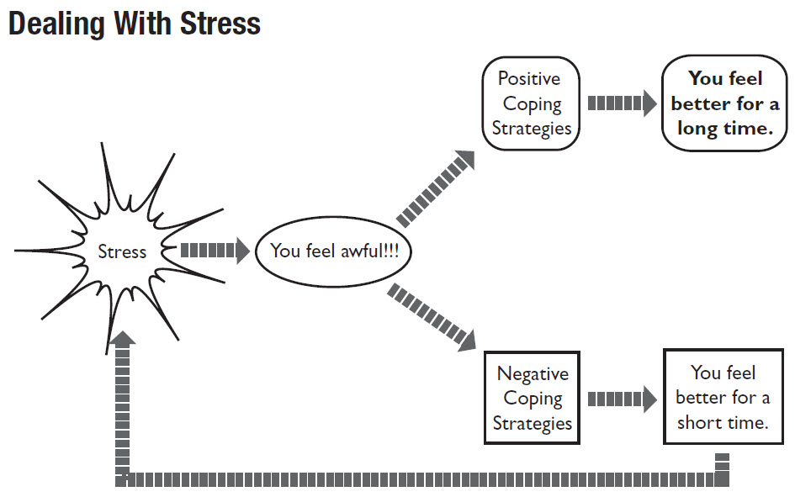 | Some Positive Coping Strategies  Exercise – Nature – Music – Meditation – Expressing – Friends/Family – Journal – Decision making / Goal Setting – Reading – Spa – Yoga – Laughter – Cooking – time management – organization – Animals – Art ….
Some Negative Coping Strategies

Smoking – Alcohol – self-isolation – anger - violence – addictions – gambling – workaholic – binge eating – starvation –video games – promiscuity – self-harm …

TIME-MANAGEMENT + ORGANIZATION GUIDELINES
Use the following guidelines to improve your time management skills and increase your productivity.
Establish goals: Establish a list of goals that you hope to accomplish. Identify your immediate and long-term goals according to priority. By establishing and prioritizing goals, you can focus your efforts on those projects that are most important to you.

Use a daily planner: Plan your day using a daily planner. Chart your schedule hour by hour, and prioritize your most important goals.

Evaluate your time-management skills regularly: At the end of your day, take 5-10 minutes to evaluate your time management. Note times wasted and make plans to correct these mistakes for the following day.

Learn to say no to activities that prevent you from achieving your goals. Before you accept a new responsibility, complete your current task or eliminate an unnecessary project. Although saying no is often difficult, it is critical to manage your time well.

Delegate responsibility: Most of us like to feel in control, and this makes delegation of responsibilities to others difficult. Nonetheless, if you become overloaded when working on a group project don’t be afraid to ask for help. Delegating responsibility to others is an easy way to reduce your workload and stress.

Eliminate distractions: Interruptions and distractions can steal precious time from your day. Identify those factors that distract you and eliminate them if possible. (phone, people, gadgets, food, tv.)

Schedule time for you: Find time each day to relax and do something you enjoy. Remember that taking an occasional break from your work is not wasting time and will improve your overall productivity by helping to energize yourself.

Reward yourself when you complete a goal: One of the simple pleasures in life is to reward yourself after you complete a goal. The reward can come in many forms: a new pair of shoes, a movie, a few days of relaxation, and so on. The importance of rewarding yourself cannot be overemphasized. People perform better when rewarded for a job well done, and a reward is an excellent means of providing encouragement (even for yourself) for future good work.

Source: Powers, Scott K., Dodd, Stephen L., Thompson, Angela M., Condon, Camie C. (2006). Total Fitness and Wellness, Canadian Edition. Toronto: Pearson Education Canada, p. 232 of 400
STRESS MANAGEMENT TECHNIQUES FOR YOU TO TRY

TECHNIQUE 1: BREATHING EXERCISES

Yoga Breathing Procedures: Source: Andrew Weil, M.D, Natural Health - Natural Medicine

- Sit with your back straight - once you master the technique you can do it any position. Press the tip of your tongue on your palate just above the backs of your two front teeth and keep it there throughout the breathing.

- Exhale completely through your mouth, making a whoosh sound.
- Close your mouth and inhale quietly through your nose to a count of four.
- Hold your breath for a count of seven.
- Exhale completely through your mouth, making a whoosh sound to a count of eight.
- Repeat 2, 3, and 4 again for a total of 4 breaths.

Try it! - TECHNIQUE 1: Breathing Exercises

- Did you find the breathing exercises effective? Yes ____ No _____

- Explain how you felt during the breathing exercises?

- Do you think you would find the breathing exercises useful as a part of your daily routine as a quick fix for stress? Yes _____ No ______ Explain why or why not.

TECHNIQUE 2: RELAXATION EXERCISES

- Neck Stretch: Roll the head slowly in a half circle to the front. Tilt your head to the right side (ear to shoulder) then slowly bring your chin to your chest by tilting chin down and slowly roll head to the other side and back up to the middle. Do not make a full circle by tilting the head back. Repeat starting on the left side. Repeat several times.

- Shoulder Lift: Hunch the shoulders as high as possible (contract) and then let them drop (relax). Repeat several times. Inhale on the lift; exhale on the drop.

- Trunk stretch and drop: Stand and reach as high as possible; tiptoe and stretch every muscle; then collapse completely, letting the knees flex and trunk head and arms dangle. Repeat 2-3 times. Inhale on the stretch and exhale on the collapse.

- Tension Contrast: With arms extended overhead, lie on your side. Tense the body as stiff as a board, then let go, and relax, letting the body fall either forward or backward in whatever direction it loses balance. Continue letting go for a few seconds after falling and allow yourself to feel like you are sinking. Repeat on the other side.

Try it! -TECHNIQUE 2: Relaxation Exercises

- Did you find the relaxation exercises effective? Yes ____ No _____

- Explain how you felt during the relaxation / stretching exercises:

- Do you think you would find the relaxation exercises useful as a part of your daily routine as a quick fix for stress? Yes _____ No ______ Explain why or why not.

TECHNIQUE 3: CONTRACT / RELAX EXERCISE ROUTINE

- Sit in a chair or lie on your back in a quiet, non-distracting atmosphere while you are learning this relaxation technique. (Later you will want to be able to use this technique in public, everyday situations, while you are at school, writing an exam, at work, or any time you are under stress.)
- Do the contract/relax exercise routine as described below. Contract the muscles to a moderate level of tension (do not use maximum contractions) as you inhale for 5 - 10 seconds. Study where you are feeling the tension. Try to keep the tension isolated to the designated muscle group without allowing it to spill over other muscles. Use the dominant side if the body first and then do the other side.
- Next, release the tension completely, instantly relaxing the muscles and exhale. Extend the feeling of relaxation throughout your muscles for 20 - 30 seconds before contracting again. Think of relaxing expressions like warm, calm, and peaceful.
- If time permits, you should practice each muscle group 2 - 5 times (until tension is gone) before going on the next group.

Contract-Relax Exercises - from fingers to toes
- Hand and Forearm - Contract your right hand, making a fist; hold 3 counts; relax and keep letting go 6 - 10 counts. Repeat on right, then do left fist, then do both fists.
- Biceps - Flex both elbows and contract your biceps; hold 3 counts; relax and continue relaxing for 6 - 10 counts. Repeat.
- Triceps - Same as biceps except extend both elbows and contract the triceps on the back of the upper arm. Repeat.
- Relax arms, forearms and hands.
- Forehead - Raise your eyebrows and wrinkle your forehead; hold 3 counts; relax and continue relaxing for 6 - 10 counts.
- Cheeks and nose - make a face; wrinkle your nose and squint; hold 3 counts; relax and continue relaxing for 6 - 10 counts.
- Jaws - Clench your teeth 3 counts; relax for 6 - 10 counts.
- Lips and tongue - With teeth apart, press lips together and press tongue to the roof of your mouth; hold 3 counts; relax and continue relaxing for 6 - 10 counts.
- Neck and Throat - Push head backward (against hands, chair or floor - depending on your position) while tucking chin into your chest; hold 3 counts; relax for 6 - 10 counts.
- Relax forehead, cheeks, nose, jaws, lips, tongue, neck and throat. Relax hands, forearms, and upper arms.
- Shoulders and upper back - Hunch shoulders to ears; hold 3 counts; relax 6 - 10 counts.
- Relax lips, tongue, neck, throat, shoulders and upper back.
- Abdomen - Suck in abdomen; hold 3 counts; relax 6 - 10 counts.
- Lower back - Contract and slightly arch the back; hold 3 counts; relax 6 - 10 counts.
- Thighs and buttocks - Squeeze your buttocks together and push your heels to the floor (if lying) or against the chair rungs (if sitting); hold 3 counts; relax 6 - 10 counts.
- Relax shoulders and upper back, abdomen, lower back, thighs and buttocks.
- Calves - Pull toes up towards the shins; hold 3 counts; relax 6 - 10 counts.
- Toes - Curl toes; hold 3 counts; relax 6 - 10 counts.
- Relax every muscle in your body.

TECHNIQUE 3: Contract - Relax Exercises

- Did you find the contract-relax exercises relaxing? Yes ____ No _____

- Explain how you felt during the contract-relax exercises:

- Do you think you would find them useful as a part of your daily routine as a quick fix for stress? Yes _____ No ______ Explain why or why not.

- Identify situations is your life when you are stressed and when either of the above relaxation techniques could help you to de-stress. Explain why you are stressed.
CHAPTER 9
Vanier Fitness Appraisal

Evaluation Forms will be sent to you by your teacher

NB: The normative values of the Vanier Fitness Appraisal tests are based on results collected from various gender-based focus groups which may not always accurately evaluate your personal level of fitness. All of the tests can be modified to meet individual needs and comfort levels.

Students are provided with a fun group activity that will allow them to analyze all of the components of fitness. The Appraisal is meant to be an educational tool for students to learn about the various components of fitness and to allow for personal reflection.
The results of the appraisal are for personal awareness and students are not graded on their performance.
Students are graded on their participation in the appraisal and their understanding of the material via written assignment for each of the different course levels. (101 LIA, 102, 103).
Students should therefore focus on the overall learning objectives and not the ratings since the test scores are meant to be used as a motivational tool for health and fitness improvement. Students will be able to assess their level of fitness and any changes that occur both positive and negative during their time at Vanier.

In some classes, pre and post testing is done so that students can practice goal setting and monitor their fitness improvements throughout a semester. This tool is primarily used in 102 and 103 classes where students will be tested at the beginning and then again at the end of the semester. After the initial testing students will be able to set personal fitness goals and work on improving their fitness level, they will then have the opportunity to redo the tests and hopefully enjoy seeing improved results.

The selection of the tests used for the Vanier Appraisal is based on the following considerations:
- ease for group testing.
- accurate representation norms for the average CEGEP population.
- ease in which the exercises can be practiced at home and thus used as a goal setting improvement experiment.

VIDEO LINK:
Watch the Video to learn about the Vanier Fitness Appraisal
How to information / test explanations / exercise and health tips:
NB: Not all tests are explained in the video so please refer to the instructions in the manual.
https://www.youtube.com/watch?v=Zo_zwT_cfiU

Blood Pressure 

All adults should have their Blood Pressure measured every year.
Blood Pressure will be taken at your Dr. visits.
Blood Pressure readers are also available at the Pharmacy.
High Blood Pressure is often referred to as the silent killer because there are no signs and symptoms of the disease. Blood pressure refers to the amount of pressure on the arteries while the heart is contracting. Blood pressure readings are represented as systolic/diastolic pressure. Systolic pressure refers to the force exerted on the walls of the arteries by the blood when the heart contracts. Diastolic pressure refers to the force exerted on the walls of the arteries by the blood between contractions, when the heart relaxes, dilates and fills with blood.

 | BLOOD PRESSURE  VERBAL RATING
Blood Pressure Category | Systolic mm Hg  (upper Number) | Systolic / Diastolic | Diastolic mm Hg  (Lower number)
Normal | Less than 120 | and | Less than 80
Elevated | 120 – 129 | and | Less than 80
High Blood Pressure  (hypertension) stage 1 | 130 – 139 | and | 80- 89
High Blood Pressure  (hypertension) stage 2 | 140 or Higher | or | 90 or Higher
Hypertensive crisis  (consult your dr. Immediately) | Higher than 180 | And / or | Higher than 120

Monitoring and controlling Blood Pressure is an important step in the prevention of cardiovascular disease. Daily physical activity, following a regular exercise program, not smoking, healthy eating habits and stress management all play an important role in heart health.
For information on Blood Pressure visit the following site for various lifestyle, exercise and nutrition recommendations.
High blood pressure | Heart and Stroke Foundation
Resting Heart Rate / Pre-Exercise Heart Rate

Resting heart rate should be taken and recorded before the test.

- Take heart rate first thing in the morning before getting out of bed for 30 seconds x 2.
- Take your heart rate at the radial or carotid pulse sites.
- Use the norm table for ratings.

- At the time of the Appraisal you will also be asked to take your pre-exercise heart rate. This is so can evaluate the difference between your resting HR and factors that can increase heart rate during the day.

- A desirable RHR is between 60-70 beats/min.
- Monitoring Resting Heart rate as with blood pressure and cholesterol levels can help identify possible cardiovascular health risks.
- High resting heart readings of > 80 bpm have been linked to high blood pressure, high body weight, and higher levels of blood fat and increased risks of premature death.
- A lower resting heart rate can be associated with a higher level of physical fitness and lower risk of heart attack.
- Low RHR can also be due to aging electrical nodes of the heart may cause occasional dizziness or fatigue.

Resting Heart Rate Verbal Rating |  |  | 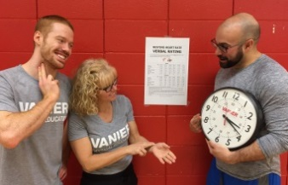
Males
Age | 18-25 | 26-35 |  | 36-45 | 46-55 | 56-65 | 65 +
Athlete | 49-55 | 49-54 |  | 50-56 | 50-57 | 51-56 | 50-55
Excellent | 56-61 | 55-61 |  | 57-62 | 58-63 | 57-61 | 56-61
Good | 62-65 | 62-65 |  | 63-66 | 64-67 | 62-67 | 62-65
Above Average | 66-69 | 66-70 |  | 67-70 | 68-71 | 68-71 | 66-69
Average | 70-73 | 71-74 |  | 71-75 | 72-76 | 72-75 | 70-73
Below Average | 74-81 | 75-81 |  | 76-82 | 77-83 | 76-81 | 74-79
Poor | 82 + | 82 + |  | 83 + | 84 + | 82 + | 80 +
Females
Age | 18-25 | 26-35 |  | 36-45 | 46-55 | 56-65 | 65 +
Athlete | 49-55 | 54-59 |  | 54-59 | 54-60 | 54-59 | 54-59
Excellent | 56-61 | 60-64 |  | 60-64 | 61-65 | 60-64 | 60-64
Good | 62-65 | 65-68 |  | 65-69 | 66-69 | 65-68 | 65-68
Above Average | 66-69 | 69-72 |  | 70-73 | 70-73 | 69-73 | 69-72
Average | 70-73 | 73-76 |  | 74-78 | 74-77 | 74-77 | 73-76
Below Average | 74-81 | 77-82 |  | 79-84 | 78-83 | 78-83 | 77-83
Poor | 82 + | 83 + |  | 85 + | 84 + | 84 + | 84 +
Source: Healthy Resting Heart Rate By Age for Men and Women (belmarrahealth.com)
Body Composition Analysis
NB: Please refer to the learning objectives below. The results of the Body Composition
Analysis are for your own personal awareness and reflection. Students can complete the Body Composition tests in class or alone if preferred. If for any reason you are not comfortable evaluating or sharing your results, you are not required to do so.

Body Composition learning objectives:

A variety of tests are assigned in Chapter 7 and in the Fitness Appraisal with the following learning objective outcomes:
- Understanding Body composition (fat vs muscle / lean body weight – body types – genetics.
- Understanding why body weight alone is not a good indicator of health (muscle mass, skinny fat, body types, and fitness level.).
- The different methods of assessing body composition (height-weight (BMI) / body weight distribution (WHR and WHtR) / % body fat)
- The risk factors associated with high levels of body fat, low levels of muscle mass and more specifically having fat stored close to the internal organs.
- The lifestyle habits recommended for achieving and maintaining healthy body composition. (Nutrition, daily activity, muscular conditioning and cardiovascular exercise).
- The realization that when it comes to our bodies, often in society, the focus is too much on appearance and not enough on health and fitness.
- Analysing the results of all of the body composition tests is important for a more accurate assessment of body composition and health risks.
- Understanding that physical fitness level is also an extremely important health indicator and that they should not simply focus on body composition results.

Assessment # 1. Waist to Hip Ratio (WHR) (Analyzing Weight Distribution)

Students need to measure the circumference of their waist and hip in cm.
A teacher or partner should be taking their measurements at the accurate location.

- Waist to Hip Ratio (WHR) is an important tool used to help determine overall health risk. The test analyses weight distribution between the waist and hip. People who store more weight around their waist are at greater risk of cardiovascular diseases.
- A high-risk rating does not necessarily mean the individual is overfat, it means that they have the body type which carries weight closer to their heart and around the visceral organs. If that same person was to gain fat weight, it would most likely be stored around the belly. (Apple Shape weight distribution).

Waist ÷ Hip = Waist to Hip Ratio
The waist to hip ratio test is designed to determine where you distribute your body weight.
Do you store fat around your waist???? Apple Shape
Do you store fat around your hips???? Pear Shape / Hourglass
Do you have a rectangle shape??? Banana
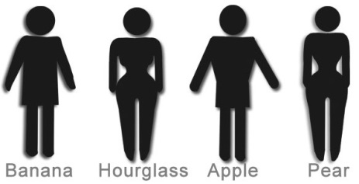
MEASURE the WAIST:  1. Find someone to measure your waist in centimeters  2. Measure at the smallest point of your waist. (Approximately 1 inch above the bellybutton) |  | MEASURE the HIP  1. Find someone to measure your Hip in centimeters.  2. Measure at the largest point of your bottom.
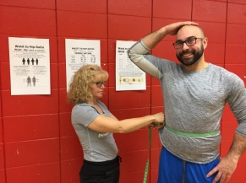 |  | 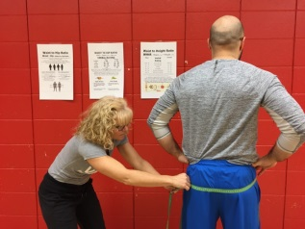

WAIST TO HIP RATIO - WHR = Waist (cm) ÷ Hip (cm) - VERBAL RATING
 | Males |  | Females
Excellent | under .84 |  | under .74
Good | .85 - .90 |  | .75 - .80
Average | .89 - .95 |  | .81 - .85
At Risk | .94 - .99 |  | .86 - .89
High Risk | over 1.0 |  | over .90
https://articles.mercola.com
If you have a high-risk rating and you have excessive fat mass in the waist area then the results warn you that you be at risk of: diabetes, high cholesterol, high blood pressure, cancer, coronary heart disease and shortened life expectancy. This risk is a result the excess fat distribution around your waist being located close to your visceral (internal organs) such as your heart and arteries.
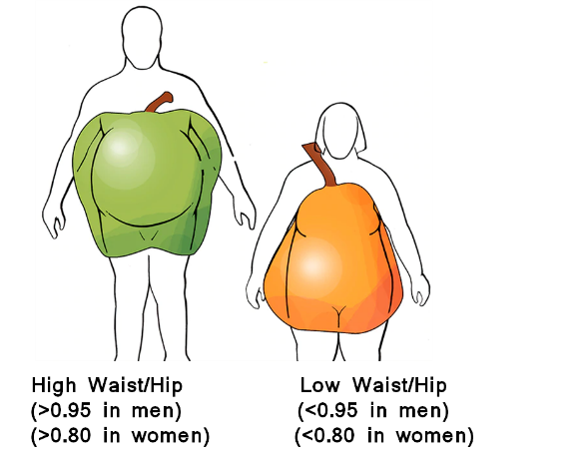
apis.classicfitnessgroup.com

Assessment # 2. Height to Waist Ratio – (WHtR) (Analyzing Weight Distribution)
A person's waist-to-height ratio (WHtR) is determined by calculating their waist circumference divided by their height (both measured in the same units – cm).
The WHtR is a measure of the distribution of body fat. Higher values of WHtR indicate higher risk of obesity-related cardiovascular diseases; it is correlated with abdominal obesity.
Waist to Height Ratio
WHtR = Waist (cm) ÷ Height (cm)
Males | Verbal Rating | Females
Under .35 | Underweight | Under .35
.35 – .43 | Underweight | .35 – .42
.44 – .53 | Healthy | .43 - .49
.54 – .58 | Possible Risk | .50 - .54
.59 – .63 | At Risk | .55 – .58
Over .63 | High Risk | Over .58
CM Lee, Huxley RR, Wildman RP, Woodward M (July 2008). "Indices of abdominal obesity are better discriminators of cardiovascular risk factors than BMI: a meta-analysis'". Journal of Clinical Epidemiology. 61 (7): 646–653. doi:10.1016/j.jclinepi.2007.08.012. PMID 18359190.
The WHtR is a measure of the distribution of body fat.
Higher values of WHtR indicate higher risk of obesity-related cardiovascular diseases such as: Type 2 diabetes, high blood pressure, high cholesterol and heart disease as well as increased cancer risk and decreased life expectancy
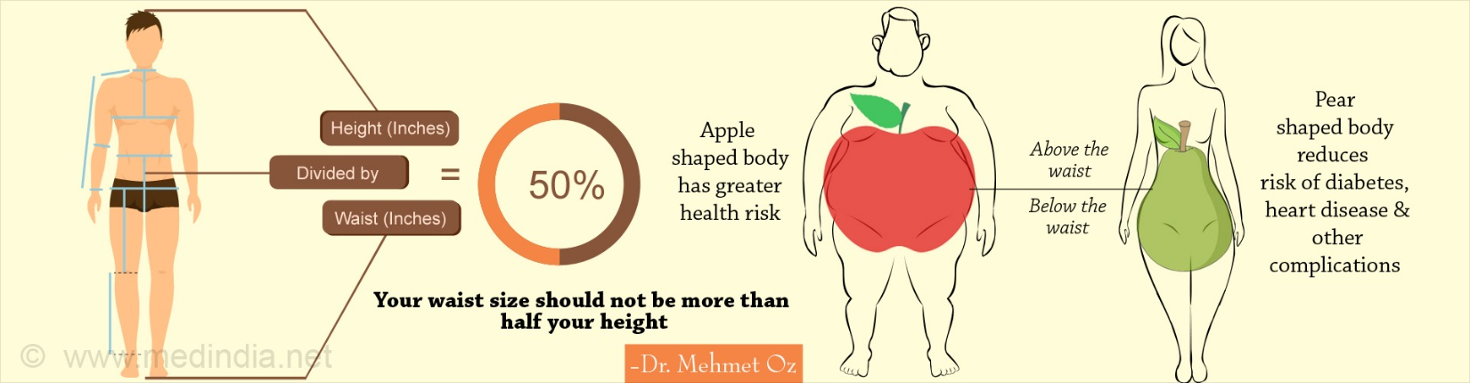

Assessment # 3: Waist Circumference (Analyzing Risk)

Waist Circumference and Risk
Verbal Rating | Males | Females
Very Low Risk | < 80 cm | < 70 cm
Low Risk | 80-99 cm | 70-89 cm
High Risk | 100-120 cm | 90-109 cm
Very High Risk | > 120 cm | > 110 cm
www.acefitness.org

Assessment # 4: Somatotypes (Self-Analysis)
When analyzing your Body Composition, it is important to consider that muscle mass, body fat distribution and metabolism may vary from person to person. There are many different body shapes and many different body types as all bodies are special and unique. One aspect of what makes them unique is their shape and how they carry weight and muscle. Regardless of body type and/or shape, health improvements can be made with regular physical activity and healthy nutrition. Regardless of your body type, achievements and improvements in strength, flexibility, and body composition can be achieved by following an exercise program, active living and healthy eating plan to reach their goals.

Somatotypes
Individuals genetic physical predisposition to a certain body shape, fat to muscle ratio and stature.
It is possible to be a mix of somatotypes as we are unique and come in all shapes and sizes
Ectomorph | Mesomorph |  | Endomorph
- Slight frame and bone structure  - Narrow shoulders  - Naturally lean  - Flat chest  - Fast metabolism  - Finds it difficult to gain weight  - Finds building muscle mass challenging | - Medium frame  - Athletic and toned body  - Muscle definition  - Generally rectangular-shaped body  - Strong  - Gains muscle easily |  | - Soft body with minimal natural muscle definition  - Tends towards a round body shape  - Prone to gaining fat  - Usually, have a larger bone structure  - Slower metabolism  - Finds it more difficult than the other body types to lose fat

WHAT TO DO for a Healthy Body Composition?
Balancing caloric intake and output is the key!

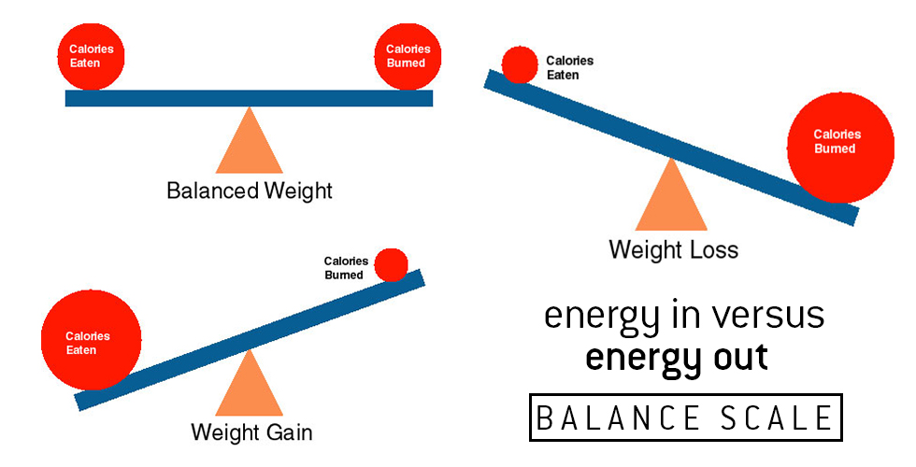
https://www.google.ca/search?client=firefox-b- ab&dcr=0&biw=1280&bih=871&tbm=isch&sa=1&ei=XwYeWtLfFIqUjwTPuaSoDg&q=calorie+intake&oq=calorie+in&gs_l=psy-ab.1.0.0l10.912653.915004.0.917780.11.11.0.0.0.0.404.1330.8j2j4-1.11.0....0...1c.1.64.psy-ab..0.11.1324...0i67k1.0.-FUZDCXZYXE#imgdii=ZoMwkQJuGIBN_M:&imgrc=8f8hmA7uPUPiyM:
Adopt Healthy Eating Habits

↑ Vegetables, fruits, quality proteins, whole grains, fiber.
↓ sugar, sugar drinks, fried foods, processed food.

Increase Physical Activity

- 30-60 minutes of daily activity (walk, move, stairs)
- Cardiovascular activity 2-3 x/week (walk, jog, bike.)
- Muscular conditioning exercises 2x /wk (push-ups, squats.)

Muscular Strength and Endurance Testing

Wall Squat |  | 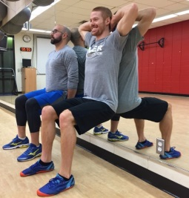
Back flat on wall - 90 ° angle at the knee - Hands on wall or behind the head
Verbal Rating for Wall Squats
Males | Verbal Rating |  | Females
≥ 2:39 | Excellent |  | ≥ 1:57
1:39-2:38 | Above Average |  | 1:17-1:56
1:09-1:38 | Average |  | 57-1:16
≤1:08 | Below Average |  | ≤56 sec.
The Wall Squat test measures the muscle endurance of the quadriceps muscles.
Poor muscular endurance signifies low levels of muscle mass, fitness and increased risk of illness, fatigue and injury risk.
To improve your muscle endurance, perform muscular conditioning exercises like squats, lunges and step ups 2-3 times each week. Adding weight while performing
the exercises will increase the intensity and fitness improvement.

École de dos. Renforcer les quadriceps. Université de Québec en Abitibi-Témiscamingue.

Retrieved from: http://uriic.uqat.ca/chroniquep/03preparationphysique/

THE FRONT PLANK
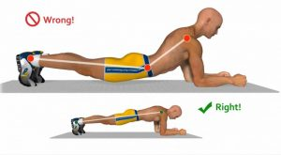 |  | 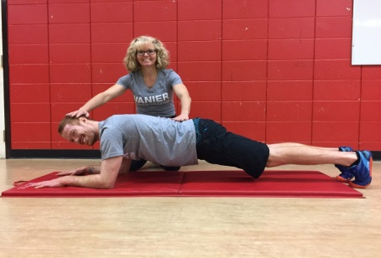
PROPER PLANK TECHNIQUE
Place elbows directly under shoulders – Bring toes forward – Raise hips so that body is parallel to the floor – keep your head up – Keep the upper back flat, not rounded –
Keep legs contracted and together – Keep hips up as to not allow lower back to sway
As soon as the correct plank position cannot be maintained you are done.
Males | Verbal Rating |  | Females
2:21 + | Excellent |  | 2:01 +
1:45 – 2:20 | Above Average |  | 1:31‐2:00
1:34 - 1:44 | Average |  | 1:20 - 1:30
1:17 - 1:33 | Below Average |  | 1:03 ‐ 1:19
≤ 1:16 | Poor |  | ≤1:02
The plank test measures the strength, endurance and stability of the trunk / core. Maintaining a strong core is a very important component of muscular fitness. Performing the plank exercise 2-4 times each week for (30-90 seconds) will help improve posture, decrease back injury, tighten the abdominal musculature, improve balance and athletic performance.
Source: Strand, S. L., Hjelm, J., Shoepe, T. C., & Fajardo, M. A. (2014). Norms for an
Isometric Muscle Endurance Test. Journal of Human Kinetics, 40, 93–102. http://doi.org/10.2478/hukin-2014-0011 (new Norms for 2018)

Vertical Jump - MUSCLE POWER TEST
- In this test you need to first mark off your standing height with one arm extended overhead.
- You will then jump as high as you can in one explosive motion and mark off your vertical jump distance with a piece of chalk.
- You make take one step and then jump.
- Calculate the difference between your standing height and the maximum jump height that you reached.
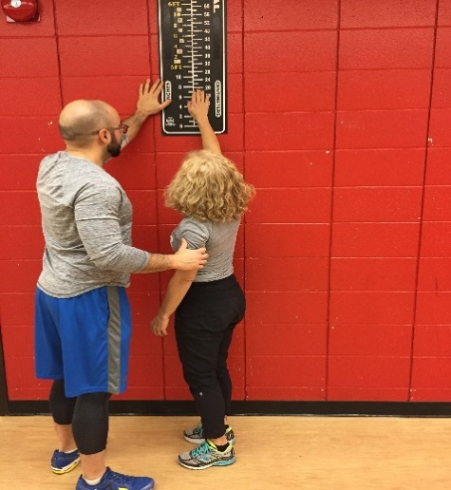 | 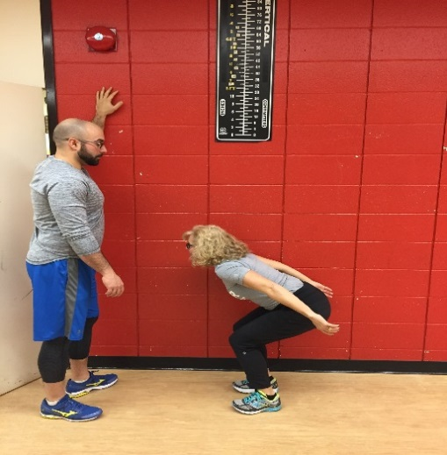 | 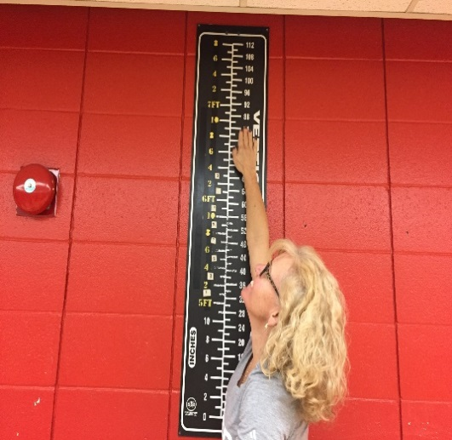

THE VERTICAL JUMP
Males |  | Verbal Rating | Females
cm | Inches |  | cm | Inches
> 65  61 – 64  48 – 60  40 – 47  25 – 39  12 – 24  < 11 | > 25.6  24 – 25.5  18.9 – 23.9  15.7 – 18.8  9.4 – 15.6  4.7 – 9.3  < 4.6 | Superior  Excellent  Above Average  Average  Below Average  Poor  Very Poor | > 42  38 – 41  35 – 37  25 – 34  17 – 24  7 – 16  < 6 | > 16.5  15 – 16.4  13.8 – 14.9  9.8 – 13.7  6.7 – 9.7  2.8 – 6.6  < 2.7
The vertical jump is a measurement of leg strength and power.
It measures how much force your leg muscles can create in a single contraction.
The higher you can jump, the stronger and more powerful your legs.
To improve muscle strength, it is necessary to do weight training exercises such as squats and lunges. Sprinting, jumping and other plyometric exercise will help with the explosive, power aspect.
When weight training to improve strength, train each muscle 2-3 days each week and use heavier weights which will force you to reach muscular fatigue within 5-12 repetitions. Perform 3-5 sets.

Modified from: Lawrence, Arthur Golding, Myers, Clayton R., Sinning, Wayne E. (1986) Y's way to physical fitness: the complete guide to fitness testing and instruction. Champaign, IL: Published for YMCA of the USA by Human Kinetics Publishers.

Standing Long Jump - MUSCLE POWER TEST
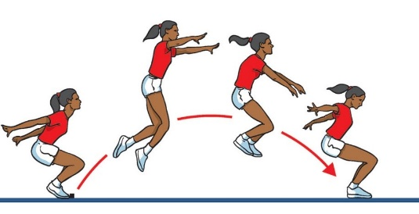  Standing-Long-Jump.jpg (916×469) (ravikooner.com) |  | - In this test you will be evaluated on how far you can jump.  - Squat down and bring your arms behind you and then jump as far as you can landing on both feet.  - Measure the distance from the start line to the heel of your back foot of where you land.
This test is designed to measure the explosive power of your legs: (quadriceps, hamstrings and gluteal muscles).
How far can you jump?
- Squat down and bring your arms behind you and then jump as far as you can landing on both feet.
- Measure the distance from the start to your heel of the back foot of where you land.
To improve upon muscle strength, it is necessary to do weight training exercises.
Example: Squats / 3-5 Sets / 5-10 Reps Maximum / 2 Days each week.
Sprinting, jumping and other plyometric exercise will also help.
Standing Long Jump | Verbal Rating Males |  | Verbal Rating Females
Excellent | > 250 cm |  | > 200 cm
Very Good | 241-250 cm |  | 191-200 cm
Above Average | 231-240 cm |  | 181-190 cm
Average | 221-230 cm |  | 171-180 cm
Below Average | 211-220 cm |  | 161-170 cm
Poor | 191-210 cm |  | 141-160 cm
Very Poor | < 191 cm |  | < 141 cm
Standing Long Jump Test (topendsports.com)

Standing Balance Test - Balance and Coordination
Record how long you can stay in the position.
- Place your hands on your hips  - Lift your foot and place it on the inside of your right leg (knee height)  - Close your eyes and hold the position for as long as you can.  - The test is over when you left foot touches the floor.  - Complete on the right and then the left leg. |  | 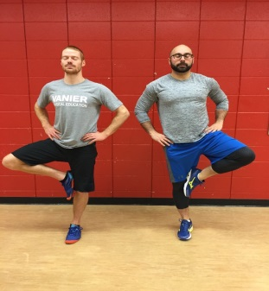
Males | Verbal Rating |  | Females
≥ 31 sec. | Excellent |  | ≥ 27 sec.
27 – 30 sec. | Above Average |  | 24-26 sec.
21-26 sec. | Average |  | 18-23 sec.
17-20 sec. | Below Average |  | 15-17 sec.
≤16 sec. | Poor |  | ≤14 sec.

Richard Chevalier, Richard. À vos marques, prêts, santé! (2010). Saint-Laurent, Québec: ERPI

1 Minute CURL-UPS
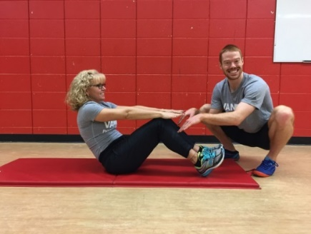 |  |  |  | Have a partner count and check technique.  - Start with your feet flat on the floor with your knees bent at 90°.  - Your hands are resting on your thighs.  - Curl-Up high enough so that your wrist meets the top of your knees. Your fingers will be touching the top of your shin. If you do not go high enough – do not count it!  - Do not bounce, raise your legs or rock on your back.  - When or if you cannot reach the tops of your knees, you are done.  - Have your partner count how many “PROPER” curl-ups you can do in one minute.
Verbal rating for 1-minute curl-ups test
Age | 16 – 25 |  | 26 - 35 |  | 36 – 45 |  | 46 – 55 |  | 56 – 65
Gender | M | F | M | F | M | F | M | F | M | F
Excellent | ≥ 50 | ≥ 44 | ≥ 46 | ≥ 40 | ≥ 42 | ≥ 34 | ≥ 36 | ≥ 28 | ≥ 32 | ≥ 25
Very Good | 44 - 49 | 37 - 43 | 40 - 45 | 33 - 39 | 35 - 41 | 27 – 33 | 29 – 35 | 22 - 27 | 25 – 31 | 18 – 24
Above Avg. | 39 - 43 | 33 - 36 | 35 - 39 | 29 - 32 | 30 - 34 | 23 – 26 | 25 – 28 | 18 - 21 | 21 – 24 | 13 – 17
Average | 35 - 38 | 29 - 32 | 31 - 34 | 25 - 28 | 27 - 29 | 19 – 22 | 22 – 24 | 14 - 17 | 17 – 20 | 10 – 12
Below Avg. | 31 - 34 | 25 - 28 | 29 - 30 | 21 - 24 | 23 - 26 | 15 – 18 | 18 – 21 | 10 – 13 | 13 – 16 | 7 – 9
Poor | 25 - 30 | 18 - 24 | 22 - 28 | 13 - 20 | 17 - 22 | 7 – 14 | 13 – 17 | 5 – 9 | 9 – 12 | 3 – 6
Very Poor | ≤ 24 | ≤ 17 | ≤21 | ≤ 12 | ≤ 16 | ≤ 6 | ≤ 12 | ≤ 4 | ≤ 8 | ≤ 2
The Curl-ups test is a measurement of the muscular endurance of your abdominal muscles. Poor abdominal strength and endurance is associated with low muscle mass, poor posture and lower back injury risk. By performing abdominal exercises like curl-ups, the plank and leg raises 2-3 x/week you will experience rapid improvements in your muscular fitness level. Once you can perform 25-30 repetitions of an abdominal exercise you are ready to select a harder exercise.

Lawrence, Arthur Golding, Myers, Clayton R., Sinning, Wayne E.

Y's way to physical fitness - the complete guide to fitness testing and instruction, (1986) p. 117

Triceps Chair Dips
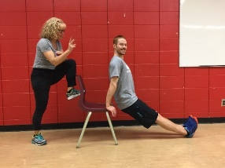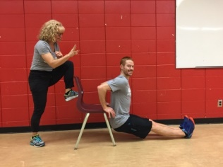 | To improve your triceps dips score try completing triceps dips 2-3 times each week.  You can easily do this exercise at home. If you find them too difficult with your legs straight, you can decrease the intensity by bending your knees. Within no time you will build up the strength and endurance in your upper arms and you will see your numbers increase.
This test is designed to measure the muscle endurance of your upper arms (triceps and shoulders).
How many chair dips can you do?
- Sit on a bench with your palms on the bench – thumbs pointing in
- Straighten your legs out in front of you and then move your bum off the bench (no more than 2 inches away from the bench).
- Bend your elbows towards the back and you are doing a chair dip.
- Lower down until you reach 90º at your elbow and then push yourself back up.
- Do as many as you can without stopping and record your results.

VANIER NORMS FOR CHAIR-DIPS
Verbal Rating | Females | Males
Excellent | 40 + | 60 +
Above Average | 30 – 39 | 45 – 59
Average | 20 – 29 | 30 – 44
Below Average | 10 – 19 | 15 – 29
Poor | 0 – 9 | 0 – 14

One Minute Squat Test
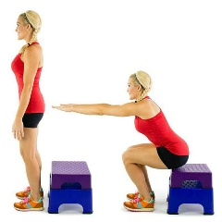  image_iphone.jpg (640×640) |  | This test is designed to measure the muscle endurance of your legs: (quadriceps, hamstrings, gluteals)  How many bench squats can you do in one minute?  - Squat down until your backside just touches the bench (don’t fully sit down) and then return to a full standing position.  - Complete as many squats as you can in one minute.

One Minute Squat Test - Verbal Rating Males
Age | 17-25 |  | 26-35 | 36-45 | 46-55 | 56-65
Excellent | ≥ 50 |  | ≥46 | ≥42 | ≥36 | ≥32
Good | 44-49 |  | 40-45 | 35-41 | 29-35 | 25-31
Above Avg. | 39-43 |  | 35-39 | 30-34 | 25-28 | 21-24
Average | 35-38 |  | 31-34 | 27-29 | 22-24 | 17-20
Below Avg. | 31-34 |  | 29-30 | 23-26 | 18-21 | 13-16
Poor | 25-30 |  | 22-28 | 17-22 | 13-17 | 9-12
Very Poor | ≤ 24 |  | ≤ 21 | ≤ 16 | ≤ 12 | ≤ 8

One Minute Squat Test - Verbal Rating Females
Age | 17-25 |  | 26-35 | 36-45 | 46-55 | 56-65
Excellent | ≥ 44 |  | ≥ 40 | ≥ 34 | ≥ 28 | ≥ 25
Good | 37-43 |  | 33-39 | 27-33 | 22-27 | 18-24
Above Avg. | 33-36 |  | 29-32 | 23-26 | 18-21 | 13-17
Average | 29-32 |  | 25-28 | 19-22 | 14-17 | 10-12
Below Avg. | 25-28 |  | 21-24 | 15-18 | 10-13 | 7-9
Poor | 18-24 |  | 13-20 | 7-14 | 5-9 | 3-6
Very Poor | ≤ 17 |  | ≤12 | ≤6 | ≤ 4 | ≤ 2
The 1-Minute Squat Challenge » Stephanie Hnatiuk Performance Nutrition

1 minute – Side Hops Test
This test is designed to measure muscle agility, coordination and endurance.
How to: Start on a line (center)
Hop right – center – left – center = 1 cycle
Have your partner count how many cycles you can do in one minute.
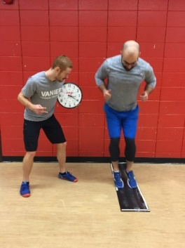 | 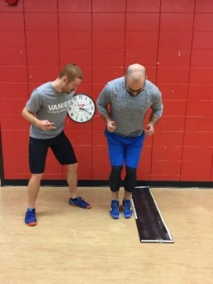 |  | 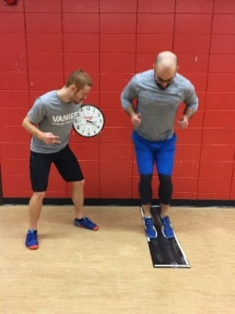 | 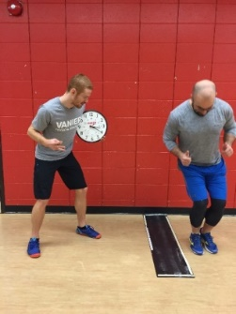
VANIER NORMS FOR SIDE HOPS
Males |  | Verbal Rating |  |  | Females
≥ 50 |  | Excellent |  |  | ≥ 46
46-49 |  | Above Average |  |  | 42-45
42-45 |  | Average |  |  | 38-41
38-41 |  | Below Average |  |  | 34-37
≤ 37 |  | Poor |  |  | ≤ 33

Push-Ups

Verbal Rating for Males
Full Push-Ups - Chest must touch the yoga block
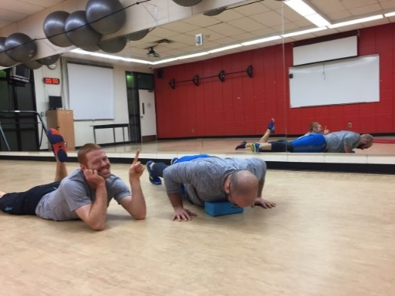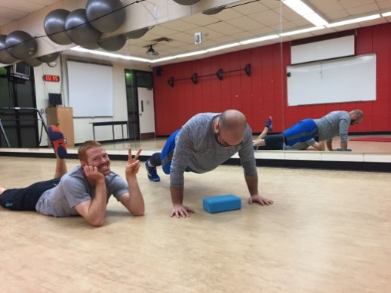
Age | 17-19 | 20-29 | 30-39 | 40-49 | 50-59 | 60-65
Excellent | ≥ 57 | ≥ 48 | ≥ 42 | ≥ 35 | ≥ 32 | ≥ 31
Good | 47-56 | 40-47 | 34-41 | 28-34 | 25-31 | 24-30
Above average | 35-46 | 30-39 | 25-33 | 21-28 | 18-24 | 17-23
Average | 19-34 | 17-29 | 13-24 | 11-20 | 9-17 | 6-16
Below average | 11-18 | 10-16 | 8-12 | 6-10 | 5-8 | 3-5
Poor | 4-10 | 4-9 | 2-7 | 1-5 | 1-4 | 1-2
Very Poor | ≤ 3 | ≤ 3 | ≤ 1 | 0 | 0 | 0
Push-Up Test / Press Up Test

Push-Ups

Verbal Rating for FeMales
Full Push-Ups - Chest must touch the yoga block
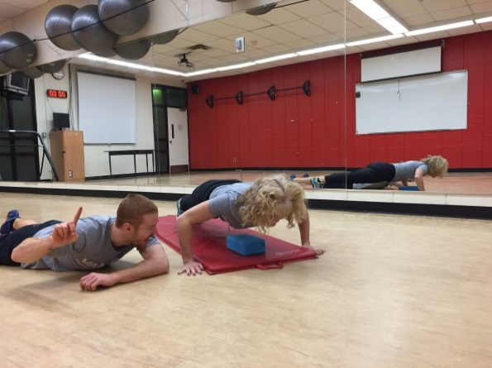
Age | 17-19 | 20-29 | 30-39 | 40-49 | 50-59 | 60-65
Excellent | ≥ 30 | ≥ 32 | ≥ 28 | ≥ 20 | ≥ 16 | ≥ 12
Good | 22-29 | 24-31 | 21-17 | 15-19 | 13-15 | 10-11
Above average | 11-21 | 14-23 | 13-20 | 10-14 | 9-12 | 6-9
Average | 7-10 | 9-13 | 7-12 | 5-9 | 4-8 | 3-5
Below average | 4-6 | 5-8 | 3-6 | 2-4 | 2-3 | 2
Poor | 1-3 | 1-4 | 1-2 | 1 | 1 | 1
Very Poor | 0 | 0 | 0 | 0 | 0 | 0
Push-Up Test / Press Up Test

Modified Push-Ups - Verbal Rating for Females
Modified Push-Ups (knees) - Chest must touch the yoga block
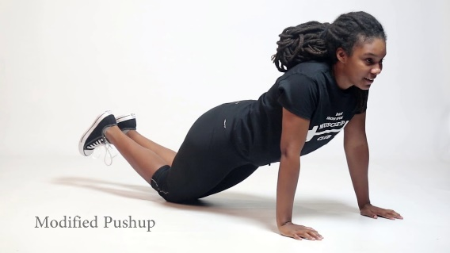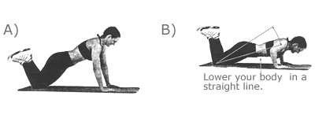
Age | 17-19 | 20-29 | 30-39 | 40-49 | 50-59 | 60-65
Excellent | ≥ 36 | ≥ 37 | ≥ 38 | ≥ 32 | ≥ 26 | ≥ 24
Good | 28-35 | 30-36 | 31-37 | 25-31 | 21-25 | 19-23
Above average | 21-27 | 23-29 | 22-30 | 18-24 | 15-20 | 13-18
Average | 11-20 | 12-22 | 10-21 | 8-17 | 7-14 | 5-12
Below average | 6-10 | 7-11 | 5-9 | 4-7 | 3-6 | 2-4
Poor | 2-5 | 2-6 | 1-4 | 1-3 | 1-2 | 1
Very Poor | 0-1 | 0-1 | 0 | 0 | 0 | 0
Source: Y’s Way to Physical Fitness: The Complete Guide to Fitness Testing and Instruction (3rd Edition) by Lawrence Golding and Clayton Myers.
Males and Females - If you have Verbal Ratings of Above Average or Higher
TRY

John Sifferman’s - Totally Unofficial Push-Up Test Standards
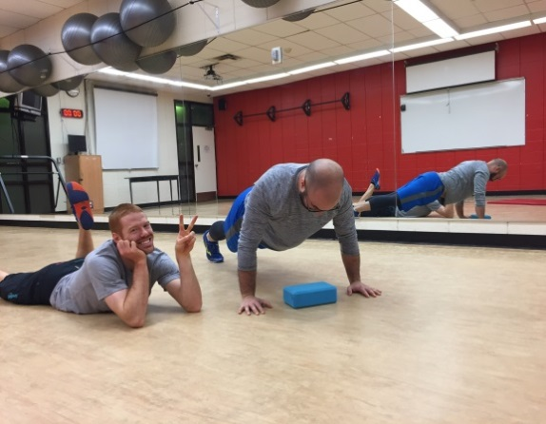 | Keep Body Straight  Keep head aligned  Keep your belly up  Bend at your elbows  Complete full Range  Breathe  Don’t Give Up  You got This!
Males | Verbal Rating | Females
1 – 10 | Newbie | 1 – 7
11 - 20 | Beginner | 8 – 13
21 – 40 | Intermediate | 14 – 27
41 – 60 | Advanced | 28 – 40
61 – 90 | Expert | 41 – 60
91 – 120 | Master | 61 – 80
121 – 140 | Wicked Sick | 81 – 93
141 – 160 | Super Human | 94 – 107
161 – 180 | Olympian | 108 – 120
181 + | Immortal | 121 +
Source: http://physicalliving.com

Push-Up Result Considerations
PUSH-UP POSITIONS – from easy to hard
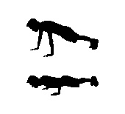

- If you are below average or poor, you are demonstrating poor muscular strength in the chest and shoulders.
- The best way to improve your muscle endurance is to improve your strength in the chest, triceps and shoulder muscles. By doing as many push-ups as you can 2-3 days each week and you will start to see your strength and endurance increase.
- If you are unable to do a proper Push-Up, do modified push-ups until you can perform up to 20-25 repetitions.
- Once you can complete 20-25 reps easily, start adding full Push-ups.

- If you are unable to do a proper Modified Push-Up you can elevate your upper body on a bench or step and it will be easier. Once you can manage that, progress to the regular modified push-up and eventually you will be doing full push-ups.

- Females who score above average or higher on the Modified Push-Ups test should be using full push-ups in their workouts.

Cardiovascular Endurance
Cooper 12 Minute Cardiovascular Test Options
Run – Bike – Swim
The following 12-minute Cooper tests (Run, Bike or Swim) measure your present cardiovascular endurance level. Your cardiovascular fitness level is one of the most important components of fitness and health.
Benefits of Good Cardiovascular Endurance
↓ risk of Heart attacks and strokes  ↓ risk of having high blood pressure  ↓ risk of having type 2 diabetes  ↓ risk of anxiety and depression | ↓ risk of obesity and related illnesses  ↑ lifespan  ↑ energy levels  ↑ concentration and focus
So, what are you waiting for?
Start walking, jogging, biking swimming, dancing, playing
15-30 minutes / 3-5 days a week is all you need!
The goal of these tests is to cover as much distance as you can in a 12 - minute period.
Before you begin the test, it is recommended to warm-up your muscles and increase your heart rate. This will prevent muscle soreness and cramping and will also help you to improve your performance in the test.
To warm-up, complete 3-5 minutes of light cardiovascular activity (walk, jog, row, bike, swim …) and then do some dynamic stretching before starting the test.

Cardiovascular Intensity Measurements:
You will be asked to measure your Heart Rate and RPE after your cardiovascular tests.
Step 1: | a) Record you Post Heart Rate  Take Your Heart Rate immediately after you finish the test - (10 seconds x 6) = Post HR bts/min.
Step 1: | b) Record your RPE using the Scale Below  Simply ask yourself how you felt during and at the end of the activity.
Step 2 | Record your 3 Minute Recovery Heart Rate.  3 minutes after you finish the Cardiovascular test retake your Heart Rate (10 seconds x 6) =  3 Minute Recovery HR bts/min

VANIER MODIFIED RPE SCALE
RATING OF PERCEIVED EXERTION /  HOW YOU FEEL | RATING
Too easy, not hard enough to get a workout  Warm-up and cool-down intensity | 1
Easy, very comfortable, can continue for a long time,  Too easy for fit participants - OK for unfit | 2
Moderately hard, comfortable, good workout  OK for most participants | 3
Hard, cannot continue for too long,  Too difficult to continue for unfit participants - OK for fit | 4
Too hard, can’t continue for longer than a minute  OK for very fit as a high intensity interval. | 5

Cooper 12 Minute Run:

Cooper 12 Minute Run
Count the distance in meters that you can complete in 12 minutes. Use a GPS tracker or running app if completing the test on your own. You can count ½ laps so do not stop until the buzzer goes off. Pace yourself throughout the test – maintain a comfortable running pace throughout the test.
DISTANCE CALCULATIONS
Main Gyms (all 3 gyms)  1 lap = 160m | Turf Field  1 lap = 400m | Upstairs Hallway  1 lap = 95m

Cooper 12 Minute Run - VERBAL RATING – MALES

The distance completed in 12 minutes (in meters)
Verbal Rating | Under 30 Yrs. | 30-39 | 40-49 | 50-59
Excellent | 2,800 + | 2,640 + | 2,480 + | 2,400 +
Above Average | 2,400- 2,799 | 2,240- 2,639 | 2,080 – 2,479 | 2,090 – 2,399
Average | 2,000- 2,399 | 1,840 – 2,239 | 1,680 – 2,079 | 1,600 – 2,089
Below Average | 1,600- 1,999 | 1,520 – 1,839 | 1,360 – 1,679 | 1,280 – 1,599
Poor | < 1,600 | < 1,520 | < 1,360 | < 1,280

Cooper 12 Minute Run - VERBAL RATING – FEMALES
The distance completed in 12 minutes (in meters)
Verbal Rating | Under 30 Yrs. | 30-39 | 40-49 | 50-59
Excellent | 2,640 + | 2,320 + | 2,320 + | 2,160 +
Above Average | 2,160– 2,639 | 2,000- 2,319 | 1,840 – 2,319 | 1,680 – 2,159
Average | 1,840- 2,159 | 1,680 – 1,999 | 1,520 – 1,839 | 1,360 – 1,679
Below Average | 1,520- 1,839 | 1,360 – 1,679 | 1,200 – 1,519 | 1,040 – 1,360
Poor | < 1,520 | < 1,360 | < 1,200 | < 1,040

Cooper 12-min Bike Test
Count the Distance (in miles) that you can complete in 12 minutes.
Use a GPS tracker and a bike route (track, bike path) with no stops
12-minute Bike Test ratings for MALES. (Distance in kilometres)
Age→ | 13-19 | 20-29 | 30-39 | 40-49 | 50-59 | 60 +
Excellent | > 9.25 | > 8.84 | > 8.43 | > 8.03 | > 7.23 | > 6.42
Good | 7.6-9.24 | 7.24-8.84 | 6.81-8.43 | 6.43-8.03 | 5.62-7.23 | 4.82-6.42
Fair | 6.03-7.59 | 5.62-7.23 | 5.22-6.8 | 4.81-6.42 | 4.1-5.61 | 3.61-4.81
Poor | 4.42-6.02 | 4.02-5.61 | 3.6-5.21 | 3.21-4.8 | 2.81-4 | 2.81-3.6
Very Poor | < 4.42 | < 4.02 | < 3.6 | < 3.21 | < 2.81 | < 2.81

12-minute Bike Test ratings for FEMALES. (Distance in kilometres)
Age→ | 13-19 | 20-29 | 30-39 | 40-49 | 50-59 | 60 +
Excellent | > 7.63 | > 7.23 | > 6.82 | > 6.4 | > 5.61 | > 4.8
Good | 6.03-7.63 | 5.63-7.23 | 5.22-6.82 | 4.82-6.4 | 4.1- 5.61 | 3.2 – 4.8
Fair | 4.42-6.02 | 4.1-5.62 | 3.61-5.21 | 3.21-4.81 | 2.4 - 4 | 2 – 3.2
Poor | 2.81-4.41 | 2.41-4 | 2.01-3.6 | 1.6 -3.2 | 1.2 -2.39 | 1.2 -1.99
Very Poor | < 2.81 | < 2.41 | < 2.01 | < 1.6 | < 1.2 | < 1.2
Source: Cooper (1982) https://www.topendsports.com/testing/tests/cycle-12-minutes.htm

Cooper 12-min Swim Test
Count the # of laps / distance in yards that you can complete in 12 minutes.
You can count ½ laps so do not stop until the 12 minutes is up.
Pace yourself throughout the test – maintain a comfortable swimming pace throughout the test.

12-minute Swim Test ratings for MALES. (Distance in meters)
Age→ | 13-19 | 20-29 | 30-39 | 40-49 | 50-59 | 60 +
Excellent | > 731 | > 639 | > 593 | > 548 | > 502 | > 456
Good | 640 - 731 | 549 - 639 | 503 – 593 | 457 - 548 | 412 - 502 | 366 - 456
Fair | 549 - 639 | 457 - 548 | 412 – 502 | 366 - 456 | 320 - 411 | 274 - 365
Poor | 457 - 548 | 366 - 456 | 320 – 411 | 274 - 365 | 229 - 319 | 229 - 273
Very Poor | < 457 | < 366 | < 320 | < 274 | < 229 | < 229

12-minute Swim Test ratings for FEMALES. (Distance in meters)
Age→ | 13-19 | 20-29 | 30-39 | 40-49 | 50-59 | 60 +
Excellent | > 639 | > 548 | > 502 | > 456 | > 411 | > 365
Good | 549 - 639 | 457 - 548 | 412 – 502 | 366 – 456 | 320 – 411 | 274 – 365
Fair | 457 - 548 | 366 - 456 | 320-411 | 274 - 365 | 229 – 319 | 183 – 273
Poor | 366 - 456 | 274 - 365 | 228 – 319 | 182-273 | 137 – 228 | 137-182
Very Poor | < 366 | < 274 | < 228 | < 182 | < 137 | < 137
Source: Cooper (1982) https://www.topendsports.com/testing/tests/swim-12-minutes.htm

Vanier Super Loop Test:
8 Laps – Super Loop – Verbal Rating
Around – Down – Along - Up
VERBAL RATING | MALES | FEMALES
Superior | ≤ 11:30 min | ≤ 12:00 min
Excellent | 11:31-12:30 | 12:01-13:00
Above Average | 12:31-13:30 | 13:01-14:00
Average | 13:31-14:30 | 14:01-15:00
Below Average | 14:31-15:00 | 15:01-15:30
Poor | > 15:00 | > 15:31
6 Laps – Super Loop – Verbal Rating
Around – Down – Along - Up
VERBAL RATING | MALES | FEMALES
Superior | ≤7:45 min | ≤8:00 min
Excellent | 7:46-8:45 | 8:01-9:00
Above Average | 8:46-9:45 | 9:01-10:00
Average | 9:46-10:45 | 10:01-11:00
Below Average | 10:46-11:45 | 11:01-12:00
Poor | >11:45 | >12:01

Flexibility
Sit and Reach
The sit and Reach test measures the flexibility of the Hamstrings and Lower Back (Erector Spinae muscles).  Poor flexibility can lead to injury, muscle stiffness, pain, headaches and poor posture. |  |  |  |  |  |  | 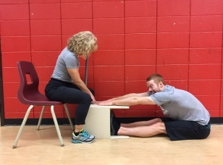
How to:
- Remove shoes.
- Sit on the floor and place the soles of your feet flat against the box.
- Both knees should be locked and pressed flat to the floor (DO NOT BEND YOUR KNEES)
- With the palms facing downwards, reach forward along the measuring line as far as possible.
- Hands must remain at the same level, not one reaching further forward than the other.
- Hold the stretch for (no bouncing or jerking)
- Record the distance.
NORMS FOR SIT AND REACH – TRUNK FLEXIBILITY (cm)
Age | 17 -19 |  | 20 – 29 |  | 30 – 39 |  |  | 40 -49 |  | 50 - 59
Gender | M | F | M | F | M | F |  | M | F | M | F
Excellent  Above Avg.  Average  Below Avg.  Poor | ≥ 46  35-45  24-34  13-23  ≤ 12 | ≥ 45  35-44  21-34  12-20  ≤ 11 | ≥ 42  34-41  23-33  13-22  ≤ 12 | ≥ 45  35-44  25-34  15-24  ≤ 14 | ≥ 43  32-42  22-31  11-21  ≤ 10 | ≥ 45  34-44  24-33  14-23  ≤ 13 |  | ≥ 41  30-40  20-29  9-19  ≤ 8 | ≥ 44  34-43  23-33  12-22  ≤ 11 | ≥ 40  30-39  17-29  6-16  ≤ 5 | ≥ 43  33-42  22-32  13-21  ≤ 12

Sit and Reach (Home Version) –  Feet Against the Wall | 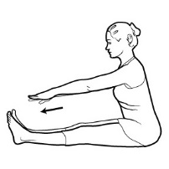
How to:
- Remove shoes.
- Sit on the floor and place the soles of your feet flat against a wall.
- Both knees should be locked and pressed flat to the floor (DO NOT BEND YOUR KNEES)
- Reach forward as far as possible.
- Hands must remain at the same level, not one reaching further forward than the other.
- Hold the stretch for (no bouncing or jerking)
- Record the distance as described below.
NORMS FOR SIT AND REACH AGAINST THE WALL – TRUNK FLEXIBILITY
How far can you reach?
Hands (palms) flat on wall | Knuckles can touch the wall | Fingers can touch toes | Fingers reach the ankles | Fingers reach ½ way down the shin
Verbal Rating
Excellent | Above Average | Average | Below Average | Poor
sit and reach against a wall - Search Videos (bing.com)

Shoulder Flexibility Test
The following modified Apley scratch test is a shoulder flexibility test that measures the range of motion and mobility of the shoulder joint. Poor shoulder flexibility and range of motion can lead to shoulder injury, muscle stiffness, rounded shoulders, neck pain and headaches. | 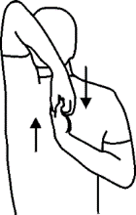
How to:
- Raise your right arm straight overhead and then bend your elbow and lower your fingertips as low as you can on your upper back.
- Bring your left arm behind you back and reach up as far on your back as you can towards your right hand.
- Keep your neck and back straight.
- Record the distance between your hands.
- Repeat on the other side
NORMS FOR SHOULDER FLEXIBILITY
How far can you reach?
Fingers Overlap  (as in photo) | Fingers touch | Fingers are less than 2 inches apart | Fingers are 2-6 inches apart | Fingers are more than 6 inches apart
Verbal Rating
Excellent | Above Average | Average | Below Average | Poor
Adapted From: Apley's Scratch Shoulder Flexibility Test (topendsports.com)

CHAPTER 10
102 - SMART Goal Setting

A goal is something that we want to achieve. The SMART goal setting process is a way for us to organize and plan so that we can be successful in achieving the goals that we set for ourselves in all facets of our life. Goal setting provides us with motivation, accountability and focus to create change and personal satisfaction.
A goal without a plan is just a wish.
https://youtu.be/i0QfCZjASX8  Take a look at this  SMART goal instructional video. | 

Step 1: Identify Initial State (Skill, habit, fitness level, problem you want to fix)
Step 2: Develop and State Your SMART Goal
Checklist for a SMART Goal
Specific | Have you stated exactly what you want to achieve? Is your goal specific, clear and precise? Can you answer what you are trying to accomplish?  Ask yourself What, When, Why?  What do you want to achieve?  When do you want to achieve it?  Why do you want to achieve it?
Measurable | Will you be able to easily measure whether or not you achieved your goal?  Is there a quantitative component to your goal? Can you answer how much, how many or how you will know if you have improved?  - Use numbers/Metrics  - Prioritize quantitative over qualitative measures
Action Oriented Achievable | Action Plan: What is your plan of action on how you can/will work on achieving this goal? What will you do to help you achieve your goal. Set a clear weekly/daily agenda. Describe the actions you will take by asking:  What will you do? When will you do? Where will you do? How will you do?  Refer to the FITT training guidelines for Fitness related goals.  Achievable:  Will your action plan be adequate enough for you to actually achieve your goal?  into account your present lifestyle, environment and skill level is this a goal that you can achieve in the time frame that you have been given?
Relevant / Reason  Realistic | Is this goal relevant and important to you? What is your reason for working towards this goal? A goal that is not meaningful to you will be more difficult to attain.  Taking you present lifestyle, environment and skill level into account, is this a goal that you can achieve in the time frame that you have been given? Is your goal expectation realistic?
Time-Bound | Your goal should have an achieve by date.  When do plan to have achieved this goal by?  This is what I can do today, what do I plan to be able to do 4-6 weeks from now?  Short term Goals: 2-8 weeks / Long term goals: 6 months – 1 year …  We can use a variety of short-term goals to help us achieve long-term goals.

Step 3: Plan your goal
Develop your Action Plan.
What strategies will you use to help you adhere to your goal? (logs, agenda, reminders, partner...)
What exactly will you be doing (Drills, workouts, habits)
Where will you be working on you goal.
When will you be working on your goal? (weekly daily, 3x / week)

Step 4: Record your progress
How will you record your progress (logs, charts)?
Develop personal logs, journal, blog to record your progress.

Step 5: Evaluate your progress
Evaluate progress regularly and adjust your goals if required,
Identify barriers that may prevent you from achieving your goal?
Identify solutions to help you overcome barriers and lack of progress.

Step 6: Final Reflection of Goal Achievement
Once you have completed the time frame that you set for goal achievement, reflect on your success, failures and your commitment to the goal.
Reflect on what you have learned in the process.
Reflect on your attitude and motivation towards working towards a goal.
Reflect on other areas in your life where the goal setting process can be beneficial.

Sample 102 Goals for Students
Performance Goals | Improve upon muscle strength and endurance (Max Push-Ups, Max Pull-ups, 1 RM Bench Press, plank time, Fitness Appraisal results
Performance Goals | Improve Cardiovascular Endurance:  5 km run time, 30 minutes consecutive, Beep test score, Total
Performance Goals | Athletic Skills Goals:  Free Throw %, Volleyball Service %, Swim stroke improvement, kayak flip, pike dive, Squat technique, sprint time, penalty shot in soccer.  Learn a new skill
Performance Goals | Grades, R-Score
Skills Goals | Athletic Skills Performance Goals:  Free Throw %, Volleyball/Badminton Service %, Sprint time
Skills Goals | Technique Goals:  Yoga Posture, Squat technique, Parallel ski turn, kayak flip, stroke improvement
Behavioural Goals | Commitment to an activity: (30 min/day, cardio 3 x/week, plank 4 x/ week)  Commitment to a Positive Lifestyle Habit: (To do lists, Meditation,
Behavioural Goals | Lifestyle Habits: Sleep Time, Screen Time, smoking,
Behavioural Goals | Time Management
Behavioural Goals | Nutrition: Eat certain # of vegetables/day, Increase / decrease specific foods.
Knowledge Goals | Learn the Rules of the Sport  Learn the Safety Rules of an Activity  Learn how to use a compass
Personal Commitment Goals | Use Pre-Post results  Goal Setting Cardio – Muscle Conditioning – Body Comp  Workout Logs – Analysis  Technique Checklists
Personal Lifestyle Goals | Initial self-evaluation  Goal Setting – Nutrition, Habits, Activity, Nature awareness  Goal Logs – Analysis

Sample Goal Setting Templates: (Use to practice in preparation for the LIA Goals Assignment:

√ | Set a Performance Goal:
I will:
Presently I can:
 | Specific | What will you achieve?
 | Measurable | What are you measuring?
 | Measurable | How, when are you measuring?
 | Action Plan | What, when and where?
 | Reason | Why?
 | Realistic | Achievable?
 | Time Frame | By when?

√ | Set a Skill Goal:
I will:
Presently I can:
 | Specific | What will you achieve?
 | Measurable | What are you measuring?
 | Measurable | How, when are you measuring?
 | Action Plan | What, when and where?
 | Reason | Why?
 | Realistic | Achievable?
 | Time Frame | By when?

√ | Set a Behavioural Goal:
I will:
Presently I can:
 | Specific | What will you achieve?
 | Measurable | What are you measuring?
 | Measurable | How, when are you measuring?
 | Action Plan | What, when and where?
 | Reason | Why?
 | Realistic | Achievable?
 | Time Frame | By when?

√ | Set a Knowledge Goal:
I will:
Presently I can:
 | Specific | What will you achieve?
 | Measurable | What are you measuring?
 | Measurable | How, when are you measuring?
 | Action Plan | What, when and where?
 | Reason | Why?
 | Realistic | Achievable?
 | Time Frame | By when?

CHAPTER 11
103 – Personal Program Development

PHYSICAL HEALTH
5 COMPONENTS of Fitness
Achieving an optimum level of physical fitness and health involves the development of the 5 components of physical fitness which are:

5 components of Physical Fitness
Cardiovascular  Endurance | Flexibility  Muscular Strength  Muscular Endurance |  |  | Body Composition & Weight Management

FITT TABLE FOR THE COMPONENTS OF FITNESS
Fitness Component |  | Frequency | Intensity |  | Time  (duration of workout) | Type
Cardiovascular Endurance  Guidelines |  | 3 - 5  times / week  2 x / week for maintenance | 60-85% of Max HR  RPE: 2-4  comfortable to moderately hard |  | 20 - 60 minutes of continuous activity or  1-2 minutes of high intensity intervals (for at least 10 minutes) between muscle conditioning exercises can also be effective. | walk, jog, bike, swim,  soccer, basketball,  elliptical, spinning,  group fitness, box fit  body weight exercises

Muscular Strength & Muscular Endurance Guidelines
Training Goal:  ↓  Select your program goal. |  | Frequency | Intensity  # of sets /  # or reps (RM)  Reps Maximum |  | Time  10 – 60 minutes  Depends on the # of exercises, sets and reps you will be doing. | Type  A variety of equipment  can be used
General Fitness  Strength & Endurance  Development |  | 2 - 3 x’s / week / muscle group | 2 - 3 sets / exercise  Reach Fatigue by 10 - 15 RM  1-2 exercises /  major muscle group |  | - All major muscle groups should be trained weekly = Full Body Training.  - A Muscle conditioning workout should last no longer than 45 – 60 minutes.  - If your workout takes longer than 60 minutes it is recommended to split your program into 2 or 3 days  For example  Day 1- Upper Body  (Mon. + Thu.)  Day 2 – Lower Body + Trunk  (Tue + Fri.) | Machines,  Cables,
Muscle  Endurance  (limited muscle strength gains) |  | 2 - 3 x’s / week / muscle group | 1 - 3 sets / exercise  Reach Fatigue by 15 – 25+ RM  2-3 exercises /  major muscle group |  |  | free weights,  dumbbells,  barbells
Muscle Strength  Advanced  (limited muscle endurance gains) |  | 1 - 2 x’s / week / muscle group | 2 - 5 sets / exercise  Reach Fatigue by 5 - 10 RM  2 - 5 exercises /  major muscle group |  |  | body weight,  tubing / elastics
Body Building  Advanced Lifters  VOLUME is KEY |  | 1 - 2 x’s / week / muscle group | 3 - 6 sets / exercise  Reach Fatigue by 8 - 20 RM  3 - 5 exercises / major muscle |  |  | Callisthenics
Flexibility  Guidelines |  | 3 - 5 days / weeks and/or  after each workout | hold the stretch (static stretches) at the point of tension |  | Static Stretches should be  held for 20 - 30 sec.  Repeat each stretch 2-3 times for flexibility gains. | Static stretches after workouts.  Dynamic stretches before workouts.
Body Composition  Weight. Management  Guidelines  Key = is to balance  Energy In vs out |  | Do Cardio FITT  Goal: To burn as many calories as you can each workout | Do Muscle FITT  Goals:  To burn calories.  To ↑ muscle mass. To ↑ metabolism. |  | Follow the Canada Food Guide for healthy eating. Goals:  To balance caloric intake with caloric expenditure.  Eat high nutrient, less processed food. Portion control. | Follow an active lifestyle outside of scheduled physical activity =  Increase in caloric expenditure
 | TRAINING REMINDERS for CARDIOVASCULAR EXERCISE
 | - Choose an activity you like and will do  - Try to do 3 - 5 workouts each week  - Workout at an intensity that you can maintain for 20 - 30 minutes  - During the workout, maintain an appropriate training intensity range (60 – 85 % of your maximum heart rate or an RPE of 2-4)  - The longer and harder you work out, the more calories you will burn |  |  | - Do a 5 - 8 minute low intensity warm-up before workout  - Do a 3-minute low intensity cool-down after the workout  - Vary your workout type to avoid overuse injuries and boredom.  - Once you can last 20 - 30 minutes at a continuous. Moderate intensity, try interval training to challenge your cardiovascular system even more or try adding High intensity intervals (HITTs) of short duration to pump up the intensity of your workouts.

CARDIOVASCULAR EXERCISE OPTIONS - NO EXCUSES! – JUST D0 IT!

Sample Walk / Jog progression:
- A 20 – 60 minute fast paced walk. Use your arms and take long strides.
- Walk 2 minutes, jog 30 seconds – for 20 – 30 minutes
- Walk 2 minutes, jog 1 minute – for 20 – 30 minutes
- Walk 2 minutes, jog 90 seconds – for 20 – 30 minutes
- Walk 2 minutes, jog 2 minutes – for 20 – 30 minutes
- Jog 3 minutes, walk 2 minutes - for 20 – 30 minutes
- Jog 3 minutes, walk 1 minute - for 20 – 30 minutes
- Jog 4 minutes, walk 1 minute - for 20 – 30 minutes
- Jog 5 minutes, walk 1 minute - for 20 – 30 minutes
- Eventually you will be able to jog for 20 – 30 minutes and then you can work on jogging longer or faster as you wish.

If you want to work out at home try:
- Following an exercise video – Tabata, Cardio HITT, Zumba, Just Dance
- Going for a walk or jog – walk with a friend – walk your dog or a friend’s dog
- Play sports with friends – soccer, ball hockey, basketball
- Circuit train – 2 minutes skipping, 2 minutes jogging, 2 minutes stairs …
- Dance in your living room – slow dancing does not count!
- Going for a walk or a jog
- Do Circuits – 10 Squat Jumps – 10 Push-Ups – 10 Mountain Climbers – repeat 3 times etc

If you can join a gym you can:
- Take Group Fitness Classes – Boot camp, Tabata, Cross-fit, Box fit, Dance, Spinning…
- Try the stationary bike, the recumbent bike, the treadmill, the Stairmaster, the elliptical, the rowing machine, the Step master - they are all great!
- Play soccer, ball hockey, basketball, squash, badminton
- Swim laps, take aqua fitness classes, jog in the shallow end of the pool, try deep water jogging

If we still haven’t tickled your fancy try outdoor activities like:
- Biking / Roller blading / Ice Skating – non-stop for 30 – 60 minutes
- Go hiking in the woods or on the mountain.
- Go cross-country skiing / Go tobogganing – climbing back up is a great cardio workout.

REMEMBER: - Every day you should spend at least 30-60 minutes doing physical activity
- 3-5 times a week you should engage in a vigorous cardiovascular workout.

MUSCULAR CONDITIONING PROGRAM DEVELOPMENT GUIDELINES

Step 1: Determine your personal training goals:
    - Muscle Strength / Muscle Endurance / General Fitness / Body Building
    - Sport Specific Training / Rehabilitation
Choose the appropriate training intensity (frequency / # sets and reps / # of exercises) that will enable you to effectively achieve your training goals (refer to FITT Table).

Step 2: Choose the exercises that you will do. Take into consideration the equipment you have available and your personal likes and dislikes.

EXERCISE SELECTION for a FULL BODY WORKOUT
- Choose exercises from each of the Major Muscle Groups
- Be sure to work opposite muscles (chest / upper back etc.) for muscle balance.
- Focus on large muscle groups
- Train large muscle groups first and smaller muscle groups after.
Legs | Muscles = Quadriceps, Gluteals, Hamstrings, Inner Thigh, Outer Thigh  Exercise Options:  a) Train all leg muscles together – (squats, lunges - work all leg muscles simultaneously)  +/ or  b) Isolate each muscle –  Quadriceps (knee extensions) – Hamstrings (leg curls / hamstring bridge / dead lifts) Gluteals (hamstring bridge / gluteal press / dead lifts),  Inner Thigh (inner thigh raises) - Outer thigh (outer thigh raises) - Calves (heel raises)
Chest | Muscles = Pectoralis Major, Anterior Shoulder (sometimes triceps are used as well)  Exercise Options: Push-Ups, Bench Press, Flyes
Upper Back | Muscles = Latissimus Dorsi, Rhomboids, Trapezius, Posterior Shoulder (Biceps are also used)  Exercise Options:  a) Bent-over Row, Seated Row, Barbell Row  b) Pulls-Ups / Chin-Ups, Lat Pull Down
Shoulders | Muscles = Anterior Deltoid / Middle Deltoid / Posterior Deltoid  Exercise Options:  - Anterior = Front shoulder raises / also used when working the chest  - Middle = Lateral shoulder raises / Overhead Shoulder Press  - Posterior = Posterior Flyes / also used when working the upper back
Biceps | Muscles = Biceps / Forearm Muscles  Exercise Options: Biceps Curls / Chin Ups
Triceps | Muscles = Triceps  Exercise Options: Triceps Dips / Kickbacks / Press Down / Skull Crushers / Push-Ups
Trunk | Muscles = Abdominals, Lower back, Obliques, Stabilizers (posture exercises)  Exercise Options:  - Abdominals – curl-ups / crunches  - Lower Back – superman / back extensions / dead lifts  - Obliques – side curl-ups / side bends  - Stabilizers – leg raises / plank / side plank

MAKING AN EXERCISE PROGRAM – GUIDE

Step 1: Decide when and how long you have to work out

Workout | Mon | Tue |  | Wed | Thu |  | Fri | Sat |  | Sun
General Cardio Guidelines
Frequency  3-5 days per week |  | Intensity  Moderate  60-85 % of max HR |  |  | Time  20 – 60 minutes  1-minute HIT Intervals |  |  | Type  Continuous training,  Interval Training or HIT  Activities you like and will do.
General Muscular Conditioning Guidelines
Frequency  Train each muscle 2-3 days each week |  |  | Intensity:  # sets/reps  Circuit, straight sets... |  |  | Time =  Depends on # of exercises you chose |  |  | Type:  Free wts. / machines / Body weight

Step: 2: Muscle Conditioning Guidelines:

1. List the exercises you would like to do (take into consideration equipment available)
a) It is important to train all major muscle groups (* = Major Muscle)
b) It is important to train opposing muscle groups

UPPER BODY |  | LOWER BODY
Chest * |  | Thighs *  Quads, Hams, Glutes
Upper Back * |  | Quadriceps *
Shoulders * |  | Hamstrings *
Biceps |  | Gluteals *
Triceps |  | Inner Thigh
 |  | Outer Thigh
 |  | Calves
TRUNK
Abdominals * |  |  | Obliques *
Lower Back * |  |  | Posture  Exercises *

Exercise Options for a full Body Workout
Choose 1 – 2 exercises / body part ---- Complete 1-3 sets / exercise ---- do 10 – 20 repetitions of each exercise
The 1st 7 leg exercises work the quads, hamstrings, gluteals and inner thigh muscles
Squats | Wall Squats | Back Lunges |  |  | Fwd Lunges |  |  | Walking Lunges |  | Split Squats | Step-Ups
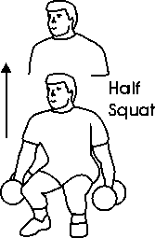 | 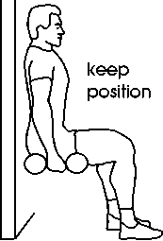 | 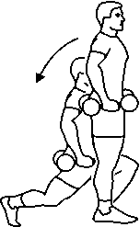 |  |  | 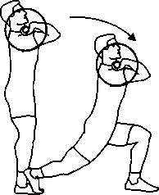 |  |  | 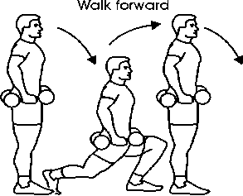 |  | 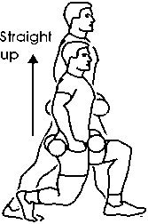 | 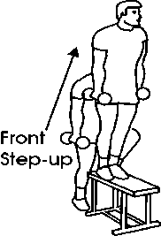
Hamstring Bridge | Gluteal Press | Inner Thigh Raise |  |  | Outer Thigh Raise |  |  |  |  | Triceps Dips | Triceps Push-Ups
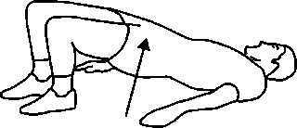 | 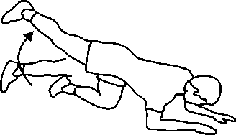 | 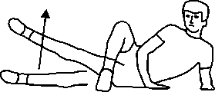 |  |  | 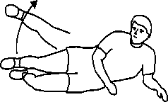 |  | 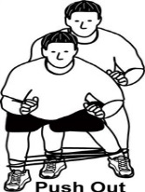 |  |  | 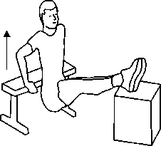 | 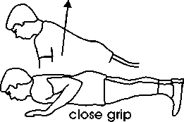
Upper back Exercise Options - Rhomboids, Lats, Trapezius, Posterior Deltoid |  |  |  |  |  |  |  |  |  | Biceps Exercise Options
Lat Pull Down | Tubing Rear Fly |  | Bent-over Fly |  |  | Bent Row |  | Tubing Row |  | Tubing Curls |  | Dbell Curls
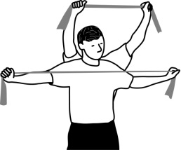 | 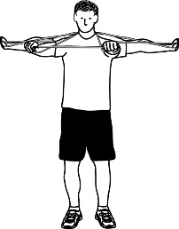 |  | 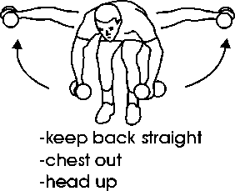 |  |  | 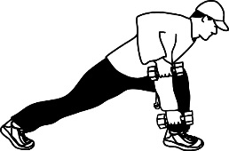  Can Use school bag |  | 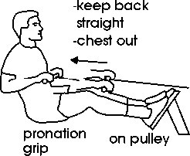 |  | 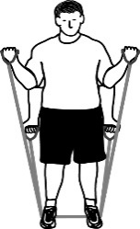 |  | 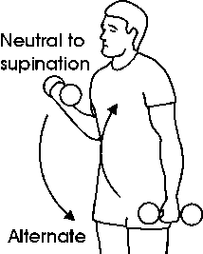
Chest Exercises |  |  |  |  |  |  |  | Shoulder Exercises
Push-Ups | Chest Flyes |  | Chest Press | Tubing Flyes |  |  |  | Front Raise | Lateral Raise |  |  | Shoulder Press
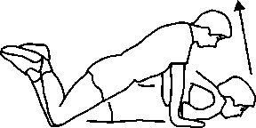  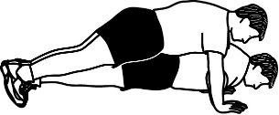 | 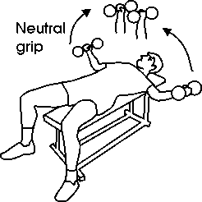 |  | 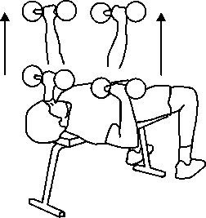 | 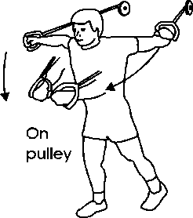 |  |  |  | 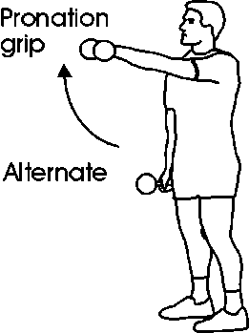 | 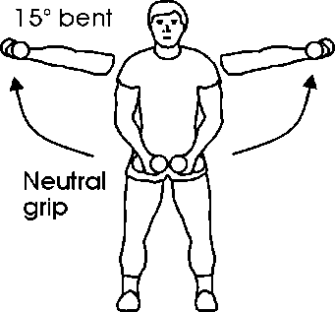 |  |  | 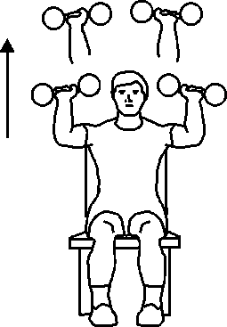

Training the Trunk Guidelines:
Choose 1-2 exercises for the low back, 1-2 for the Abs, 1-2 for the Obliques, 1-2 for Posture
Do 1-3 sets of each exercise / if you can do more than 25 reps (or 90 seconds), ↑ the level of difficulty.
Supermans /  Lower back | Curl-Ups / Abdominals | Reverse Curls / Abdominals | Side Curl-Ups / Obliques | Plank / Posture | Side Plank / Posture / Obliques
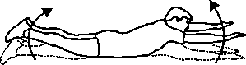 | 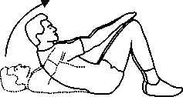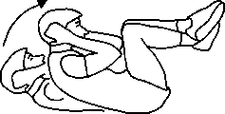 | 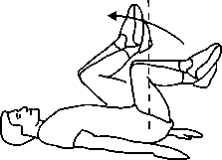 | 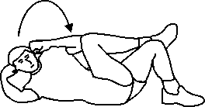 | 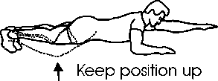 | 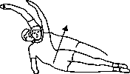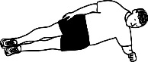

Stretching Exercise Options - Choose 1-2 stretches for each muscle worked – Hold 30 seconds and repeat.
Neck  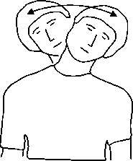 | Lower back  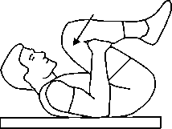 |  | Lower back + Gluteals  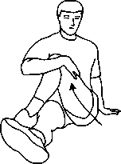 |  | Gluteals  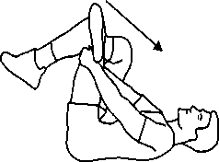 |  | Hamstrings  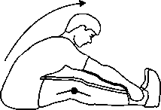 |  | Hamstrings  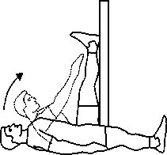 |  | Inner Thigh  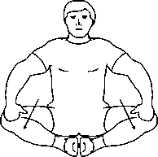 | Inner Thigh 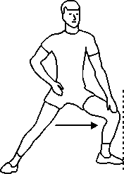
Quadriceps  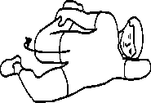 |  | Quadriceps  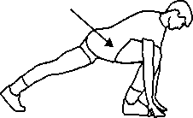 |  | Calves  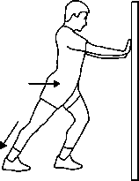 |  | Abdominals  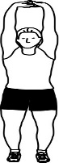 |  | Obliques  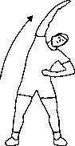 |  | Upper back  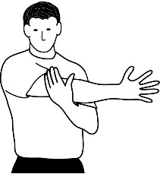 | Chest & Triceps 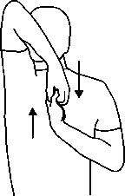 | Chest  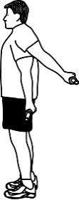

Cardiovascular Exercise Options – 20 – 60 minutes of continuous non-stop activity
At Home  Exercise Videos / Skip / stairs /  Walk the Dog / Dance | Fitness Centre  Elliptical / Treadmill / Rowing /  Stairmaster / Stationary bike /  Aerobics–Step–Dance Classes  Swim / Aqua fitness | Sports  Ball Hockey / Hockey  Basketball / Soccer /  Badminton / Squash / Racquetball | Outdoors  Walk / Jog / Hike / Swim  Roller Blade / Skating  X-country Ski / Snow shoe  Biking

Sample Workout Preps

Elliptical Workout  Cardio | Bootcamp Workout  Cardio / Muscle | Weight Training –  Legs and Chest Day | Soccer Game
Warm-Up
3 min Thermal:  Elliptical  2 min. ROM:  ankles, knees, hips, lower back  2 min Mobility:  Lunges, plank, Supermans | 3 min Thermal:  Skip, Jacks, butt kicks  2 min ROM:  Leg swings, arm swings,  Spinal rotation  3 min Mobility:  Squats, Lunges, Inchworm, push-ups | 2 min. Thermal:  Rowing Machine  2 min ROM:  Knees, Hips, Shoulders  4 min Mobility:  Lunges, Squats, Toe Touches, Lunge and Rotate, Plank  Light Weight Sets | 5 min Thermal:  Shuffle, jog, butt kicks, karaoke, high knees  3 minutes ROM:  Ankle, knee, hip, lower back, shoulders  3 min Mobility:  Squats, Fwd Lunges, Lateral Lunges, Plank  5 min Movement Specific:  Passing, game simulation, shooting
Workout
20 minutes Elliptical  Interval Workout  60-85% HR Range | Round 1: Lunges –  Push-Ups – Ball Slams – Skipping  Round 2:  Pull-Ups – Box Jumps – Strict Press - Plank | 4 x 10-12 RM  Legs: Lunges, Squats, Deadlifts, 1 legged Bridge  Pectorals: Bench Press, Incline Dbell Press, Dbell Flyes, | Play  5 min mini warm-up if coming from bench
Cool-Down
2 Minute low intensity Elliptical ↓ HR | 2 Minute walk around Cardio Cool-down ↓ HR |  | 2 Minute light jog across field ↓ HR
5 Minutes Static Stretching: 2x30 sec  Calves, Quads, Hamstrings, Glutes, Hip Flexors | 5 Minutes Static Stretching: 2x30 sec  Quads, Hamstrings, Glutes, Pectorals, Abs, Obliques, Lower Back | 5 Minutes Static Stretching: 2x30 sec  Quads, Hamstrings, Glutes, Pectorals, Triceps | 5 Minutes Static Stretching: 2x30 sec  Quads, Hamstrings, Glutes, Inner Thigh, Calves, Lower Back, Abdominals

RELATED WEBSITES

www.exrx.com
- Weight training - Exercise options for the various muscle groups, muscle charts, weight training program information, common errors.
- Cardio training information - FITT principle
- Fitness Tests and Norms: BMI, Target Wt., Curl-ups, Push-ups, Flexibility, Cardio.

www.youronlinefitness.com
- Weight Training - exercise options for the various muscle groups.
- Cardiovascular Training Information - FITT principle

www.exercise.about.com
- General Exercise Information
- Back care & Posture Information
- Product information - equipment, exercise videos.

www.hc-sc.qc.ca (Health Canada)
- Lifestyle & Health Information - Healthy living guide
- Physical activity guide
- Canada Food Guide

www.americanheart.org
- Lifestyle & Health Information
- Exercise Information
- Fitness Testing Information

www.bmi-calculator.net/body-fat-calculator
- Calculate your BMI
- Calculate your Body Fat
- Calculate your Ideal Body Weight
Bibliography
Vanier College Physical Education by Shawna Lambert

Hoeger, Werner W.K., Hoeger, Sharon A., Locke, Marius & Lauzon, Lara. (2009). Principles and Labs for Fitness and Wellness, First Canadian Edition. Toronto: Nelson Education Ltd.
Total # of pages: 480
Pages used: 21-22 (2)
ISBN: 139780176104047

Heart and Stroke Foundation. Logo Image. Retrieved from: http://ottawaheart.ca/images/2.6-Heart-and-Stroke-logo.gif

CPR/First Aid for Public, First aid, CPR and AEDs: Learn to save a life! Canada: Retrieved from: www.heartandstroke.ca

Government of Canada. Heart Disease – Heart Health. Retrieved from: http://www.healthycanadians.gc.ca/diseases-conditions-maladies-affections/disease-maladie/heart-disease-eng.php

Participaction. Canadian Activity Guidelines for Adults - ages 18-64. Retrieved from: http://www.participaction.com/get-informed/physical-activity-guidelines/guidelines-for-adults/

American College of Sports Medicine. (2011). News Release. ACSM Issues New Recommendations on Quantity and Quality of Exercise. Retrieved from: http://acsm.org/about-acsm/media-room/news-releases/2011/08/01/acsm-issues-new-recommendations-on-quantity-and-quality-of-exercise

American Council on Exercise, (1991). Personal Trainer Manual, The Resource for Fitness Instructors. San Diego, California: American Council on Exercise. P. 304
Total # of pages: 521
Pages used: p.304 (1)
ISBN: 0961816112

Powers, Scott K., Dodd, Stephen L., Thompson, Angela M., Condon, Camie C. (2006). Total Fitness and Wellness, Canadian Edition. Toronto: Pearson Education Canada.
Total # of pages: 388
Pages used: 228, 232, 323-324, 243 (5)
ISBN: 0205445489

Bodyweight Exercise. (2010) Free Muscle Chart. Retrieved from:
http://bodyweightexexercise.blogspot.ca/2010/09/free-muscle-chart-download.html

Muscle anatomy diagram. Wikipedia, the free Encyclopedia, Retrieved from: http://webanatomy.net/anatomy/muscleman.gif

All exercise, posture and stretching exercises in the Manual were retrieved from:
Trainer Clip Art Strength and Conditioning Illustrations Designed by Strength Coaches of Strength Coaches (purchased CD in 2014). www.TrainerClipart.com

Health Canada. Food and Nutrition. CANADA'S FOOD GUIDE TO HEALTHY EATING. Retrieved from: http://www.hc-sc.gc.ca/index-eng.php

Choose My Plate.gov Retrieved from: http://upload.wikimedia.org/wikipedia/commons/5/50/USDA_MyPlate_green.jpg

Health Canada. Food and Nutrition. Canada Food Guide. Take a step today... towards eating well. Retrieved from: http://www.hc-sc.gc.ca/fn-an/food-guide-aliment/maintain-adopt/limit-eng.php

Williams, Melvin H., Lifetime Fitness & Wellness, (1996). Madison, WI: Brown & Benchmark Publishers.
Total # of pages: 368
Pages used: p. 275-276, 331-337 (9)
ISBN: 06971267069780697126702

Powers, Scott K., Dodd, Stephen L., Jackson, Erica M. (2011). Total Fitness and Wellness, Third Edition, Media Update. San Francisco: Pearson Benjamin Cummings.
Total # of pages: 354
Pages used: p. 245 (1)
ISBN: 0321676238

Hales, Dianne. (1994). An Invitation to Health – sixth edition. California: Benjamin / Cummings Publishing Company.
Total # of pages: 672
Pages used: p.50 (1) + reference
ISBN: 0805354808

Health Canada. Food and Nutrition. CANADA'S FOOD GUIDE TO HEALTHY EATING. My Food Guide Servings Tracker. Retrieved from:

http://hc-sc.gc.ca/fn-an/food-guide-aliment/track-suivi/index-eng.php

Health Canada. Body Mass Index Chart. Retrieved from:
http://www.hc-sc.gc.ca/fn-an/nutrition/weights-poids/guide-ld-adult/images/bmi_javachart-eng.gif

Body Mass Index Online Calculator. Retrieved from: http://www.bmi-calculator.net/

Lawrence, Arthur Golding, Myers, Clayton R., Sinning, Wayne E. (1986) Y's way to physical fitness: the complete guide to fitness testing and instruction. Champaign, IL: Published for YMCA of the USA by Human Kinetics Publishers.
Total Pages: 191
# of Pages Used: p.114-118 (4)
ISBN: 08732221489780873222143

École de dos. Renforcer les quadriceps. Université de Québec en Abitibi-Témiscamingue. Retrieved from: http://uriic.uqat.ca/chroniquep/03preparationphysique

Richard Chevalier, Richard. (2010) À vos marques, prêts, santé! Saint-Laurent, Québec: ERPI

Total # of Pages: (pag. multiple) # of pages used: 1 - ISBN: 9782761327138 2761327136

Davies, Phil. Total Soccer Fitness - The Complete Guide to Soccer Fitness – ebook (purchased in 2012)

Cardiovascular Endurance. 12-minute Copper Test Norms (1986) Retrieved from: http://en.wikipedia.org/wiki/Cooper_test

American College of Sports Medicine (ACSM). (1986). Guidelines for Exercise Testing and Prescription - 3rd Edition. Lea and Febiger.

Fleck, Steven J., PhD., Kraemer, William J., PhD. (1996). Periodization Breakthrough. Ronkonkoma, NY: Advanced Research Press, Inc.
Total Pages: 181
# of Pages used: reference
ISBN: 1889462004 9781889462004

McArdle, William D., Frank I Katch and Victor L. Katch. (2007). Exercise Physiology, Energy, Nutrition and Human Performance – 6th Edition. Philadelphia: Lippincott Williams & Wilkins.
Total Pages:1068
# of Pages used: reference
ISBN: 9780781749909 0781749905

Happy Fitness to You :)

